Week 1 ENERGY

- Listen to the introduction to a presentation.
Vocabulary: concern –
there are concerns about
the concern that wind energy is unreliable

- What will the presentation focus on?

- You will get a picture related to a source of energy.
- What source of energy is your picture related to?
- Which geographical location is it often found in?
- Is it a renewable source of energy?
- Is it used in your own country?

Different sources of energy

A 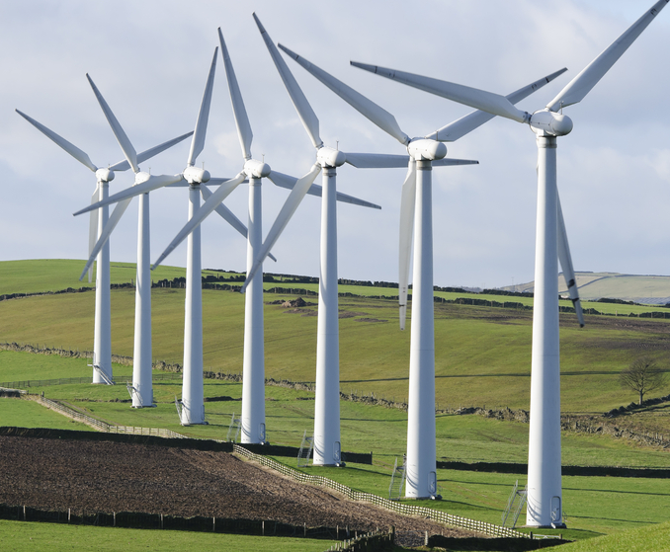 B 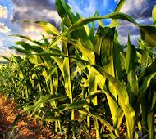 C 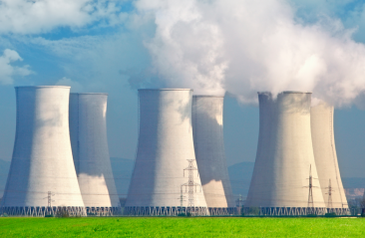

C 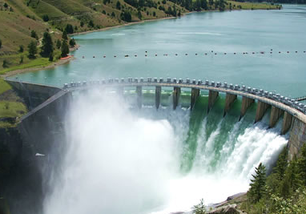 D 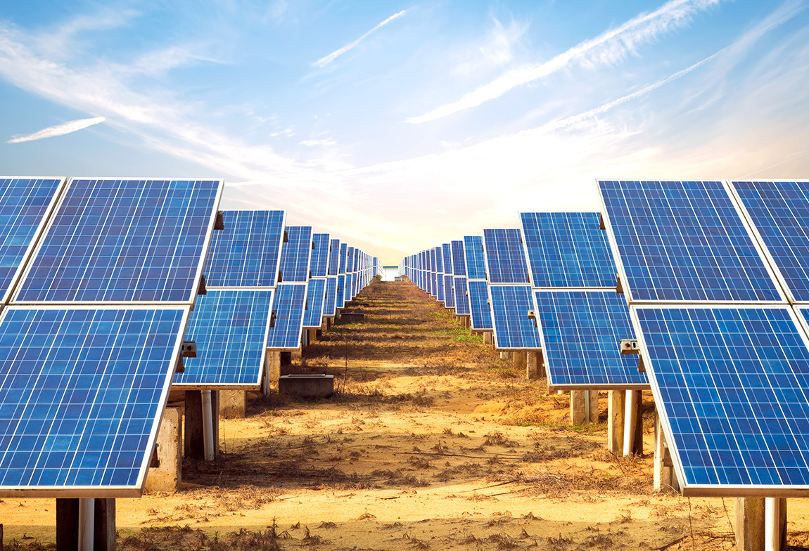 E 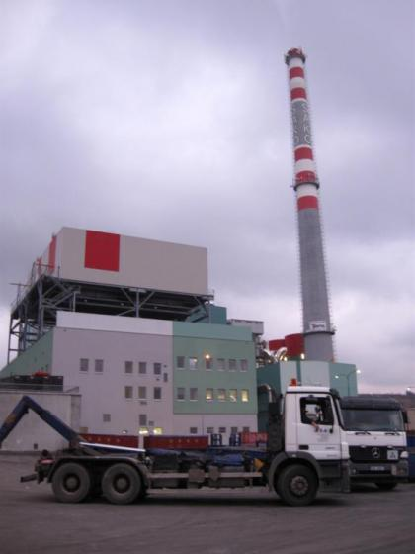

- Talk in groups. Identify a problem for each energy source. Look at the problem from different perspectives.

Example: Biofuels use up a large quantity of plants such as maize, which could be eaten by humans or animals. Growing all these plants takes up a lot of space, which again could be used for other purposes.

Vocabulary:
efficient x inefficient wind farms
expensive x cost-effective national grid – rozvodná síť
photovoltaic cells initial costs
convert energy competitive - konkurenceschopný
generate electricity alternative energy source
capture sun’s energy nuclear plant
- Look at an extract from a book Renewable Energy: Power for a Sustainable Future. Which three energy sources does the text mention?

There are several benefits of using renewable energy supplies in preference to conventional sources. They cut carbon dioxide emissions, they decrease a country’s reliance on imported fuel, and they cut emissions of acid rain pollutants, sulphur dioxide and nitrogen oxides. However, all renewable energy sources have some environmental consequences. Their benefits have to be seen in relation to the alternatives.
It is unlikely, for example, that there will be much further development of large-scale hydroelectricity within the EU, apart from re-powering existing schemes. When new dams are built, large populations have to be relocated. The problems of flooding large areas of land are sufficient to rule out further expansion.
Similarly, municipal solid waste is widely burned, and contributes to national renewable energy totals, yet it faces opposition because of fears of dioxin emissions. This, too, is omitted from many promotion schemes, although the gasification and burning of waste which might have lower emissions are included.
Biomass also needs to be burned cleanly to avoid air pollution. In an extreme case, the Indian government has a policy to discourage the use of firewood as a cooking fuel in cities. Moreover, growing plants for fuel means that there are less crops grown for food.
The intensive cultivation of energy crops is being encouraged in spite of the fact that it may require the use of fossil fuel in the production of fertilizers and the harvesting and transport of the produce.

- Match the headings 1 and 2 with the correct descriptions a] or b]

- What are the environmentally sustainable options?
- Balancing economic and environmental considerations

a] a discussion of the environmental problems associated with different energy sources

b] a description of the choices for ways of producing energy that are environmentally sustainable

Re-read the text and choose the appropriate heading, 1 or 2.

- According to the text - Why should we look at renewable sources in relation to the alternatives?
What hinders building new dams?
Which source of energy faces opposition?
Which solutions are supported?

- Highlight complex prepositions in the text (i.e. phrases made up of more than one word).

- Complete the sentences 1 – 5 with a complex preposition used in the text above.
- Using renewable energy technologies ………………… conventional source can benefit the environment.
- There are other factors which must be taken into consideration when planning a new power station, …….…..…….. simply the financial costs.
- …………………. concerns about safety, many governments are unwilling to commit to nuclear energy programmes.
- As with any technology, the benefits of wind power need to be evaluated ……….…… other technologies.
- Gasification and burning of waste is encouraged ………….……... fears of dioxin emissions.
- No sound video: work in pairs and describe what is in your extract to your partner.
https://www.youtube.com/watch?v=RQPs0jAqeGk
1st extract 0.20 – 1.00, 2nd extract 1.36 – 2.21

- Co-operate and retell the story from the video report.

- Vocabulary: complete the phrases with the words from the list. Then watch the report.

entrepreneur underway reserves turbines blades brakes placed tapped

1. hot water ………………… underground
2. wind power hasn’t been ………………… into
3. work is ………………… on a new concept
4. simplicity, as the ………………… says, is the key
5. traditional ………………… can spin out of control
6. it has precisely engineered …………………
7. it slows down without needing …………………
8. the invention ………………… 2nd on a national reality show

TEAM PRESENTATIONS
- Complete the structure with your own suggestions.

- Introduction
- open the presentation, introduce the group
- introduce the ……………………… of the presentation
- preview the key points
- explain how the presentation is ……………………

- Main Body
- present each main point
- give ………………………… or supporting information
- evaluate solutions

- Conclusion
  - summarize what ……………………… you have ……
  - give overall evaluation
  - invite the audience to ask questions
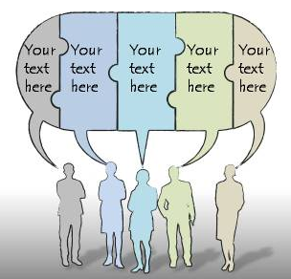

2. You will hear extracts form a presentation about finding additional sources of energy. For each speaker, note down
 | initial phrase + topic | evaluation | closing phrase
1

2

3

INTRODUCTION
Open the presentation, introduce the group, state the title, give an overview of the aims of the presentation:

This presentation is about …
We are going to look at three solutions…
There are three ways to …
What we want to do is to show that…

Describe the structure:
So, firstly, Louisa’s going to talk about…
Then Yakut is going to look at …
And finally, I’ll talk about a third solution, …
HANDING OVER TO THE NEXT SPEAKER
So…over to you, Louisa.
Now I’d like to hand over to Yakut to talk about
OK, so I’ll hand over to Kris for the last part.

Present each main point and supporting details
The main concern about … is …

CONCLUSION
To sum up, …
There is evidence to suggest that…
Thank you for listening.
Now we’d be happy to answer your questions.

3. Work in threes. Choose a problem and think about solutions. Practise the structure of the presentation by using the phrases from above, starting with introduction and ending with inviting questions.

4. Homework: FOCUSING
Structures beginning with what, why, where, how, etc. Are used to draw attention to specific information. They are useful for spoken presentations as a signal of new information for the listener.

Example There are I’d like two main reasons, which to look at next.
What I’d like to look at next are the two main reasons.

Change the sentences so that they start with wh- word.
1. I’m saying that environmental and economic interests must be balanced.
What …

2. I’d like to emphasize the difficulties connected with destroying nuclear waste.
What …

3. It’s hard to decide where new wind turbines can be situated.
Where…

