Week 3 ECONOMIC DEVELOPMENT

MEDC LEDC NIC

1. Classification of countries based on Gross Domestic Product + Human Development Index
- Try to give words for the abbreviations.
- Which characteristics can you use for categorizing countries?

2. Economics in LEDC – Informal sector
https://www.youtube.com/watch?v=W-lBVV_kbs8

- After watching the video summarize what ‘informal sector’ is.

3. OECD: Better international co-ordination could lead to more benefits from migration
Adapted from http://www.oecd.org/dev/better-international-co-ordination-could-lead-to-more-worldwide-benefits-from-migration.htm

Questions:
- Where are the migrants heading?
- How is the income difference between developing and developed countries changing?
- What factors influence migration?
- What does OECD recommend as a solution?
- What effects does the migration have on the countries that people are leaving?

Find translations or synonyms of these words:
disparity facilitate reinforce remittances exert

Read the report and complete the text with the phrases below.

- developing, emerging and advanced economies
- increase of about 85 million people in two decades
- has jumped from 36% to 51%
- less than 10% of total migrants worldwide
- address the potential impacts
- migrants send home remittances
- life expectancy, security, health and education
Perspectives on Global Development 2017: International Migration in a Shifting World shows that while the share of global migrants originating from developing countries has remained fairly stable at around 80% over the last 20 years, the share of developing country migrants heading to high-income countries 1____ of the world total.
Various factors influence today’s migration patterns. Notwithstanding rapid economic growth in many developing economies, the average per-capita income differential between developing and advanced economies has increased from around USD 20,000 in 1995 to more than USD 35,000 in 2015, making the latter even more attractive for migrants. While well-being in developing countries has improved in areas like 2_____, the disparity with advanced countries remains high. The presence of migrant networks (family, friends and community) already living in destination countries facilitates migration, reinforcing the concentration in a few preferred destinations.
Other factors affecting migration patterns include immigration policies, rising education levels in developing countries, and changing demographics and labour market needs worldwide.
The share of the world population living outside their country of birth has risen from 2.7% in 1995 to 3.3% in 2015, an 3_____ to roughly a total of 245 million international migrants.
"Migration is a natural result of economic development that can benefit both countries of origin and destination. This trend is here to stay, so it has to work for all countries," said Angel Gurría, the OECD Secretary General. "Improved co-operation would help 4______ better manage migration to the benefit of all, making sure that there are more winners and fewer losers from migration."
Migration can have both positive and negative impacts on countries of origin as well as those of destination. For the countries migrants are leaving, the loss of labour can relieve pressure in over-crowded labour markets, propping up wages and easing unemployment. Moreover, 5______ and bring knowledge and ideas as they return. But emigration also can come with economic and social costs, such as labour shortages, a loss of educated and skilled workers.
Countries of destination can benefit from migration to make up for worker shortages, especially in specific sectors. Immigrants also contribute more than just their labour: they also invest in their host country and help create jobs. Public policies in developing countries of destination need to invest in immigrants’ economic and social integration and 6_____ that large inflows can exert on the capacity of public services.
As the number of people migrating is likely to continue to increase, the need is growing for greater international co-operation to manage migration flows as well as a framework for handling refugee crises – which are a separate and smaller phenomenon than economic migration. Even with the current crisis, refugees represent 7_____
Better international co-operation should span areas such as the protection of migrants’ rights, visa agreements, recruitment and remittance costs, as well as qualifications and skills partnerships.

Dilip Ratha: The hidden force in global economics: sending money home 0 – 8.47
https://www.ted.com/talks/dilip_ratha_the_hidden_force_in_global_economics_sending_money_home#t-119309

Watch the speech and discuss what the speaker’s point of view shows.

TYPES OF AID – complete the definitions with your own suggestions
http://www.bbc.co.uk/schools/gcsebitesize/geography/development/aid_rev1.shtml
Emergency or short-term aid - needed after sudden d……………… such as the 2004 Asian tsunami.
Conditional or tied aid - when one country donates money or resources to another (bilateral aid) but with c………………. attached.
Charitable aid - funded by donations from the public through ch………………. and non-governmental organizations.
Long-term or development aid - involves providing local communities with education and skills for s……………. development.
Multilateral aid - given through i…………………. organisations such as the World Bank rather than by one specific country.
Arguments for and against giving aid
http://www.bbc.co.uk/schools/gcsebitesize/geography/development/aid_rev2.shtml

Phrases for expressing opinion:

I think that
In my view
From my point of view

From an economic perspective
As far as politics are concerned
If we look at this from a social perspective
What do you think?
What are your views on this?
I see what you mean but

- There are mixed opinions about the role of aid in solving the problems of world poverty. Work in groups of 4 and prepare some arguments for and against. Then take roles and discuss different views.
1. a representative of a non-governmental organization
2. an immigrant
3. a politician
4. the chairperson in the discussion

Micro Hydro in Peru
https://www.youtube.com/watch?v=vKQ6t0000Kc

1. Watch the video and discuss how much the activity fits into the scheme of sustainable development shown below
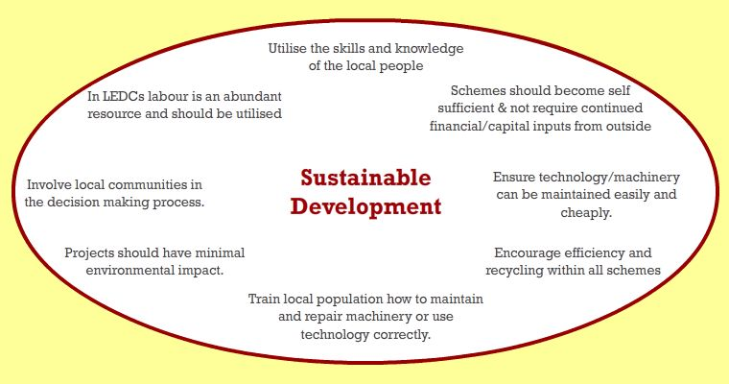
- Express these sentences in English. To check, listen again to the part 2.44 – 4.14.

1. Větší uživatelé platí sníženou sazbu.
2. Bez elektřiny by žádná z těchto věcí nebyla možná.
3. Peruánská vláda nyní plánuje zdvojnásobit počet malých hydroelektráren.
4. Mechanizace ulevila v namáhavé práci.
5. Malé firmy rostu jako houby po dešti.
Key p.2: 1C 2G 3B 4A 5F 6E 7D

