CARTOGRAPHY, MAPS

1. Which types of maps are shown below? Complete their characteristics with the five words.
http://guides.library.stonybrook.edu/c.php?g=35399&p=224896 http://www.icsm.gov.au/mapping/maps_intro.html

grid themes natural national contour

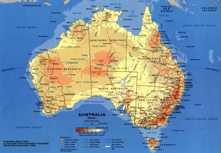

- is colourful
- cities are named
- major transport routes (highways and railways) are identified
- 1 ……….. features such as rivers, lakes and mountains are named
- elevation is shown using a simple colour shading
- has 2 ……….. included – e.g. city population size

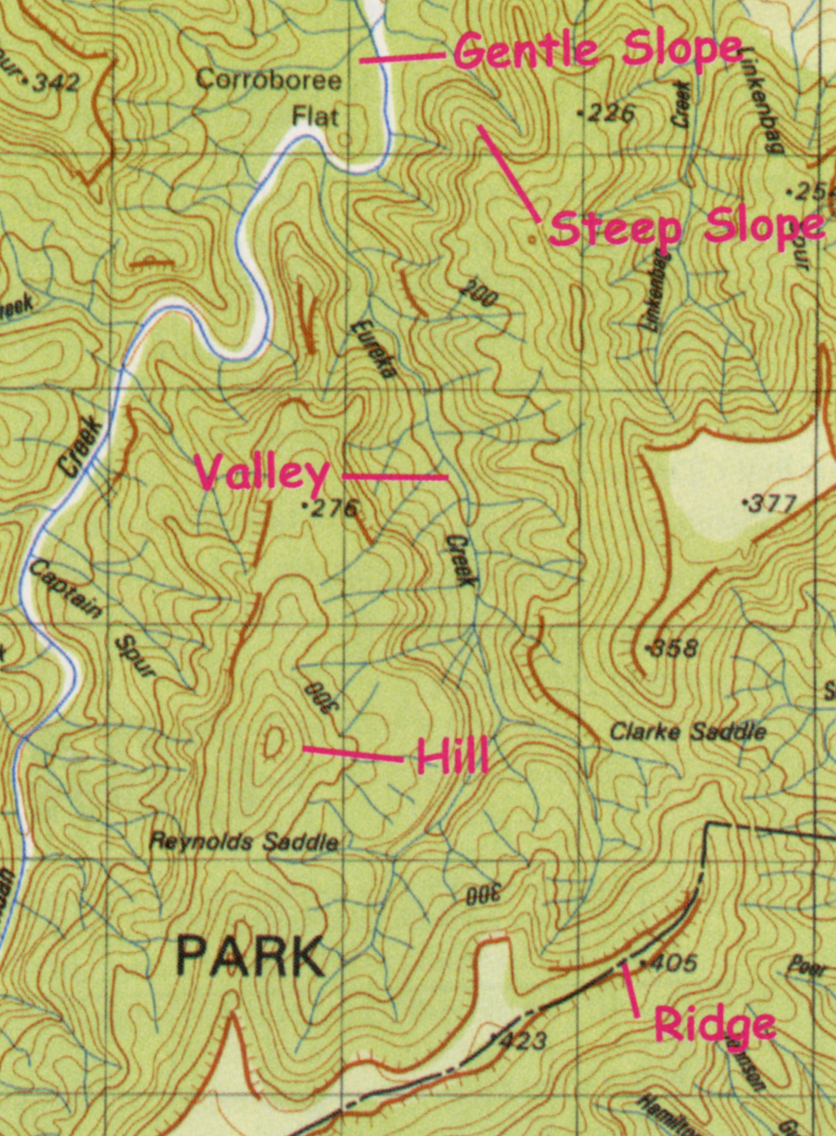

- shows elevation using 3 ………… lines
- has an emphasis on showing human settlement (roads, cities, buildings etc.), but may include some thematic information such as vegetation or the boundaries of 4 ……….. parks
- has very good location reference systems – including latitude and longitude, but may also have 5 …………… lines

2. Explain the main difference between the two types of maps.

Read the passage and compare your answer.

General reference maps show important physical (natural and man-made) features in an area. They usually have a primary purpose of summarising the landscape. They are small-scale maps, such as maps covering a continent, region, or country on a single sheet.

General reference maps also include thematic maps (maps about a subject, which show such things as population and crop distribution).
Like the general reference map, topographic maps are a summary of the landscape and show important natural and man-made features in an area. The primary difference is that they show elevation in detail.

3. Study the picture of the topographic map.
- What is the contour interval used on the map?
- Which saddle is higher in elevation, Clarke or Reynolds?
- Find hachures. 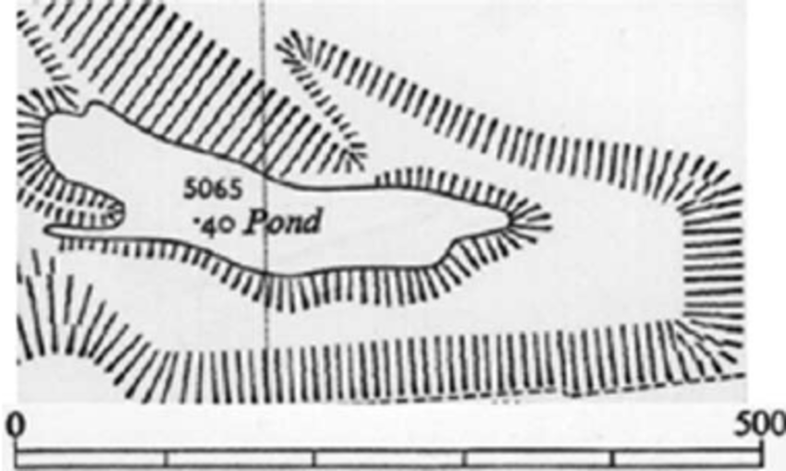 Are they oriented towards rising or falling terrain?
MAP SCALE http://www.physicalgeography.net/fundamentals/2a.html (abbreviated)

4. Discuss the questions and then look for the information in the text:
- What is a fraction and what is a ratio? Give some examples.
- How can you express the scale of a map in different ways?
- How do you categorize maps according to the scale?

Maps are made at a scale that is much smaller than the area of the actual surface being depicted. The amount of reduction that has taken place is normally identified somewhere on the map. This measurement is commonly referred to as the map scale. Conceptually, we can think of map scale as the ratio between the distance between any two points on the map compared to the actual ground distance represented. This concept can also be expressed mathematically as:
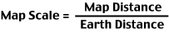
On most maps, the map scale is represented by a simple fraction or ratio. This type of description of a map's scale is called a representative fraction. For example, a map where one unit on the illustration represents 1,000,000 of these same units on the actual surface of the Earth would have a representative fraction of 1/1,000,000 (fraction) or 1:1,000,000 (ratio). Of these mathematical representations of scale, the ratio form is most commonly found on maps.

Scale can also be described on a map by a verbal statement. For example, 1:1,000,000 could be verbally described as "1 centimeter on the map equals 10 kilometers on the Earth's surface".

Most maps also use graphic scale to describe the distance relationships between the map and the real world. In a graphic scale, an illustration is used to depict distances on the map in common units of measurement.
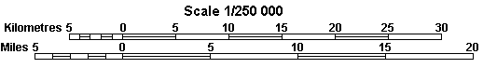
Maps are often described, in a relative sense, as being either small scale or large scale. Below we have maps representing an area of the world at scales of 1:100,000, 1:50,000, and 1:25,000.

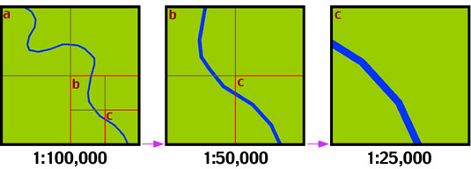
The map on the far left has the smallest scale, while the map on the far right has the largest scale. Note what happens to the amount of area represented on the maps when the scale is changed. A doubling of the scale causes the area shown on the map to be reduced to 25%.

5. Reread the the text to find synonyms for these words. (in the same order 1-5 in the text)

1. described –
2. idea -
3. real -
4. numbers showing size / gaining the numbers of size -
5. making something twice bigger -
6. Introduction to Cartography and Making Maps
https://www.youtube.com/watch?v=4ONjZsFxcg8&index=5&list=PLT_j51lDoaE75xTIx4Ts7aEf9bbTB4jQm

What is your definition of cartography? Complete the sentence.
Cartography is …………….. which deals with …
OR Cartography is …………….. of …….. –ing …

Listen and complete the sentences.
- Maps are designed by the cartographer to c…………. a message to the map reader.
- The purpose often dictates the type of map – t………………… or cho……… map which shows measurement of statistical v………………
- When making a map we transform a s…………….. surface into f………….. map.
- This transformation is known as map p………………….. .
- Transformation process always results in d………………. .
- Maps are often considered l……………. scale or s………. scale in relation to one another.
- If you convert the ratios to d……………. value, you can see which one is larger.
- Every map has been g………………. to some extent.
- The width of highway is exaggerated so that it would be v…………….. at the scale.
- The smaller the scale, the greater the need to generalize map f………………. .
- Most maps have a l…………….. or a k………. which explains to the user the symbols used on a map.

7. HOMEWORK Complete the text with the words from the list.

Adapted from https://en.wikipedia.org/wiki/Cartography by Eva Čoupková

information projections editing practice

traits modeled traditional agenda
Cartography is the study and 1) …………….. of making maps. Combining science, aesthetics, and technique, cartography builds on the premise that reality can be 2) …………….. in ways that communicate spatial information effectively.
The fundamental problems of 3) …………….. cartography are to:
- Set the map's design and select 4) …………….. of the object to be mapped. This is the concern of map 5) ……………... Traits may be physical, such as roads or land masses, or may be abstract, such as toponyms or political boundaries.
- Represent the terrain of the mapped object on flat media. This is the concern of map 6)……………...
- Eliminate characteristics of the mapped object that are not relevant to the map's purpose. This is the concern of generalization.
- Reduce the complexity of the characteristics that will be mapped. This is also the concern of generalization.
- Orchestrate the elements of the map to best convey its message to its audience. This is the concern of map 7) ……………...
Modern cartography is largely integrated with geographic 8) …………….. science (GIScience) and constitutes many theoretical and practical foundations of geographic information systems.
Activists Cartographers

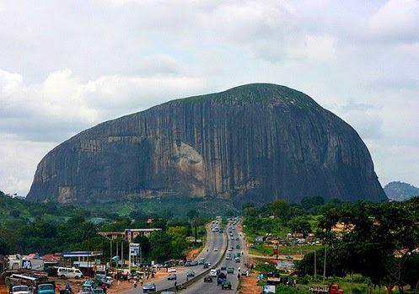

1. Look at the picture – what ideas does it give you about
- the countryside
- the infrastructure of the place
- the economic level of the country

2. Vocabulary from the video. Match the words and their descriptions

A to be unaware of 1 distrustful, cautious, suspecting danger
B resources 2 a person who lives in a particular place permanently
C to be wary 3 not informed about the current developments
D emergency 4 means that can be used to cope with a difficult situation
E resident 5 an unexpected event which requires immediate help

3. Watch the report and decide whether the statements are true or false.
http://www.voanews.com/content/nigerian-activists-google-map-capital-city-abuja/1591551.html

- Foreign investors know about the changes in the country.
- According to the project director, emergency services need better maps.
- The cartographers receive money for mapping the city.
- Government and police arrest the activists.
- The cartographers are local citizens.

4. Summarize causes and effects.
1. The expected effects of mapping:

2. Possible causes why the residents are afraid of mapping:

3. Reasons why the police are wary:

