Week 7 **MAP PROJECTIONS**

1. **Look at the figures and find:**

parallel lines

curved line

horizontal line

vertical line

perpendicular lines

right angle

diagonal / oblique line

tangent

secant





1. **Draw these figures and answer the questions below:**

***a circle a square a rectangle a triangle a semi-circle***

1. Which figure is curved?
2. Which figures have parallel sides?
3. Which figure has a curved side and a straight side?
4. Which figure always has equal sides?
5. Which figure may have equal sides?
6. Which figure has 3 angles?
7. **Now make sentences from the table.**

|  |  |  |  |  |  |
| --- | --- | --- | --- | --- | --- |
| A coin  A ruler  A set square  A protractor  A chess-board | is  shaped  like a | square  rectangle.  semi-circle.  triangle.  circle. | It is | rectangular  circular  square  semi-circular  triangular | in shape. |

1. A ball is shaped like a sphere, it is ……..…..
2. A test-tube is shaped like a cylinder, it is ….
3. A funnel is shaped like a cone, it is ……..….
4. Flat surface is like a plane, it is ………

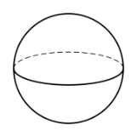 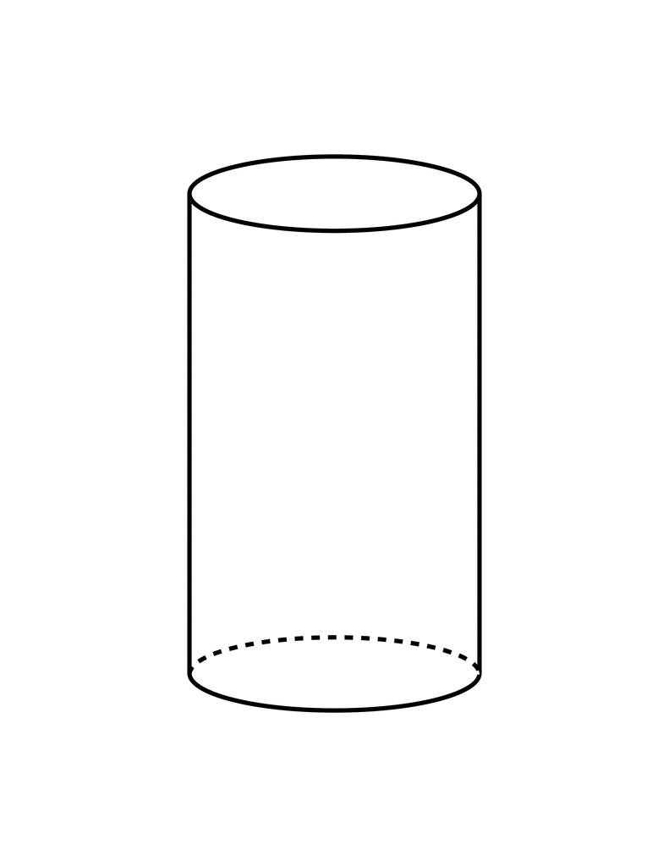 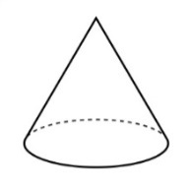 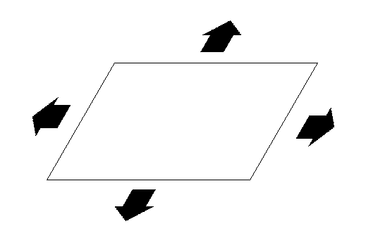

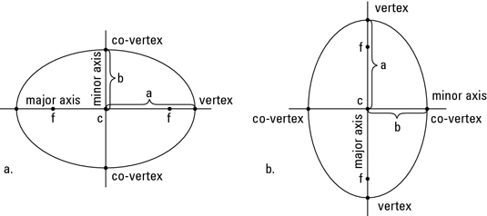 e)The path of the Earth around the Sun is like an ellipse, it is …

1. **Are the statements below true or false?** A**)** The cross-section of a cone is circular.

B) The cross-section of a cylinder is rectangular.

C) The longitudinal section of a hemisphere is semi-circular.

**5. Eternal dilemma of map makers**

**Watch the extract without sound** 0 – 1.10 **and write the script for the video.**

https://www.youtube.com/watch?v=kIID5FDi2JQ&t=3s

**6. With the help of the pictures, explain how we can visualize what a map projection is.**

<http://earth.rice.edu/mtpe/geo/geosphere/topics/mapprojections.html>

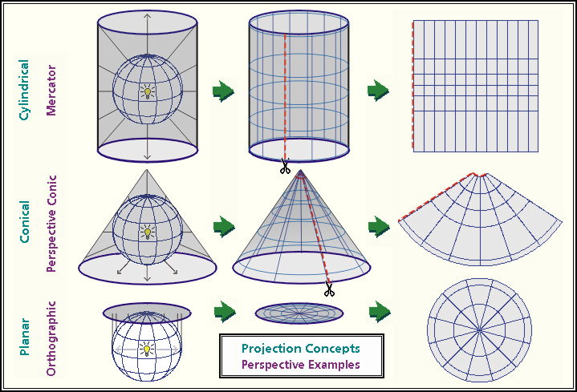

**7. Complete the text with suitable words form page 1.**

The systematic way in which a 1 …………… surface is represented on a flat plane (such as a page in an atlas) is called a map projection. Three such projection methods are easy to visualize – 2………………, 3 ……………… , and 4 ……............ . If a spherical or spheroidal (or "squashed sphere") object is imagined as a wire-frame model with a light source in the center, the shadows created beyond the 5 …………… can be "projected" onto a flat surface. There are several variations possible with any of these configurations; for example, placing an imagined light source in a place other than the center of the wire-frame, skewing the cylinder, 6…………… or plane to a non-upright orientation, or even allowing the "paper" to "slice" through the sphere. The conic and planar projections constructed as shown in the diagram above are called " 7 ……….. projections," because in these cases the "paper" is touching the surface of the sphere without slicing it. The "8 ….………… projection" maps (where the "paper" slices through the sphere), are more conceptual and complicated to produce, but are generally preferred over the tangent map varieties, due to the lower amounts of distortion revealed.

<http://www.geog.ucsb.edu/~dylan/mtpe/geosphere/topics/map/map1.html#proj>

**8. DISTORTION**

These pictures from 1921 compare how the drawing of man’s head changes in different projections.

Try to explain what ‘*distortion*’ means.

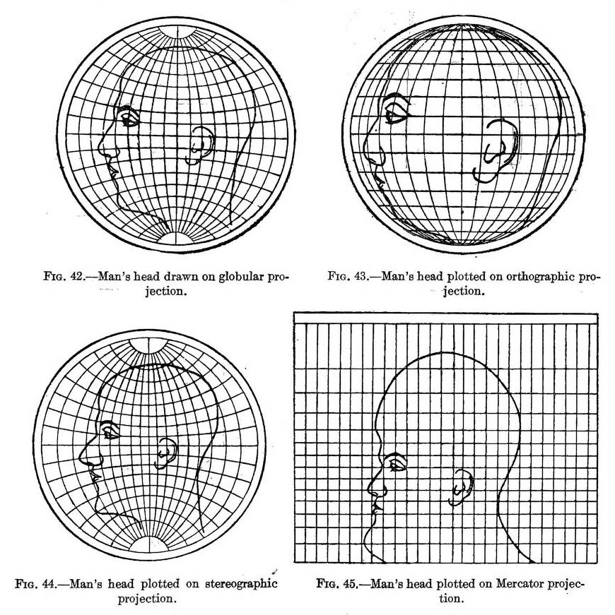

http://geoawesomeness.com/amazing-image-1921-will-explain-essence-map-projections/

**Metric properties measured on the Earth's surface**  **- match the properties and definitions.**

Adapted from https://en.wikipedia.org/wiki/Map_projection

*area shape direction bearing distance scale*

1. the information contained in the relative position of one point with respect to another without distance information
2. the angle between a line connecting two points and a north-south line
3. a numerical description of how far apart objects are
4. the ratio of a distance on the map to the corresponding distance on the ground
5. the form of an object or its external boundary
6. a quantity expressing the two-dimensional size of a defined part of a surface

**Which properties are preserved in the different types of projection? Complete the table.**

|  |  |
| --- | --- |
| *Projection* | *preserves* |
| Conformal |  |
| Equal area |  |
| Equidistant |  |
| Azimuthal |  |

**Watch and check**

<https://www.youtube.com/watch?v=v5fSBQRbPR0> 3.12 – 5.15

# **9. READING**

# **Choosing a model for the shape of the Earth**

* What models for representing the shape of the Earth are used?

**Complete the text with the missing parts.**

1. distinct major and minor axis
2. terrestrial and satellite gravity measurements
3. large and medium scale maps
4. closer in shape to an ellipsoid

The projection is also affected by how the shape of the earth is approximated. In the following discussion on projection categories, a sphere is assumed, but the Earth is not exactly spherical but is A) ……….with a bulge around the equator. Selecting a model for a shape of the earth involves a choice between the advantages and disadvantages between using a sphere vs. an ellipsoid. Spherical models are useful for small-scale maps (features are small) such as world atlases and globes since the error at that scale is not usually noticeable or important enough to justify using the more complicated ellipsoid. The ellipsoidal model is commonly used to construct topographic maps and for other B) ….. that need to accurately depict the land surface.

A third model of the shape of the earth is called a geoid, which is a complex and more or less accurate representation of the global mean sea level surface that is obtained through a combination of C) …… . This model is not used for mapping due to its complexity but is instead used for control purposes in the construction of geographic datums. A geoid is used to construct a datum by adding irregularities to the ellipsoid in order to better match the Earth’s actual shape (it takes into account the large scale features in the Earth’s gravity field associated with mantle convection patterns, as well as the gravity signatures of very large geomorphic features such as mountain ranges, plateaus and plains). Datums are always based on ellipsoids that best represent the geoid within the region the datum is going to be used for. Each ellipsoid has a D)……….. and different controls (modifications) are added to the ellipsoid in order to construct the datum, which is specialized and used for specific geographic regions (such as the North American Datum).

https://www.gislounge.com/map-projection/

Match these terms with the underlined parts of the text:

* datum
* geoid
* spherical models

**HOMEWORK**: Supply the missing forms.

|  |  |  |
| --- | --- | --- |
| *noun* | *adjective* | *adverb* |
| sphere |  |  |
|  | global |  |
|  |  | geographically |
| equator |  |  |
|  | cylindrical |  |
| mathematics |  |  |
|  |  | topographically |
|  | gravitational |  |

Sources A. Křepinská:Rozšiřující materiály pro výuku anglického jazyka, Matfyzpress, 2006

Ex. 2 – 4 prepared by Jana Kubrická, homework – Eva Čoupková