Week 8 THE THEORY OF PLATE TECTONICS

1. Warm-up
Describe the Earth’s structure: Discuss what you know about tectonic plates.

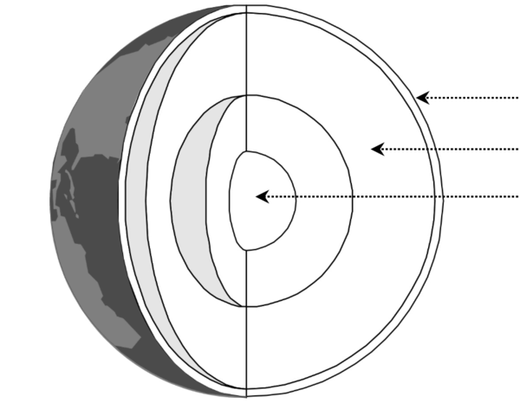

2. Complete the first column of the table with the types of contact zones / margins.
- constructive margins
- collision zones
- passive margins
- destructive margins / subduction zones

TYPE | DESCRIPTION | EXAMPLE
 | plates move away from each other, new oceanic crust appears forming mid-ocean ridges with volcanoes | Mid-Atlantic Ridge (Americas moving away from Eurasian and African Plates)
 | Oceanic crust moves towards continental crust but, being heavier, sinks and is destroyed forming deep trenches and islands with volcanoes | Nazca sinks under South American Plate (the Andes)
 | two continental crusts collide and, as neither can sink, are forced up into fold mountains | the Himalayas, the Alps
 | two plates move sideways past each other, land is neither formed nor destroyed | San Andreas fault in California
D. Waugh, Geography, 2002, p.14

3. Comparing two items: both, neither, either, both … and, neither … nor, either … or
Practise here http://www.grammar.cl/english/both-either-neither.htm

Complete:
- ……... books are very good and …….…. of them is expensive so you can study from …..… one.
- But our professor doesn’t like …………… of them.
- I was ……. tired …… hungry after the long lessons.
- …….... she studies harder ………. she’ll fail the exam.
- Few people attended the lecture. ..……. Tom ..….. Robin were there.

Find these on the map in ex. 1: Mid-Atlantic Ridge, the Andes, the Himalayas, San Andreas fault.
Discuss what happens at these places in relation to tectonic plates. Use some of the words from above in the discussion.
4. Video - Plate Tectonics Theory https://www.youtube.com/watch?v=mB2pzhWUaiU

A) Watch the first part. Check your words for the Earth’s structure in ex.1. 0-0.50
What information is given about the parts?

B) Watch and complete the details about: 0.50-2.20

- Two kinds of crust:
- Why plates move:
- In what directions:

C) Examples. 2.20 – 8.10 Check the meanings of these words before watching the last part.
emerge ooze solidify
friction trench fertile
release ash plume
edge fold debris

Complete the types of plate margins A-D plus the examples and the gaps in the report.

A…………………. EXAMPLE:

In 1963 Icelandic fishermen spotted plumes of ash, 1…………….. and lava shooting out of the sea.
Almost overnight a new island 2…..………. . Later this will be named Surtsey. (ABBREVIATED)
What had happened? At the bottom of the ocean two plates have slowly moved apart. 3………….. rock called magma lying below the plates oozed up through the cracks. When it reached the 4…..……….. , the magma cooled and solidified, forming lava. This built up until it broke through to the ocean surface to form an island. A 5…..…….… of lava mountains has been formed where the two plates have moved apart.

B…………………. EXAMPLE: Mount Merapi in ……………
C conservative margin EXAMPLE:
D…………………. EXAMPLE:

NOTE
fault - a break in the lithosphere along which movement has occurred

fold - flat and planar surfaces, such as sedimentary strata, are bent or curved as a result of permanent deformation
5. The Andes Mountains. Read the text and answer the questions below.
http://www.coolgeography.co.uk/GCSE/AQA/Restless%20Earth/Andes/Andes%20Case%20study.htm

The Andes Mountains run the length of the West Coast of South America, rising in the north in Colombia and finishing in Chile and Argentina in the south. They are the world's longest mountain range running for over 7,000 km and covering 6 countries.
The mountains have been formed as a result of the convergence of the Nazca plate and the South American plate. The heavier oceanic crust of the Nazca plate is pushed towards the South American plate, and because it is denser it is subducted underneath. The South American plate is less dense so it sits on top of this subduction zone, but the rocks of the South American plate have been folded upwards and crumpled into fold mountains. There are also volcanoes and earthquakes along this destructive plate boundary - earthquakes are caused by stresses building up as the two plates try to move past one another, and volcanoes are caused by magma working its way up through vents in the Earth's crust. This has created a sequence of volcanoes and fold mountains, rising up to 6962 m at Aconcagua. The trench (marking the boundary between the Nazca and South American plates) to the West of the Andes mountains is called the Peru-Chile Trench, and reaches an incredible depth of 8066 m under the sea level.
These areas are very hard to live in because of the physical geography. The relief is very steep making farming difficult, and the high altitude makes breathing difficult. Due to the mountainous terrain it is hard to construct roads and railways.

1. Which countries are situated in the Andes?
2. How has the South American plate been deformed?
3. What are the volcanoes caused by?
4. What is the depth of the Peru-Chile trench?
5. Why is it difficult to live in these areas?

