**Biotin[6]uril sulfone dimer: a water-soluble dimeric anion receptor**

Tomáš Lízal†, Nicolaj N. Andersen‡, Kristina Eriksen‡, Nicolai S. B. Hansen‡, Micke Lisbjerg‡ and Michael Pittelkow‡

†*Department of Chemistry and RECETOX, Masaryk University, Kamenice 5, 625 00 Brno, Czech Republic;*

‡*Department of Chemistry, University of Copenhagen, Universitetsparken 5, DK-2100 Copenhagen, Denmark*

Biotin[6]uril is a water-soluble macrocyclic anion receptor containing six d-biotin units. It binds large soft anions such as I- in 1:1 binding mode1. Oxidation of biotin[6]uril with H2O2 in acetic acid yields the biotinsulfone[6]uril macrocycle (six sulfones) which has been found to bind anions more strongly. The macrocycle displays 2:1 binding mode, an anion is complexed between two biotinsulfone[6]uril macrocycles.

Inspired by the pioneering work by Kubik on dimeric cyclopeptide receptors2, we decided to link two biotinsulfone[6]uril together to investigate how preorganization affects anion binding. The biotinsulfone[6]uril was monofunctionalized via an amide coupling to expose a thiol group, and the two macrocycles were connected by oxidation to a disulfide (Figure 1). The supramolecular properties of the dimer were studied by isothermal titration calorimetry and NMR spectroscopy showing that the dimer bind anions in a 1:1 stoichiometry. The thermodynamic parameters of the complexes between the dimer and anions show a significant difference compared to the parameters found when binding anions with the monomeric receptor.

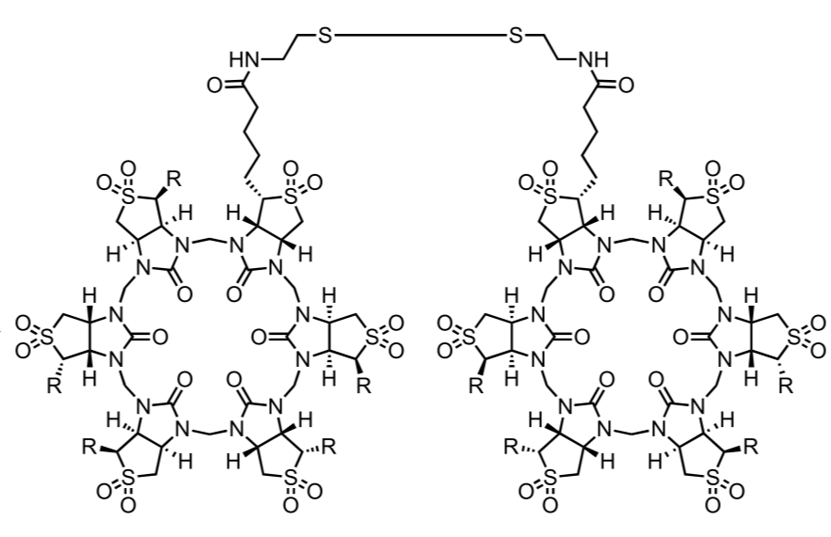

Figure 1: Biotin[6]uril sulfone dimer.

(1) Lisbjerg, M.; Nielsen, B. E.; Milhøj, B. O.; Sauer, S. P. a; Pittelkow, M. *Org. Biomol. chem.* **2015**, 13 (2), 369–373.

(1) Kubik, S.; Kirchner, R.; Nolting, D.; Seidel, J. *J. Am. Chem. Soc.* **2002**, 124 (43), 12752–12760.