Canadian cities in transition. New directions in the twenty-first century, 4th ed.
edited by Trudi Bunting, Pierre Filon, Ryan Walker

Bunting T., Filion P., Walker R. (2010): Canadian Cities in Transition. New Dirctions in the Twenty-First Century. Don Mills,Oxford University Press, 468 pp., ISBN 978-0-19-543125-4
It is an introduction for university students to the Canadian urban phenomenon, presenting different facets of the city:
- its historical evolution
- economic dynamics
- environmental impacts
- dependence on natural systems
- urban lifestyles
- cultural makeup
- social structure
- infrastructures
- governance
- planning
- and appearance.

The volunre also is designed to assist the next:
- generation of citizens
- consumers
- experts
- business people
- and politicians
in their efforts to solve the urban problems:
- traffic congestions
- different forms of environmental damage
- crime
- social segregation
- governance-they are inheriting

The text is situated at the confluence of different disciplines with an urban dimension: mainly
geography and planning, but also economics, political science, sociology, ecology, and history.

Changing Parameters of Urban Form, Structure, and Policy
- Fundamentals of Cities
- Epochs of Canadian Urban Development
- Transition in the city
The Structuring Parameters of Twenty-First-Century Urbanization
- The Global imperative
- Getting serious about Urban sustainability: Eco-Footprints and the vulnerabiIity of Twenty-First-century cities
- The Dynamics of Economic Change in Canadian Cities: Innovation, Culture, and the Emergence of a Knowledge-Based Economy
- Economic Change in Canadian Cities: Locational Dynamics of Employment
- Life course and Lifestyle changes: Urban change through the Lens of Demography
- New Diversity: Socia| Change as Immigration
- New Divisions: sociaI Polarization and Neighbourhood Inequality in the Canadian City
- The Canadian city at a crossroads between ´Passage' and ´Place'
- Neo-Liberal Governance: Entrepreneurial MunicipaI Regimes
in Canada
- The Economics of Urban Land
´Placing' and Planning the Twenty-First-Century City
- Black Holes or White Knights? Cities and the Environment
- Re-imaging, Re-Elevating' and Re-Placing the Urban: The cultural Transformation of the lnner city in the Twenty-First century
- Slow Growth and Decline in Canadian cities
- Fear, Insecurity, and the Canadian city
- Emerging Urban Forms in the Canadian City
- The Changing Meanings of Urban Places
- At Home in the City: Housing and Neighbourhood Transformation
- Younger cities, older cities, and cities in the Balance: Spaces
and Places of the Younger and Older Population
- Aboriginal People in Canadian Cities
- The Built Environment and Obesity: Trimming Waistlines through Neighbourhood Design
- Food systems and the city
Towards a Sustainable, Healthy, and 'Smart' Future for Canadian Urban communities
- Conlusion: Challenges and Opportunities in the
Twenty-First-Century City
- Digita| Data in Urban Research
- Selected Data on Canada's census Metropolitan Areas

Chapter 1
Fundamentals of Cities

- How cities operate
- How they relate to broker social trends in order to address contemporary urban issues
- Understanding of urban dynamics
- Complexity, human creations, relativem stable structure/syntax
- Infrastructure network – connections between different assamblages of buildings/land use
- Economic and value systems behind urban built environment with its multiple use
- Perceptions and interpretations of this environment

Florida R. (2008): Who´s Your City? How the creative economy is making where to live the most important decision of your life. Random House Canada, 374 pp., ISBN 978-0-307-35696-3
p.314-5
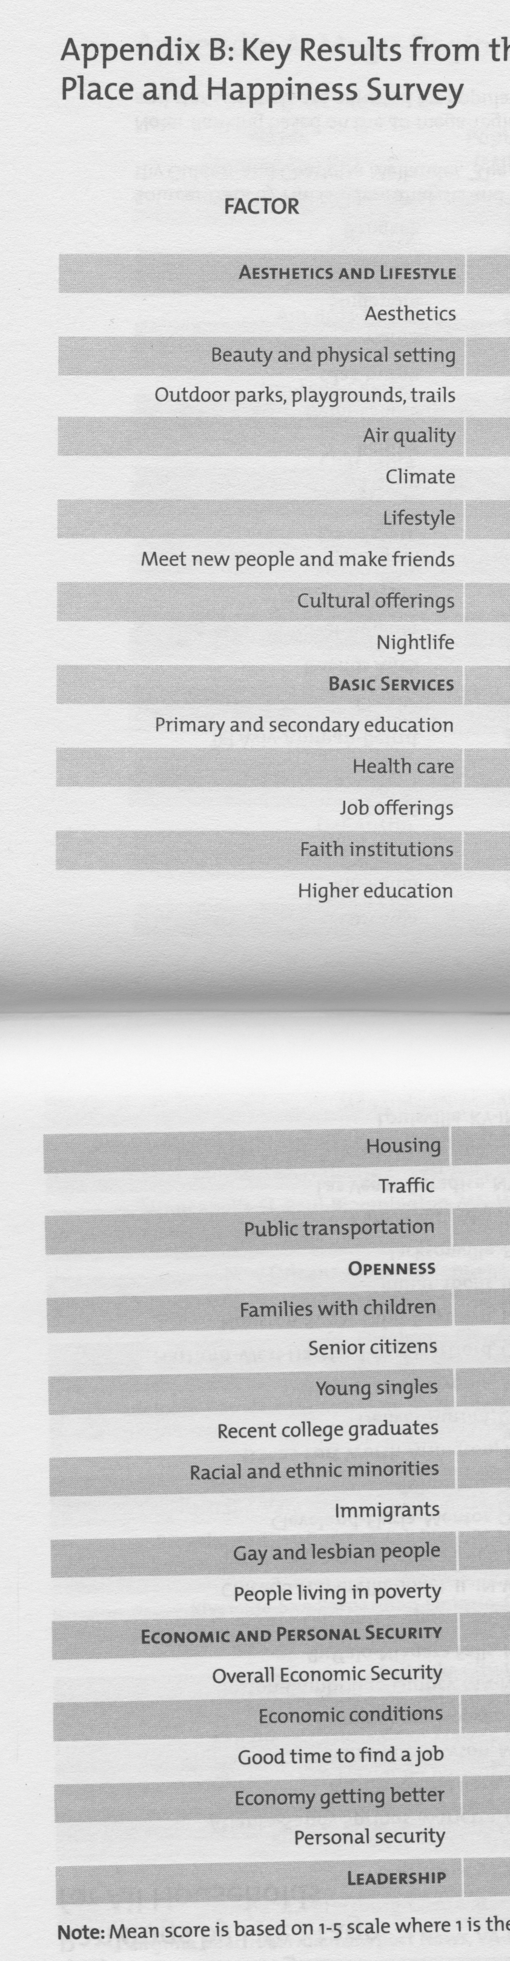
Fundamental properties for understanding the urban phenomenon:
- production
- proximity
- reproduction
- capitalization
- place
- governance
- environment

production
- create jobs
- brings people to the city
- main reason for urban growth
- change urban form and structure
- consumption and export
- transportation systems
- export-based specialization
- products and resources for sustaining….energy, water
- service rural areas, resources and labour
- ecological footprint (Rees in Ch5)
- creative class (R.Florida)
- manufacturing sector, deindustrialization
- explosion of restaurants and personal services, places of entertainment and cultural activities
- shift to service economy….administration

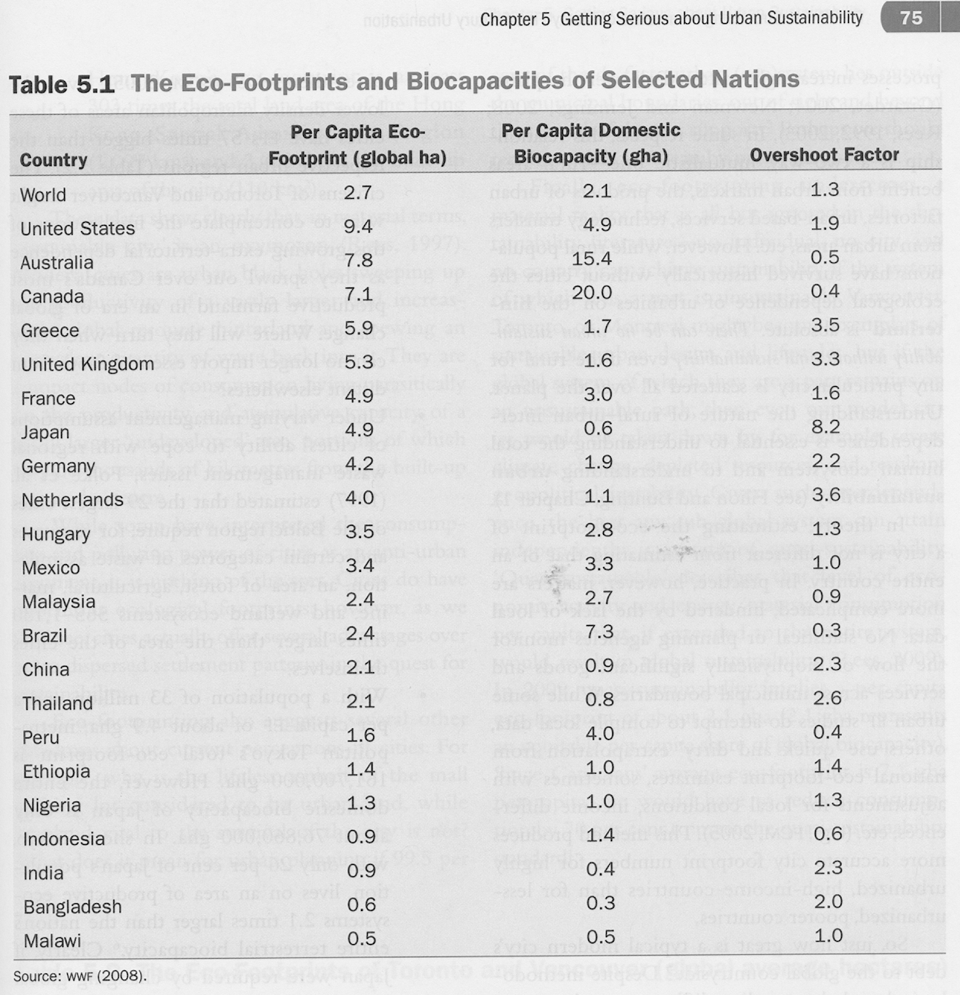

- goods and services counterbalancing the import….taxes, protection, decisions, staple cities
- economic exchange, interdependence, heartland and hinterland
- globalization

proximity
- communication – minimize the cost (time, effort, money) of interaction
- frequent and repeated interactions….businesses and institutions
- innovation as by-product of interaction
- cities – places of economic enterprise
- just-in-time-delivery
- high cost of city land, inner accessibility….transportation systems…activity distribution pattern…mode of transportation
- Toronto – Greater Golden Horseshoe = 180 km distance
- Telecommunications – end of geography?
- The Economist Oct 27th-Nov 2nd 2012-11-05

Reproduction
- Continued provision of an ample labour force
- Wel-being of family/household units…health care, education, social services, family and community support facilities, immigration policies, etc.
- History – epidemics, water treatment/sewage, immunization
- Pollution, obesity, SARS, low birth rate, stress, crime
- Hygiene, maintenance
- Role of women…health, education, child care, labour force
- Growing public sector difficulties….welfare state??????
- Low-tax, low-wage jurisdictions …cutting corporate-based fiscal revenues vs. high tax leveles… politically unrealistic option
- Reduced spending capacity, cutbacks in public sector reproduction services….coincided with risik expectations and demand for such services
- Private funding education, university fees…major source of social inequality
- Underfunding of public sector…tragedies of water quality…..natural hazards – hurricanes

Capitalization
- Urban land – compact, scarce – maximized capital investment
- Residents, business, services…technologies
- Durable…path dependence
- Changes in technology of lifestyles
- Brownfields, greyfield sites, greenfields…financial constraints
- Bind pattern of behaviour to built environment (aliance on the automobile and the truck…)
- Citizen resistence to redevelopment…NIMBY…emotions
- Suburban capitalization ( rous, water, schools, hospitals, private industry, residential and commercial development
- Inner cities residential intensification – high-rise condominiums
- Economy of investments both public and private sectors
- Home as main asset for a majority of households
- Speculative property bubbles
- Growing consumer debt….homeownership

Place
- Sense of place, enhanced interest, urbanites – meaning to space
- Yi-Fu Tuan topophilia….subjective attachment
- Place design – urban form
- Quality of individual and collective life, physical environment
- Diminishment of topophilic places
- Suburban places….shopping malls, power centres…junk-scapes
- Place as atribute of urbanity…dwellers and locales…symbolic meanings
- Fluid sense of place….industry, marketing the place
- Municipal land-use policies…economic development, tourism
- Places that are valut
- Places in globalization

Governance
- Generating policies suited to the specific circumstances confronting cities
- Distinct management measures for urban community
- Collective kontrol and co-operation between karby neighbours over communal space
- Functioning of shared infrastructures and services
- Rights, payment facilities, cohabitation of a wide variety of land-use
- Planning kontrol… chaos, pollution, noisy, bottlenecks, no laissez-faire approach
- Administrative arrangements…municipal affairs, housing programmes, public sector, urban management
- Bigger and required more infrastructure
- Public demands, interventions, huge budget cuts, limited tax revenues in municipalities…local administrativ

Environment
- Cities must respect their natural environment
- Severely degraded environment in cities – dangers to health
- Ignoring environmental damages
- Environmental awareness
- Pollution, emissions ( Montreal protocol CFC…)
- Consumerist lifestyle….MillEcoAssess
- Climate chase
- EnviImpactAsses

