Motion
What is the difference between a vector and a scalar?
- Divide the following quantities into vector or scalar quantities:
speed, mass, displacement, weight, force, density, acceleration, velocity, distance, energy, volume, temperature, momentum, power, time, area
2. Discuss these questions.
- Can you give an example of a scalar that you have used in your everyday life? What makes it a scalar?
- Are there any sports that could provide a great example for the use of vectors?
  - What are vectors?
https://ed.ted.com/lessons/what-is-a-vector-david-huynh
Listen to the talk and answer questions.
- Which examples of vectors and scalars are given?
- What is the important property of vectors?
- What is the Cartesian coordinate system composed of?
- What is an array?
- How are the two arrays in an example different?
- What is the similarity between a group of letters and an array?
- What are tensors?
- What is stress (in physics)?
- Where are tensors used?
  - Key terms. Study these key terms. Then fill in the appropriate term for items a-p.
position | distance | acceleration due to gravity
motion | instantaneous speed | free fall
scalar | average velocity | centripetal acceleration
vector | displacement | projectile motion
average speed | instantaneous velocity | acceleration

- ___ displacement/travel time i. __ has magnitude and direction
- ____has magnitude only j. ___ motion solely under the influence of gravity
- ___velocity at an instant time k. ____ motion of a thrown object
- ___ directed toward the centre of circular motion l. ____speed at an instant of time
- ____ actual path length m. ______the location of an object
- ______ straight-line directed distance n. ______9.8 m/s²
- ______ a continuous change of position o. ___distance travelled/travel time
- ______ time rate of change of velocity
5. Now read the text and think about explanations for more terms.
  - reference point
  - force
  - uniform velocity
  - friction
Motion
Motion is everywhere. We walk or drive. The wind blows the trees, the rivers flow. Even the continents drift. In the larger environment, the Earth rotates on its axis, the Moon revolves around the Earth, the Earth revolves around the Sun, the Sun moves in the galaxy, and the galaxies move with respect to one another.
In physics, motion is change of location or position of an object with respect to time. To designate the position of an object, we must give a reference point, for example “the book is on the table.” When an object is undergoing a continuous change in position, we say that the object is in motion. Change in motion is the result of an applied force.
Two basic kinds of motion are straight-line motion and circular motion.
Motion is typically described in terms of speed and velocity. They are often used interchangeably, in physical science, however, they have distinct meanings. The former is a scalar quantity, (it has only magnitude, e.g. 90 km/h), the latter is a vector quantity (it has magnitude and direction, e.g. 90 km/h north).
The average speed of an object is the total distance travelled divided by the time spent in travelling the total distance. The instantaneous speed of an object is its speed at that instant of time.
The average velocity is the displacement divided by the total travel time, where displacement is the straight-line distance between the initial and final positions, with direction toward the final position. If the velocity is constant, it is referred to as uniform velocity.
The speed and direction may change. This motion is then called accelerated motion. An acceleration may result from a change in speed, a change in direction, or a change in both. Acceleration is defined as the time rate of change of velocity. The acceleration due to gravity at the Earth’s surface is directed downward and its magnitude is g=9.80 m/s². This value means that the velocity changes by 9.8m/s each second, thus it goes from 0 to 9.8m/s during the first second, to 19.6m/s during the second second, and so forth. Galileo Galilei was one of the first scientists to assert that all objects fall with the same acceleration. This, however, assumes that friction is negligible.
An object in uniform circular motion has a constant speed. Its velocity, however, is not constant, because it is continuously changing direction. A change in velocity results in acceleration which is toward the centre of the circle and is called centripetal acceleration.
6. What can you see in the picture?

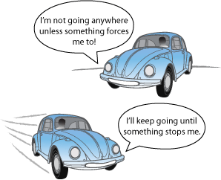
http://p6patel16.blogspot.cz/2012/04/physics-101.htm
Fill in the missing words.
1) An object remains at r_ _ _ or in u_ _ _ _ _ _ motion in a straight line unless acted on by an e_ _ _ _ _ _ _ force. This tendency of an object to resist a change in its motion is called
_ _ _ _ _ _ _.
2) F = ma, i.e. ………………………………………………………………………………. Alternatively, force is _ _ _ _ _ _ _ _ _ p_ _ _ _ _ _ _ _ _ _ _ to the time derivative of m_ _ _ _ _ _ _ .
3) For every action there is an …………………………………………………………….
Whenever one object exerts a force on a second object, the second object exerts an equal and opposite force on the first object.
4) Have a look at the picture and explain its meaning.
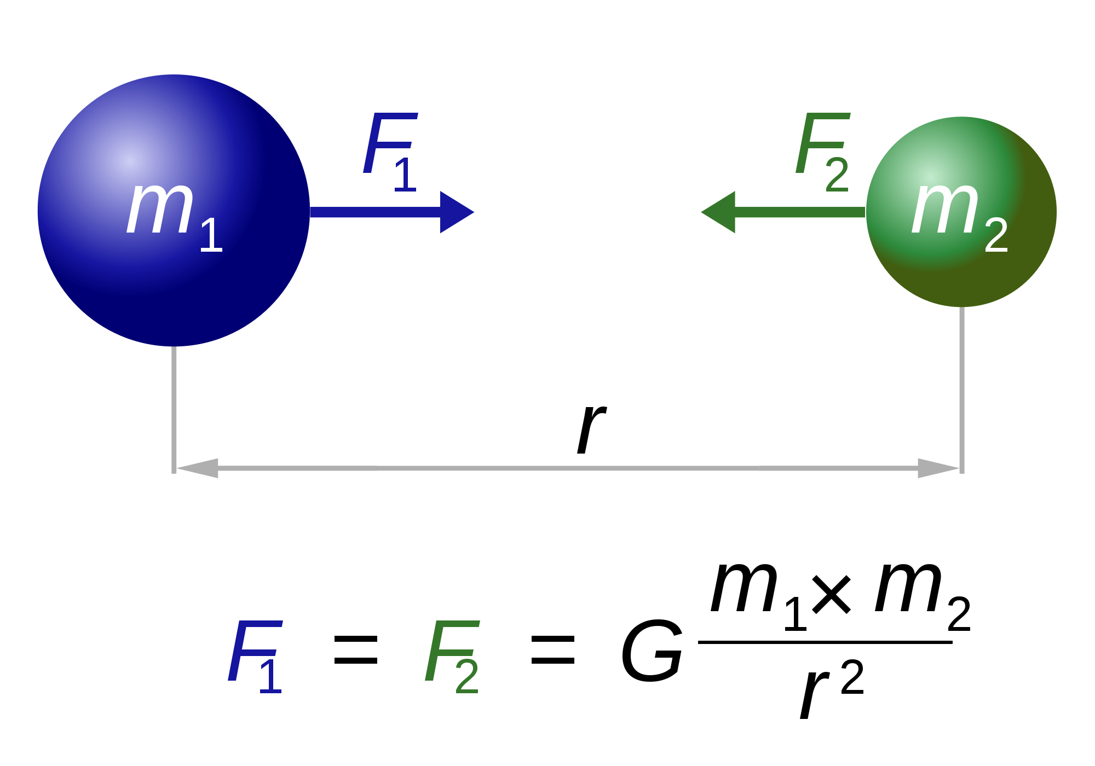

7. Expressing cause-effect relationship.
a) Go back to the text about motion and try to find expressions indicating cause-effect.

Think about more cause-effect expressions and divide them into groups:

Verbs: result in, ……………………………………………………………..

Nouns: consequence, ………………………………………………………..

Linking words: due to, ……………………………………………………..

b) Complete the cause-effect sentences and add two more examples related to physics.

1 A slight rise in the temperature of the sea can ………………. an increased level of water in the air.

2 Heat …………………. iron to expand.

3 When objects go in paths around a centre of motion or axis of rotation, angular momentum ………………………………

4 Linear momentum arises ……………………mass is multiplied by velocity.

5 Acceleration is ……………………… a change in speed, direction, or both.

6 As the distance increases, …………………………………………………………………

7……………………………………………………………………………………………..

8 …………………………………………………………………………………………….

HW – Consider this problem. The Monkey and Zookeeper

http://www.physicsclassroom.com/mmedia/vectors/mzi.cfm
There is an interesting monkey down at the zoo. The monkey spends most of its day hanging from a limb of a tree. The zookeeper feeds the monkey by shooting bananas from a banana cannon to the monkey in the tree. This particular monkey has a habit of dropping from the tree the moment that the banana leaves the muzzle of the cannon. The zookeeper is faced with the dilemma of where to aim the banana cannon in order to hit the monkey. If the monkey lets go of the tree the moment that the banana is fired, then where should she aim the banana cannon?
