**Describing Graphs**

1. **Types of graphs**

**Match the types of graphs on the left below with their respective charts. Then complete the sentences below.**

1

3

2

A column chart

A line chart

A pie chart

A bar chart

An area chart

4

5

6

An XY (scatter) chart

A stock chart

A surface chart

A doughnut chart

A bubble chart

A radar chart

9

8

7

11

10

1. A ­­­­­­­­­surface chart is useful when you want to find optimum ___________ (combine) between two sets of data. As in a topographic map, colours and patterns indicate areas that are in the same range of _________ (evaluate).
2. Pie charts show the size of items in one data series, proportional to the sum of the items. The data points in this type of chart are displayed as a _________ (per cent) of the whole chart.
3. Area charts __________ (emphasis) the magnitude of change over time, and can be used to draw attention to the total value across a trend.
4. Column charts are useful for showing data changes over a period of time or for illustrating _________ (compare) among items.
5. You could use a stock chart to indicate the __________ (fluctuate) of daily or annual temperatures.
6. Like a pie chart, a doughnut chart shows the relationship of parts to a whole, but it can contain more than one data series.
7. A bar chart is a _________ (graph) method of displaying several data series in the form of a two-dimensional chart of three or more quantitative ____________ (vary) represented on axes starting from the same point.
8. **Identify the graph that matches each of the following stories:** 
   1. I had just left home when I realized I had forgotten my books so I went back to pick them up.
   2. Things went fine until I had a flat tire.
   3. I started out calmly, but sped up when I realized I was going to be late.

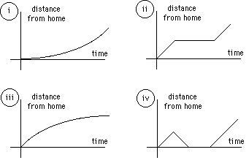

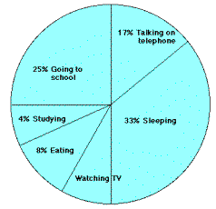

1. **The graph represents the typical day of a teenager. Answer these questions:** 
   1. What per cent of the day is spent watching TV?
   2. How many hours are spent sleeping?
   3. What activity takes up the least amount of time?
   4. What activity takes up a quarter of the day?
   5. What two activities take up 50% of the day?
   6. What two activities take up 25% of the day?

**What would your graph look like? Draw it and then describe it using verbs like: spend, take up, consume, devote, (waste?), etc. in the correct form.**

1. **Study the handout “Describing Graphs –IELTS exam preparation” and then decide which answer/answers best suits each of the graphs below**

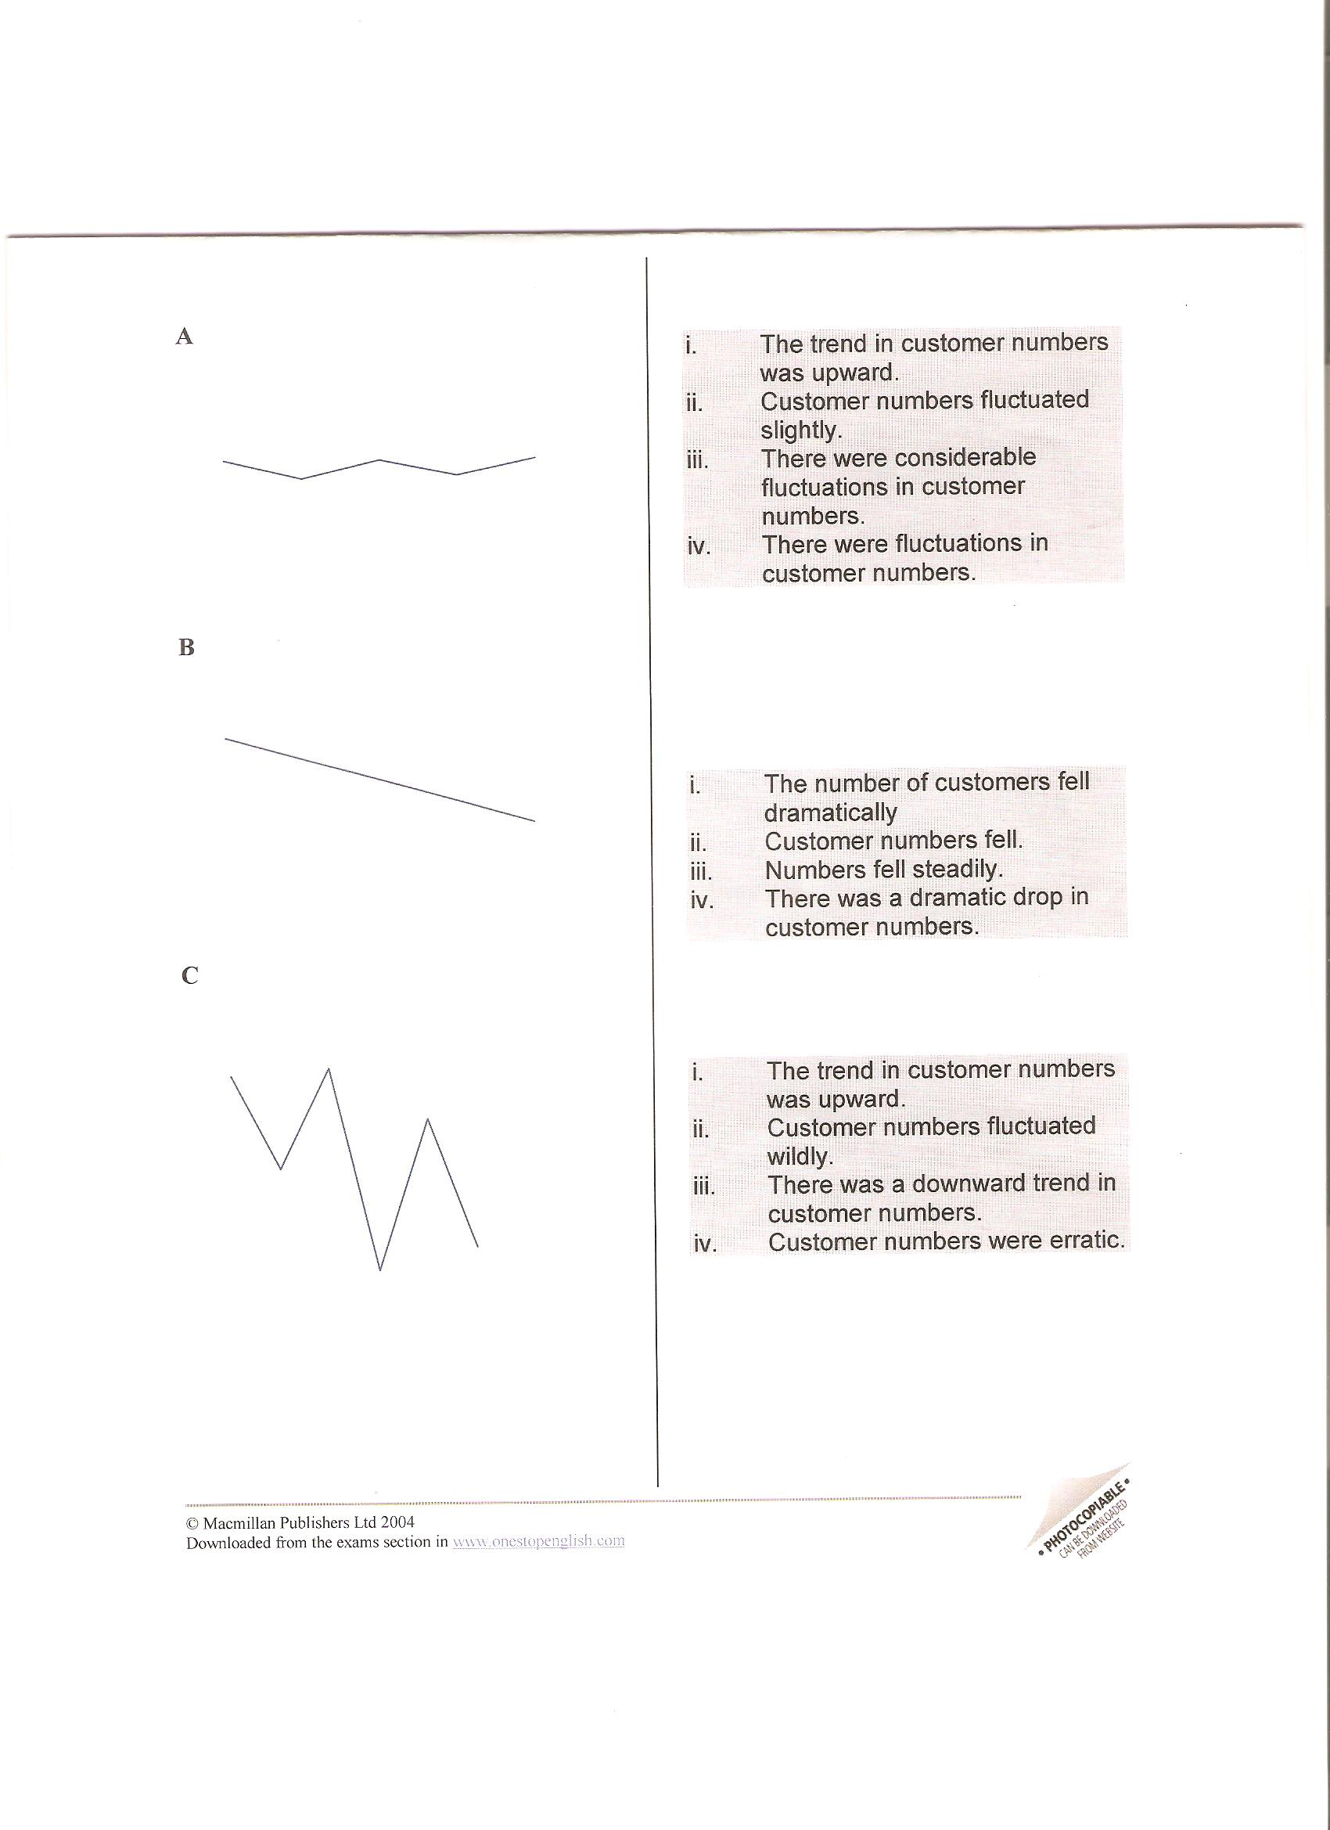

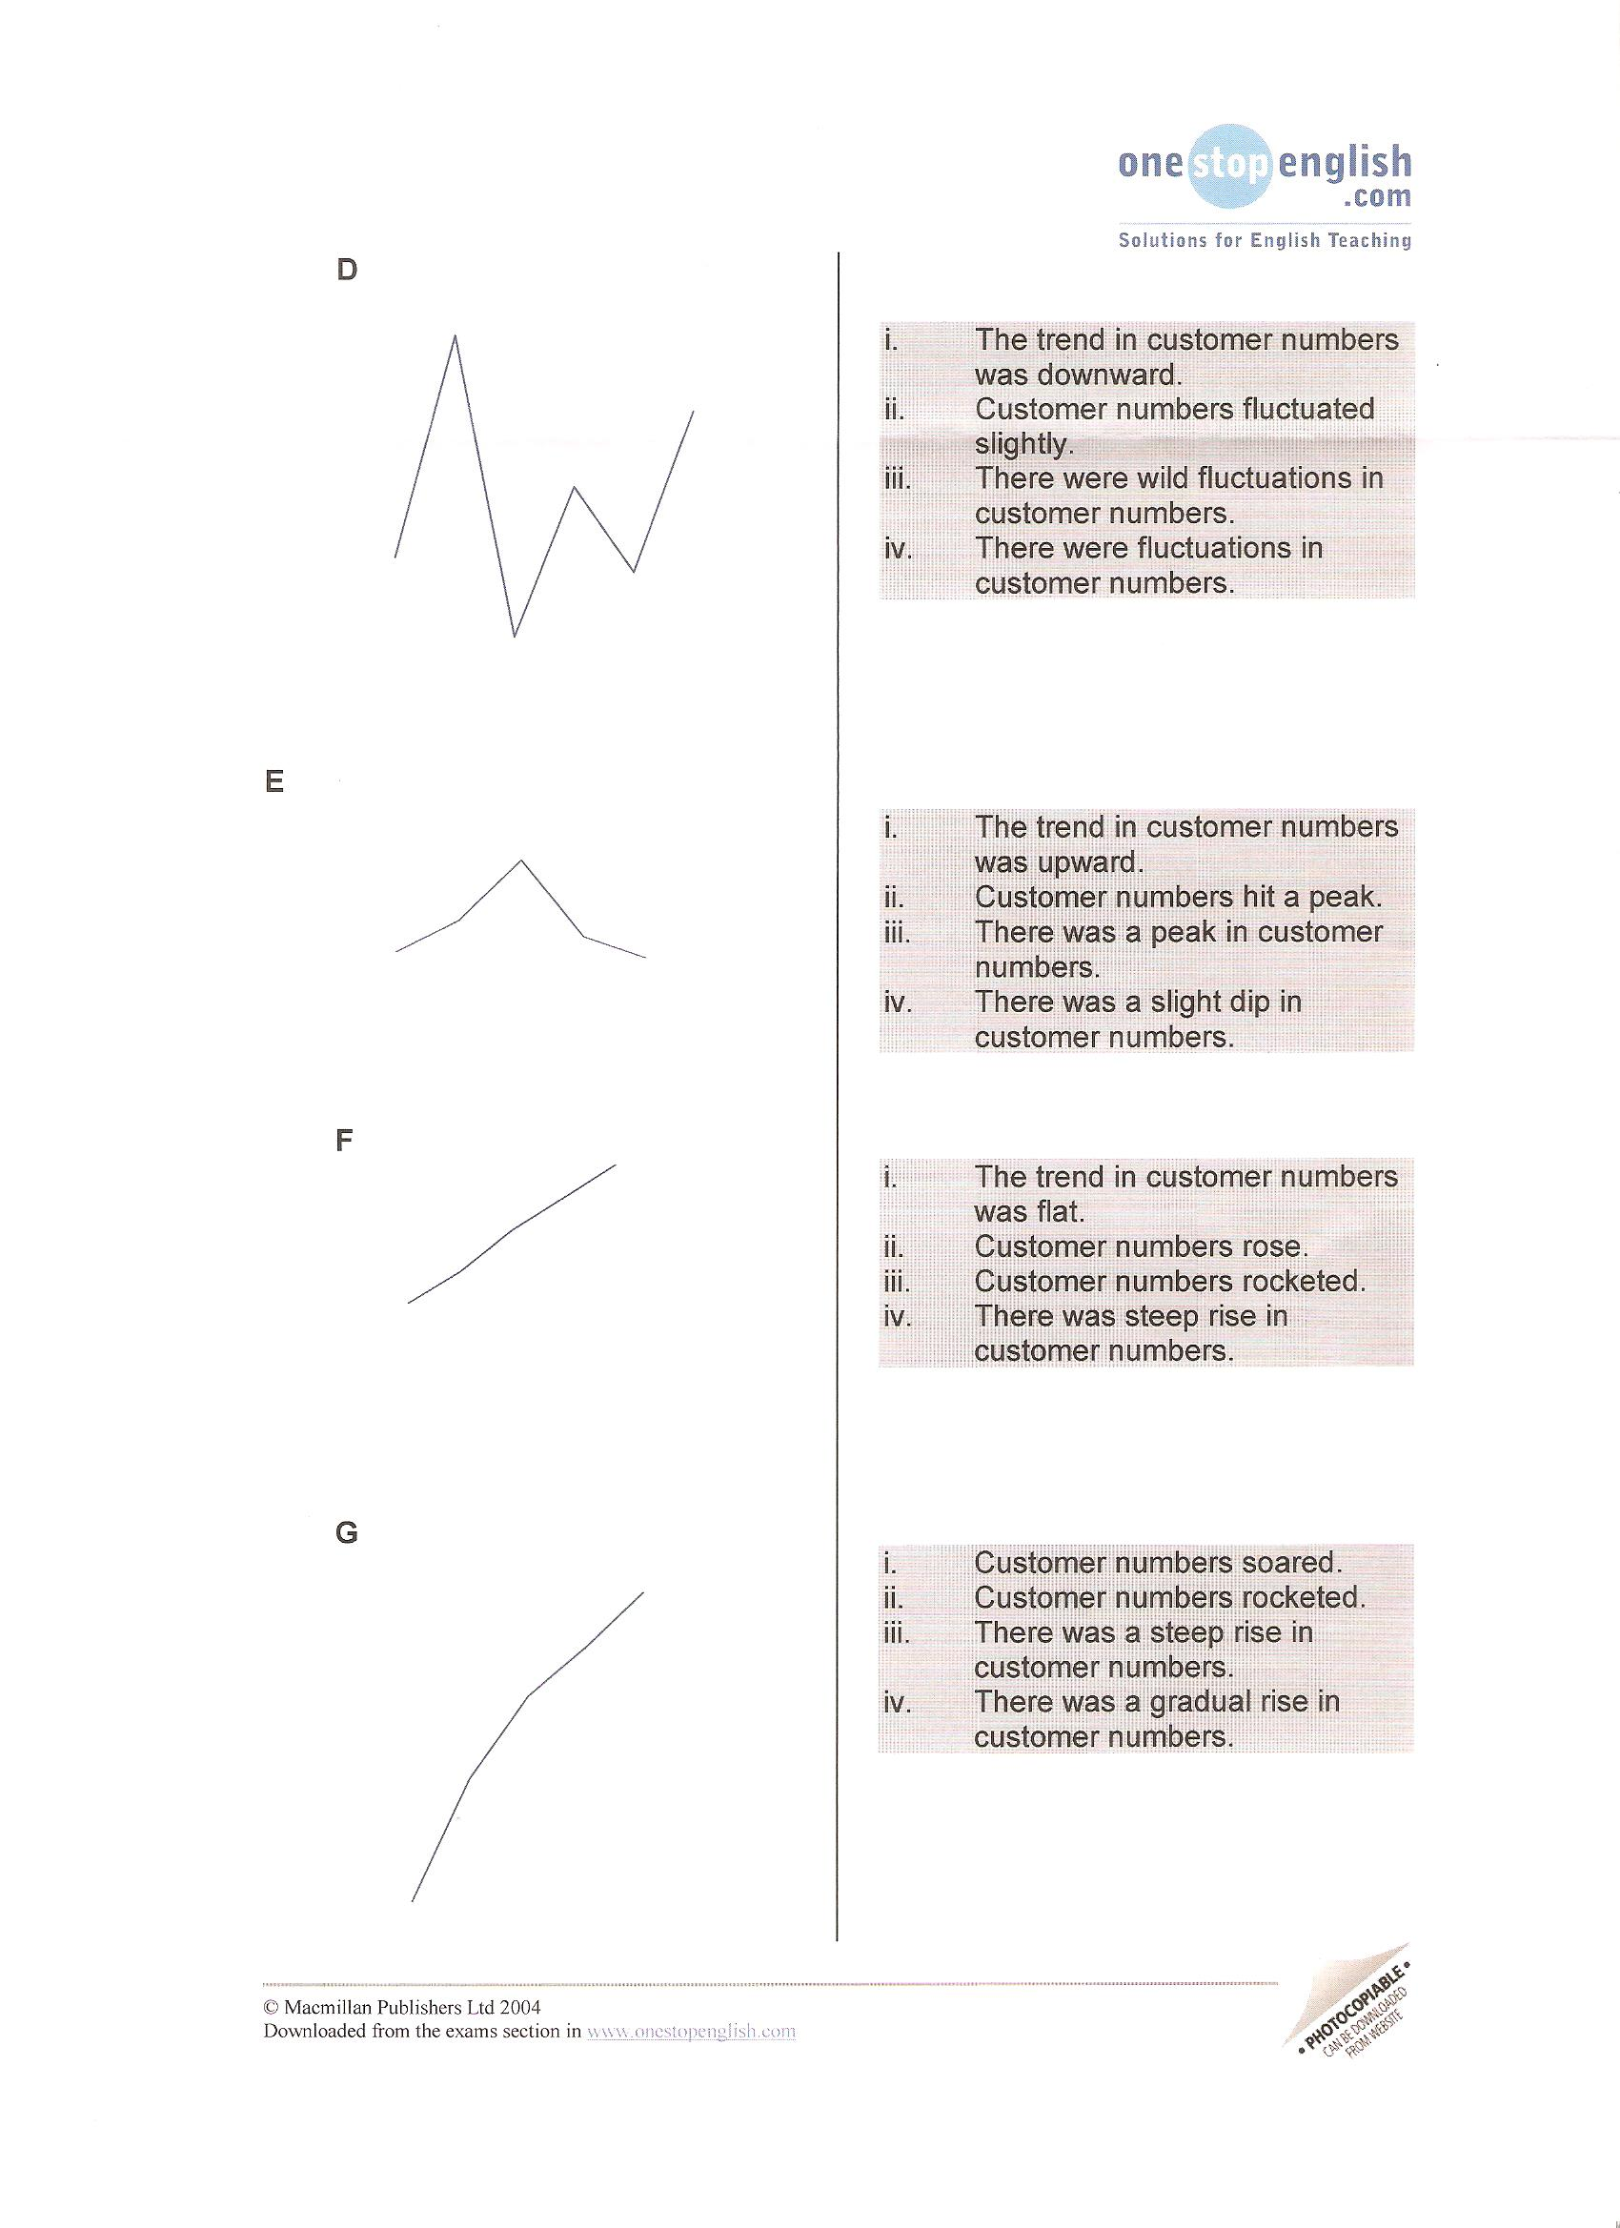

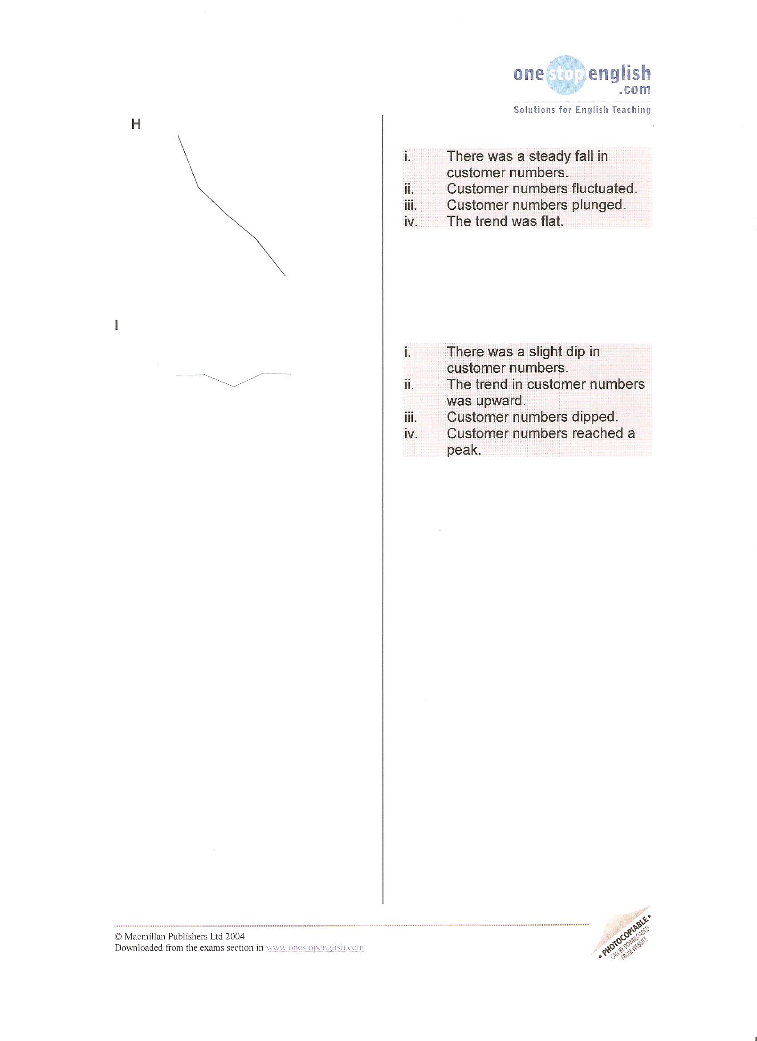

1. **Now transform these sentences using the given word so that they mean the same:**
2. There's been a slight decline in sales.   
   Sales …………………………………….
3. We made a sharp increase in investment.

Investment ………………………………

1. There was an abrupt drop in sales in March.

Sales………………………………………

1. Unfortunately, consumer interest suddenly decreased.   
   There…………………………………………
2. The dramatic growth has come after we invested in a new product line.

We've …………………………………………

1. Profit has been flat over the past two years.

There………………………………………..

1. There has been steady improvement over the past three months.  
   Sales ……………………………………..
2. **Look at the nouns below and decide whether they denote a trend of going up, going down, remaining the same or others.** Think of the verbs you would change these nouns to (and appropriate prepositions that follow them)

a boom a slump a reduction a levelling out a recovery a peak a fluctuation plateau

1. **Vocabulary task – match words with their definitions:**

***extrapolation median discreet variable mode line of best fit mean interpolation range continuous variable negative correlation***

1. to estimate a value by following a pattern and staying within the values already known
2. a relationship between two sets of data - it will show a positive correlation, a negative correlation, or no correlation
3. upper extreme minus lower extreme
4. to estimate a value by following a pattern and going beyond the values already known
5. the middle value of all the numbers in the sample.
6. the most frequently observed value of the measurements in the sample
7. the sum of all the results included in the sample divided by the number of observations
8. one set of data decreases as the other set of data increases
9. measurements that are distinct, periodic, and unconnected between data points
10. measurements are uninterrupted and connected between data points (e.g. growth of a plant)
11. **Read the following text, which describes the graph below. Complete it with the missing words.**

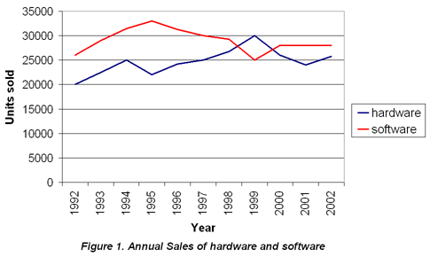

The graph 1._________ the sales figures for two products from 1992 to 2002. The 2._________ axis represents years and the 3.___________ axis represents units sold. The graph 4._________ both the 5.___________ and the 6.___________ in sales for both products, as sales 7.___________ during the ten-year period.

1. **Study the graph below. Write a brief paragraph describing the data shown in the graph.**

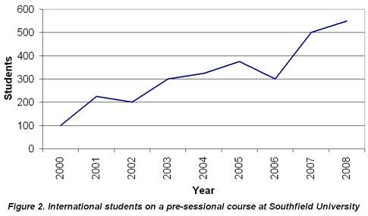

*The graph shows…*

Source: adapted from a lesson prepared by Jana Kubrická

[www.microsoft.com](http://www.microsoft.com)

[www.ielts.com](http://www.ielts.com)

[www.onestopenglish.com](http://www.onestopenglish.com)

[www.elanguages.ac.uk](http://www.elanguages.ac.uk)