**Unit 8 – Conic Sections (Conics)**

***1 Look at the pictures and say/write down what they illustrate.***

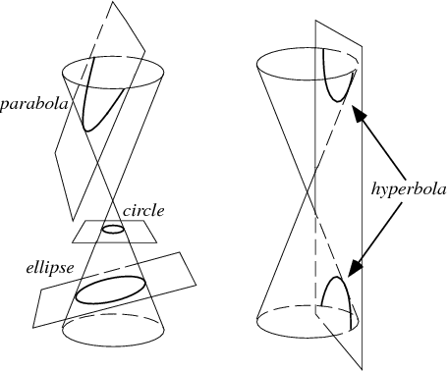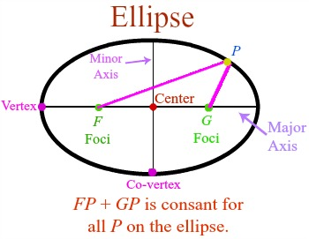

***2 Listening***

***a) Pre-listening. What are plural forms of these nouns?***

Focus ………………………………..

Axis …………………………………….

Radius ……………………………….

Vertex…………………………………

Locus ………………………………….

Directrix ……………………………

***b)* Listen to the recording and answer questions.** [**http://www.brightstorm.com/math/algebra-2/conic-sections/the-ellipse/#**](http://www.brightstorm.com/math/algebra-2/conic-sections/the-ellipse/)

1. Which synonym for the term „ellipse“ does the speaker use?

1. How is the concept of being equidistant different for a circle and for an ellipse?
2. Which tools does the speaker use to draw an ellipse?
3. Which two different arrangements of an ellipse does he mention?
4. What is the difference between the major and minor axis?
5. Where can vertices of an ellipse be found?
6. Where are the co-vertices?
7. What does *x* (and *y*) radius denote?
8. How are the equations for horizontal and vertical ellipses different?
9. What does a letter *b* denote?
10. What are the foci of an ellipse?

***3. Read the text and fill in the missing information in the table. Use the expressions from Exercise 2a.*** *(Texts and pictures from A. Křepinská, M. Bubeníková, M. Mikuláš: Angličtina pro student MFF UK, Matfyzpress 20013,* [*https://en.wiktionary.org*](https://en.wiktionary.org)*,* [*https://en.wikipedia.org*](https://en.wikipedia.org)*)*

The conic sections are curves obtained by the intersection of a right circular cone and a plane. According to the angle of intersection, the conic is an ellipse, a parabola and a hyperbola. A circle is also a conic, it is a special case of an ellipse.

|  |  |  |
| --- | --- | --- |
| https://upload.wikimedia.org/wikipedia/commons/thumb/9/93/Ellipse-ll-e.svg/296px-Ellipse-ll-e.svg.png |  |  |
| An ellipse is a closed curve which is the ……………….. of a point such that the sum of the distances from that point to two other fixed points *F1* and *F2* (called the ……………….. of the ellipse) is constant. | A hyperbola is a conic section defined as the ……………….. of all points in the plane the difference of whose distances from two fixed points *F1* and *F2* (called the ………………..) is constant. | A parabola is an open curve which is the ……………….. of a point that moves in a plane so as to be equidistant from a fixed line *l* and a fixed point *F*. |
| The line through *F1* and *F2*is the major ……………….. (*x*). The line perpendicular to *x* through the centre is the minor ……………….. (*y*). | The line through *F1* and *F2*is the transverse or major ……………….. (*x*). The line perpendicular to *x* through the centre is the conjugate or minor ……………….. (*y*). | The fixed line *l* is called the ……………….. and the fixed point *F* is called the ……………….. . |
| The ellipse is symmetrical about both its ……………….. . | The points where the transverse axis cuts the hyperbola are the ……………….. . | The line through the focus perpendicular to the to the directrix is the ……………….. of the parabola. |
| The points where the axes cut the ellipse are the ……………….. . | The centre of the hyperbola is the midpoint of the ……………….. . | The point where the axis cuts the parabola is the ……………….. . |
| The centre of the ellipse is the midpoint of the ……………….. . | The hyperbola is a two-branched open curve. The branches of the hyperbola approach two straight lines which are called the asymptotes. |  |
| The two lines at distance $d= \frac{a^{2}}{c}$ and parallel to the minor axis are called ………………. of the ellipse. | Two fixed lines *l1* and *l2* situated at the opposite side of vertices are ……………….. . The ratio of distance of a point on hyperbola from a focus and the corresponding directrix are in the same ratio. |  |

***4. Decide whether the following statements are true or false.***

1. An ellipse is an open curve.
2. A transverse axis is a straight line through the foci.
3. The fixed points of conics are called the vertices.
4. A circle is a special case of a group of curves known as conic sections.
5. A parabola has two foci.
6. A parabola is a two-branched open curve.

***5. Describe the following graphs:***

|  |  |
| --- | --- |
| https://dj1hlxw0wr920.cloudfront.net/userfiles/wyzfiles/ff5887d6-dcec-4497-ae84-ca1bde94dbf0.gif | Image result for conic sections examples |
| Image result for hyperbola examples | https://dj1hlxw0wr920.cloudfront.net/userfiles/wyzfiles/16172bb1-bec0-4e66-aa1e-c751fcc558bd.gif |

<https://www.wyzant.com/resources/lessons/math/algebra/conic_sections>,

<https://www.varsitytutors.com/assets/vt-hotmath-legacy/hotmath_help/topics/more-on-hyperbolas/more-on-hyperbolas-image015.gif>

|  |  |
| --- | --- |
| Image result for conic sections examples | <https://saved-work.desmos.com/calc_thumbs/production/fkn3rh3z9o.png> |