- VISUALS
- Slides (courtesy of Hana Němcová, also adapted from Oxford EAP Upper-Intermediate, E. de Chazal, OUP 2012)
- use visuals to support or summarize what you say
- design your slides so they get a message across to your audience in a visual way - be as visual as possible
- with each slide, get a message across
- use KISS technique (Keep It Short and Simple) – the content should be concise, both verbally and visually
- state that message verbally in the title area as a short sentence (10–15 words on a maximum of two lines); e.g. the temperature increased much faster than anticipated
- slides are for the audience – they should NOT be designed as a memory aid for the speaker - don't read from them
- plan about one slide per minute
- avoid language mistakes and misprints in slides
- use sans serif fonts, such as Arial, Tahoma, Verdana (x Times New Roman is a serif font used in word documents – serifs are the small features at the end of strokes)
- use a pointer and/or masking techniques where appropriate
- face the audience as much as possible.
- don’t block the audience’s view.

1a. Effective titles. Visuals need to have good titles. Rewrite items b-e to make them more effective. Use noun phrases.
- Reasons commonly given to explain why the climate is changing Common reasons for climate change
- The economic advantages of doing business internationally. ……………………….
- People who have seen the Loch Ness monster. ……………………………………..
- Difficulties that international students typically experience …………………………
- Some of the ways in which culture can have an effect on advertising ………………………………………………………………………………………..

- Introducing the visuals

- OK. Let’s take a look at …..
- The first / second / next / final slide is …..
- This shows / illustrates /
demonstrates / refers to …..
- This is I graph / an organigram which shows …..
- As you can see, this is …
- As you can see from these figures...
- Here we can see …..
- I'd like you to look at this graph...
- Let me show you this pie chart...
- Let's have a look at this model...
- Let's turn to this map...
- To illustrate my point let’s look at some diagrams...

- If you look at these photographs you'll see...
- If you look at this bar chart you'll notice...
- If you look at this histogram you'll appreciate...
- If you look at this flow chart you'll understand ...
- If you look at this matrix...
- I’d like to draw your attention to …..
- One of the most important aspects of this is …..
- At first glance it seems ….. but …..

Name these types of diagrams

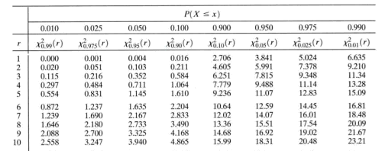

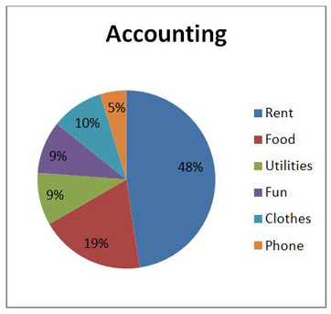

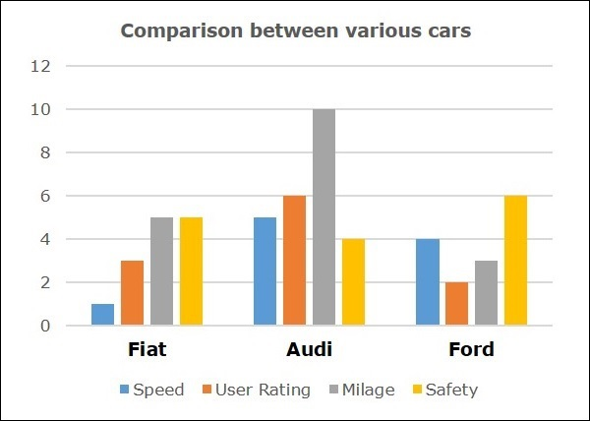

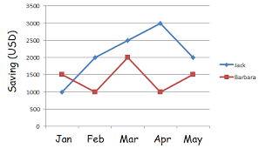

Which type of diagram in 3 would you use to show the following information?

Trends, e.g. the increase in the price of oil over the last year

Raw data, e.g. methods of travelling to work with the number of people using each one

Proportion, e.g. percentages for different types of vehicle journey

Comparison, e.g. the number of cars per adult in different countries

Read the description of a graph and draw a simple picture.

The chart illustrates the change in life expectancy for men and women in the UK between 1841 and 2005. The data shows that life expectancy for men improved from 42 years to 77 years between 1841 and 2005, and from 45 to 82 years for women. It also demonstrates the five-year gap in life expectancy between males and females. If current trends continue, life expectancy should increase steadily in the next 50 years.

6. Which sentences 1-4 are

a) a detailed description or explanation of the content?

b) a concluding statement?

c) a reference to the diagram and a brief description of the content?

Identify the verbs / verb phrases in the text that are used to:

a) refer to the diagram

b) describe the content

c) make a prediction

7. Which of the verbs below can be used to refer to diagrams?

illustrates shows believes suggests indicates represents states argues

demonstrates gives reflects gives a breakdown of

8. Which types of visuals can you use in a presentation? Watch the video and comment on the way the speaker uses visuals in his talk. https://www.youtube.com/watch?v=fTznEIZRkLg

Introduction to Differential Equations www.maths.duke.edu/ode

The spread of a rumor
Suppose two students at your school start a rumor. How could we describe the spread of the rumor throughout the school population? Could we determine a function S such that S(t) approximates the number of people that know the rumor at a time arbitrary time t, where t is measured in, say, hours?
We'll begin by trying to decide what the graph of S might look like. Assume that M is the population of your school and that M is sufficiently large that it makes sense to model discrete numbers of students with a continuous function. Thus, if S(3) = 127.8, we'll predict that the number of students who know the rumor after 3 hours is approximately 128.
- Study the six graphs below. For each graph, decide whether or not it could be the graph of the function S. In each case, give the reasons for your decision.
Possible Graphs of S
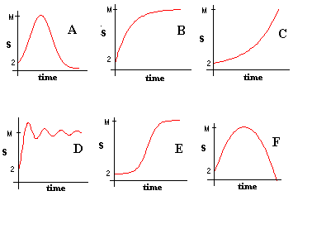
- Describe three conditions that dS/dt, the rate of spread of the rumor, should satisfy. Keep in mind that we are describing the rate of change of the number of students who know the rumor. Suppose for example, that you know the number of "rumor-aware" students at two o'clock. What factors might determine the number of rumor-aware students at three o'clock? Consider the nature of the rumor itself, conditions at your school, and at least one condition that changes as the rumor spreads.
..........................................................................................................................
..........................................................................................................................
.......................................................................................................................................

Differential equation

From Wikipedia, the free encyclopedia http://en.wikipedia.org/wiki/Differential_equation

Have a look at the text and try to fill in the missing words.
A differential equation is a mathematical equation for an unknown function of one or several a) ............. that relates the values of the function itself and its derivatives of various orders.
Differential equations arise in many areas of science and technology: whenever a deterministic relationship involving some continuously varying quantities b) ............ by functions and their rates of change in c)........... and/or time (expressed as derivatives) is known or postulated. This is illustrated in classical mechanics, where the d)............ of a body is described by its position and e)............ as the time varies. Newton's Laws allow one to relate the position, velocity, f)............ and various forces acting on the body and state this relation as a differential equation for the unknown position of the body as a function of g).......... In some cases, this differential equation (called an equation of motion) may be h).......... explicitly.

a) variables derivatives equations
b) described modelled drawn
c) time force space
d) state position motion
e) acceleration velocity position
f) velocity acceleration time
g) time space gravity
h) counted solved guessed

WORD STUDY: Prefixes are important means of creating new words, usually the opposites. There are some words from the text, try to supply prefixes forming new expressions.

dependent .............................. partial .........................................

proportional .......................... significant ..................................

known .................................... real ............................................

natural ................................... continuous ................................

changing ................................ finite ........................................

predictable ........................... mixed .......................................

important ............................. varied .....................................
