Signposting
- Watch five short clips from Extracts 1 and 2 of the lecture. Indicate the new topic introduced in each case and the phrases the lecturer uses to introduce a new topic / indicate a transition between topics.
Adapted from Oxford EAP B2 de Chazal and Rogers. OUP 2013

- What I’d like to focus on first of all is a brief history of how the process of classifying information has developed, and look at one or two key figures in this process.
- So, let’s start by taking a brief look at the history of classifying the world. If we go back to very early history…
- OK, moving on to one of the most important figures in the development of Western thought…
- Right, so now that we’ve got an idea of the importance of Aristotelian classification, I’d like to look at a more recent figure, who was hugely influential in the eighteenth century.
- So that was classification in terms of the natural world. If we can turn now to classification systems…

- Watch two more clips and note down the phrases used to sequence information.
----------------------------------------------------------------------------------------------------
----------------------------------------------------------------------------------------------------
Signposting language
Try to divide the phrases into three groups: a) introducing a new point b) indicating a transition c) indicating sequence or order
OK, moving on to … What I’d like to focus on first of all is…
So, let’s start by taking a brief look at…
Finally this brings us to… If we can turn now to…
So that was all about… After that comes… If we can turn now to…
Next is…. So now that we’ve discussed…
We’ll then turn to… So that was… And lastly we’ll…
Explaining connections between phenomena.
1. Work in pairs and discuss how fast you think the world is moving towards a cashless society, where all payments are made electronically by cards or phone. What are the advantages and disadvantages of such a development?
Pros Cons

2. Now think about the main body of a presentation. The topic is cashless society, and you would like to mention these points, using appropriate signposting language:
a) a reduction in travelling time and costs – mobile tickets for planes and trains
b) increased business activity and productivity
c) freer movement of people
d) fraud is easier
e) an increase in revenue
f) a decrease in employment rates – fewer workers are required
g) increased employment – more jobs are created
h) a reduction in control of finances

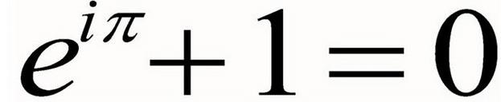
https://www.youtube.com/watch?v=AuA2EAgAegE
Pre-listening tasks.
- What is a mathematical constant? …………………………………………..
- Complete the missing information.
- Archimedes’constant …..
- ………………………. e
- Pythagora’s constant …..
- ……………………….. i
- The Feigenbaum constants …
- Apéry’s constant ………..
- The golden ratio ………
- The Euler-Mascheroni constant …
- …………………………………..
- ………………………………….
- How is the constant e different from π or √2? ………………………………………………..
- What is the constant e related to?.................................................................
- What is compound interest? …………………………………………………
- Imagine that your bank is extremely generous. You have 1 pound on your account and they offer you a 100% interest. How much money will you get if this interest is paid annually ?…………………..
- If you interest is 50% in every six months, is it better or worse? Why? ………………
- What happens if you do that more often? What about every month, week or day? How much will you earn? …………………………………………………………………………………….
- How would you define continuous interest?……………………………………..
- What interest can you get nowadays on savings accounts and how is it calculated? ……………………………………………………………………………………….
Listening. Now listen to the talk and note other important information about constant e. (when, why, how, where, what, who)

A Visual Guide to Simple, Compound and Continuous Interest Rates

https://betterexplained.com/articles/a-visual-guide-to-simple-compound-and-continuous-interest-rates/
- Study the first part and try to explain the underlined words – you can use a synonym.
- Complete the missing items in a survey.
Interest rates are confusing, despite their ubiquity. This post takes an in-depth look at why interest rates behave as they do.
Understanding these concepts will help understand finance (mortgages & savings rates), along with the omnipresent e and natural logarithm. Here’s our table:
Words to complete: growth inflation instant principal temperature yield
fixed annual
Term | Formula | Description & Usage
Simple | 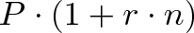 | a)…., non-growing return (bond coupons)
Compound  (b)…….) | 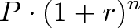 | Changes each year (stock market, c)………)
Compound  (n times per year) | 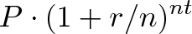 | Changes each month/week/day (savings account)
Continuous d)…….. | 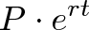 | Changes each e)…… (radioactive decay, f)………)
APR | Annual Percentage Rate (compounding not included)
APY | Annual Percentage g)……….. (all compounding effects included)
- P = h)……., your initial investment (i.e., $1,000)
- r = interest rate (i.e., 5% per year)
- n = number of time periods (i.e., 3 years)
- Have a look at graphs which show several kinds of interests. Try to suggest some key words for each graph and explain what happens. Add signposting language and present those three graphs.
- Try to consider and answer three questions. Explain your answers.
- Is a 4.5 APY better than a 4.4 APR, compounded quarterly? ………………..
- Should I pay my mortgage at the end of the month, or the beginning?.............
- Should I use several small payments, or one large payment?.............................

a)
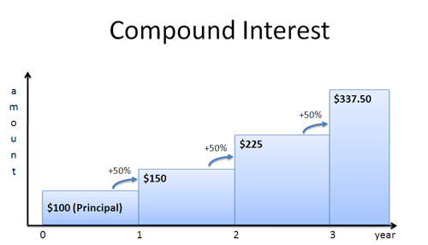
b)
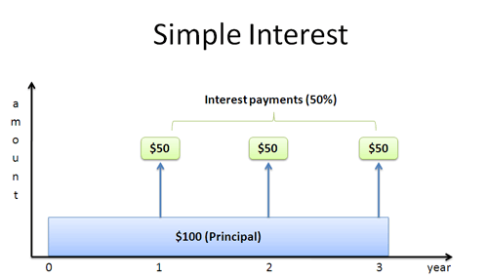
c)
