**5 CARTOGRAPHY AND MAPS**

**1.You will hear factual information about the Earth.**

**Before listening, make sure you know the vocabulary below.** <https://ttsreader.com/>

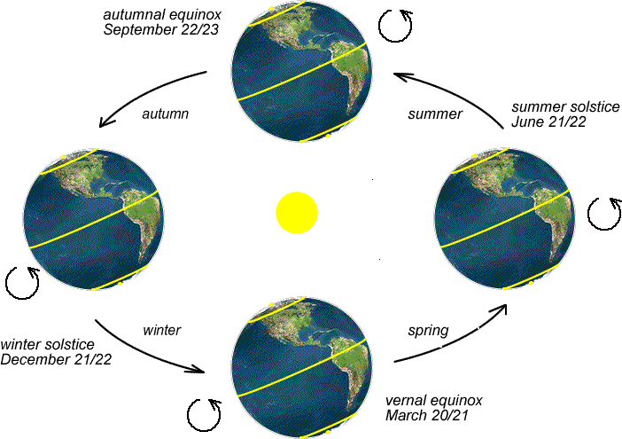

*prove*

*descend*

*eclipse*

*well*

*curved shadow*

*cast a shadow*

*light a match*

*lean toward*

*equal*

**Write down examples of evidence that ancient Greeks had for the claim that the Earth is round.**

1. …

2. **…**

**Describe the two ways how the Earth moves:**

The Earth ……………………..on its ………………….., once every………………… . It causes us to have ………..

The Earth………………………. around ……………………., once every…………… . It causes us to have ………….

**Now finish these sentences with predictions:**

1. If the Earth were flat, …

2. If you light a match on an airplane, …

3. If you travelled around the Earth on the day of spring or autumnal equinox, …

**Which of the predictions is probable and which is hypothetical?**

*A probable prediction* – a prediction that will come true if certain conditions are met.

*A hypothetical prediction* - a prediction that will also come true if certain conditions are met, but these conditions are very unlikely to occur.

**Complete these sentences:**

1. Sarah decided not to apply for the job. She isn’t really qualified for it, so she probably ……………….….….. (not / get) it if she ………………. (apply).

2. ‘Shall we tell them the truth?’ ‘I think if we ………..……….…. (tell the truth), they ……………..………… (not believe) us.’

3. ‘I’m writing a report in English but there might be mistakes. Will you check it for me after I………………………. (finish) it?’ ‘Of course, I ……………………….. (check) it for you when you ………………………… (finish) it.

4. We’re going to Rome next week. When we ……………….. (be) there, we hope to visit some friends.

5. ‘Is Ken going to take the examination?’ ‘No. If he ……………………. (take) it now, he …………………… (fail).

**2. CARTOGRAPHY: What is your definition of cartography? Complete the sentence.**

*Cartography is ………….….….. which deals with …*

*Cartography is ……………..….. of ………….... –ing …*

**Watch the tutorial ‘Introduction to Cartography and Making Maps’ and complete the sentences.**

<https://www.youtube.com/watch?v=4ONjZsFxcg8> 11.15 – 16.23

*glossary: convey – tell choropleth – thematic transform – change scale – ratio of distances*

1. Maps are designed by the cartographer to convey a m…………….. to the map reader.
2. The purpose often dictates the type of map – either t………………… , or choropleth map which shows measurement of statistical v……………… .
3. When making a map we transform a spherical surface into f…………….. map.
4. This transformation is known as map p…………………….. .
5. Transformation process always results in d…………………. .
6. Maps are often considered l…………...…. scale or s…………. scale in relation to one another.
7. If you convert the ratios to d………………. value, you can see which one is larger.
8. Every map has been g…………………. to some extent.
9. The smaller the scale, the greater the need to generalize map f…………………. .
10. Most maps have a l………….…….. or a key which explains to the user the symbols used on a map.

# **HOMEWORK** **Complete the text with the words from the list.**

# **Adapted from** <https://en.wikipedia.org/wiki/Cartography>

### information projections editing practice

### traits modeled traditional agenda

Cartography is the study and 1) …………….. of making [maps](http://en.wikipedia.org/wiki/Map). Combining science, [aesthetics](http://en.wikipedia.org/wiki/Aesthetics), and technique, cartography builds on the premise that reality can be 2) …………….. in ways that communicate spatial information effectively.

The fundamental problems of 3) …………….. cartography are to:

* Set the map's design and select 4) …………….. of the object to be mapped. This is the concern of map 5) ……………... Traits may be physical, such as roads or land masses, or may be abstract, such as [toponyms](http://en.wikipedia.org/wiki/Toponomy" \o "Toponomy) or political boundaries.
* Represent the terrain of the mapped object on flat media. This is the concern of  map 6)……………...
* Eliminate characteristics of the mapped object that are not relevant to the map's purpose. This is the concern of [generalization](http://en.wikipedia.org/wiki/Cartographic_generalization).
* Reduce the complexity of the characteristics that will be mapped. This is also the concern of generalization.
* Orchestrate the elements of the map to best convey its message to its audience. This is the concern of  map 7) ……………...

Modern cartography is largely integrated with [geographic 8) …………….. science](http://en.wikipedia.org/wiki/Geographic_information_science) (GIS science) and constitutes many theoretical and practical foundations of [geographic information systems](http://en.wikipedia.org/wiki/Geographic_information_system).

**3. TYPES OF MAPS**

<http://guides.library.stonybrook.edu/c.php?g=35399&p=224896> <http://www.icsm.gov.au/mapping/maps_intro.html>

**What are some differences between the two maps below? Are there any similar characteristics?**

**Complete the map descriptions below with the five words:**

*grid themes natural national contour*

**GENERAL REFERNCE MAPS**

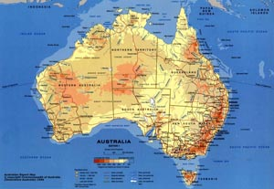

* is colourful
* cities are named
* major transport routes (highways and railways) are identified
* ***1*** …………….. features such as rivers, lakes and mountains are named
* elevation is shown using a simple colour shading
* has ***2*** …………..….. included – e.g. city population size

**TOPOGRAPHIC MAPS**

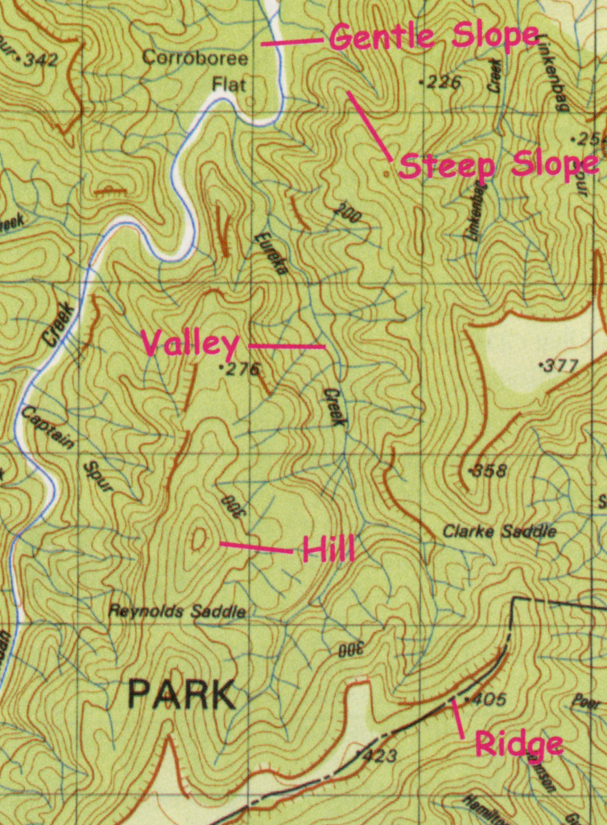

* shows elevation using ***3*** [………….……… lines](http://www.icsm.gov.au/mapping/cartographic.html#elevation)
* has an emphasis on showing human settlement (roads, cities, buildings etc.), but may include some thematic information such as vegetation or the boundaries of ***4*** ………………….. parks
* has very good location reference systems – including [latitude and longitude](http://www.icsm.gov.au/mapping/coordinates.html), but may also have ***5*** […………..……… lines](http://www.icsm.gov.au/mapping/map_projections.html#grid_amg)

**Study the picture of the topographic map and discuss:**

* What is the contour interval used on the map?
* Which saddle is higher in elevation, Clarke or Reynolds?
* Find hachures. 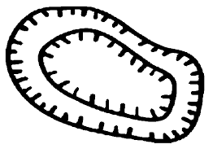 Are they oriented towards rising or falling terrain?
* Is this map large-scale or small-scale?

**4. MAP SCALE**

* We can think of a map scale as of a ratio. What ratio?
* How can a map scale be expressed in different ways?
* What categories of maps according to their scale are there?

**Find out what answers are given in the textbook article:**

Maps are made at a scale that is much smaller than the area of the actual surface being depicted. The amount of reduction that has taken place is normally identified somewhere on the map. This measurement is commonly referred to as the [map scale](http://www.physicalgeography.net/physgeoglos/m.html#map_scale). Conceptually, we can think of map scale as the ratio between the distance between any two points on the map compared to the actual ground distance represented. This concept can also be expressed mathematically as:

http://www.physicalgeography.net/fundamentals/images/mapscale.jpg

On most maps, the map scale is represented by a simple fraction or ratio. This type of description of a map's scale is called a [representative fraction](http://www.physicalgeography.net/physgeoglos/r.html#representative_fraction). For example, a map where one unit on the illustration represents 1,000,000 of these same units on the actual surface of the Earth would have a representative fraction of 1/1,000,000 (fraction) or 1:1,000,000 (ratio). Of these mathematical representations of scale, the ratio form is most commonly found on maps.

Scale can also be described on a map by a verbal statement. For example, 1:1,000,000 could be verbally described as "1 centimeter on the map equals 10 kilometers on the Earth's surface".

Most maps also use [graphic scale](http://www.physicalgeography.net/physgeoglos/g.html#graphic_scale) to describe the distance relationships between the map and the real world. In a graphic scale, an illustration is used to depict distances on the map in common units of measurement.

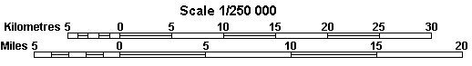

Maps are often described, in a relative sense, as being either small scale or large scale. Below we have maps representing an area of the world at scales of 1:100,000, 1:50,000, and 1:25,000.

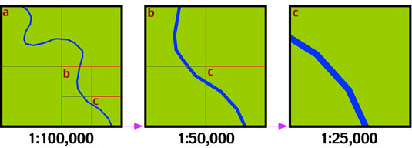

|  |
| --- |
| The map on the far left has the smallest scale, while the map on the far right has the largest scale. Note what happens to the amount of area represented on the maps when the scale is changed. A doubling of the scale causes the area shown on the map to be reduced to 25%.  <http://www.physicalgeography.net/fundamentals/2a.html> (abbreviated) |

**Reread the text to find synonyms for these words.** (in the same order in the text)

1. described

2. real

### 3. is the same as

4. making something twice bigger

### 5. Compare the characteristics of general reference and topographic maps.

### *General reference maps* show important ….

### They usually have a primary purpose of …….

### They are ……..……….-scale maps, such as maps covering a continent, region, or country on a single sheet.

### General reference maps also include ……………………… maps (maps about a subject, which show such things as population and crop distribution).

Like the general reference map, ***topographic maps*** are a summary of……

and show important ……..

The primary difference is that …….