1. Match the words or phrases used in statistics (1-10) to the definitions (a-j)

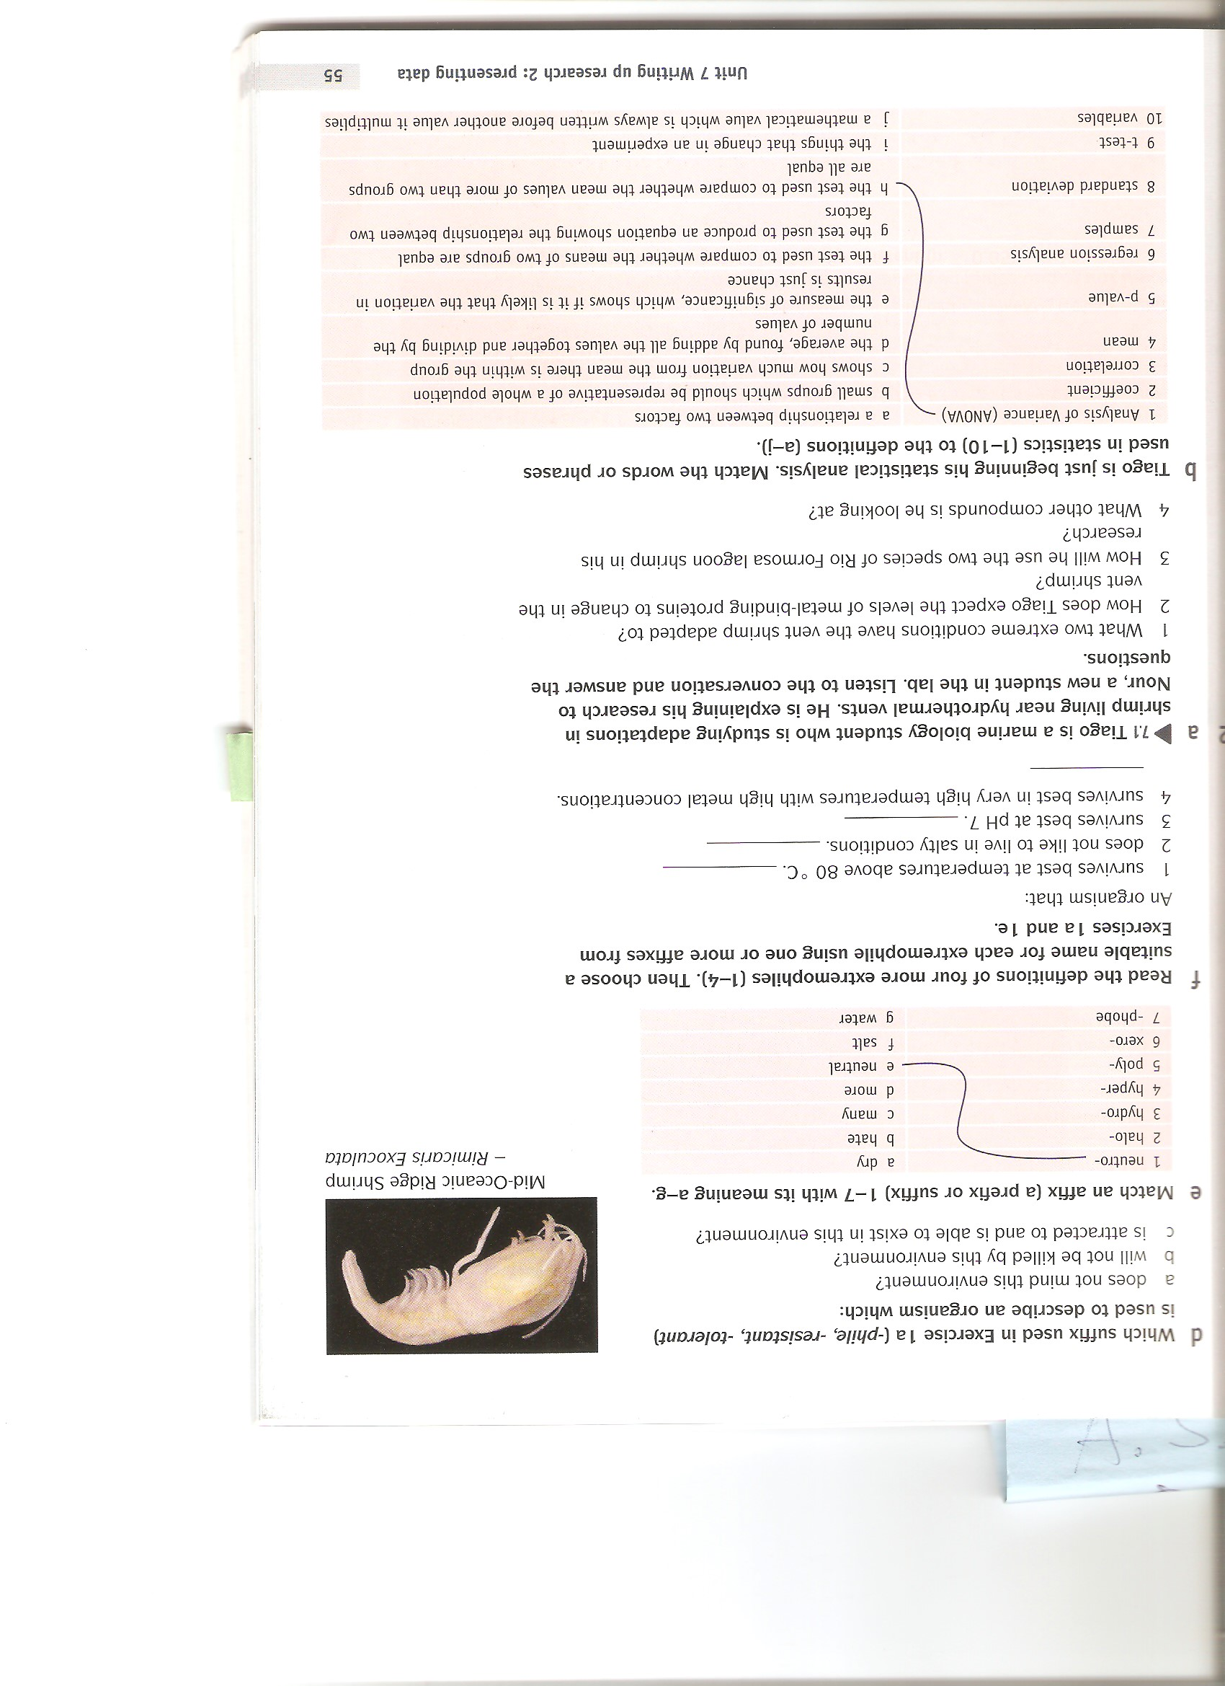

1. Tiago is a marine biology student studying adaptations in shrimp living near hydrothermal vents. Listen to the conversation and answer the questions.



1. Based on statistical analysis in the table below, complete the following sentences using the words in the box.

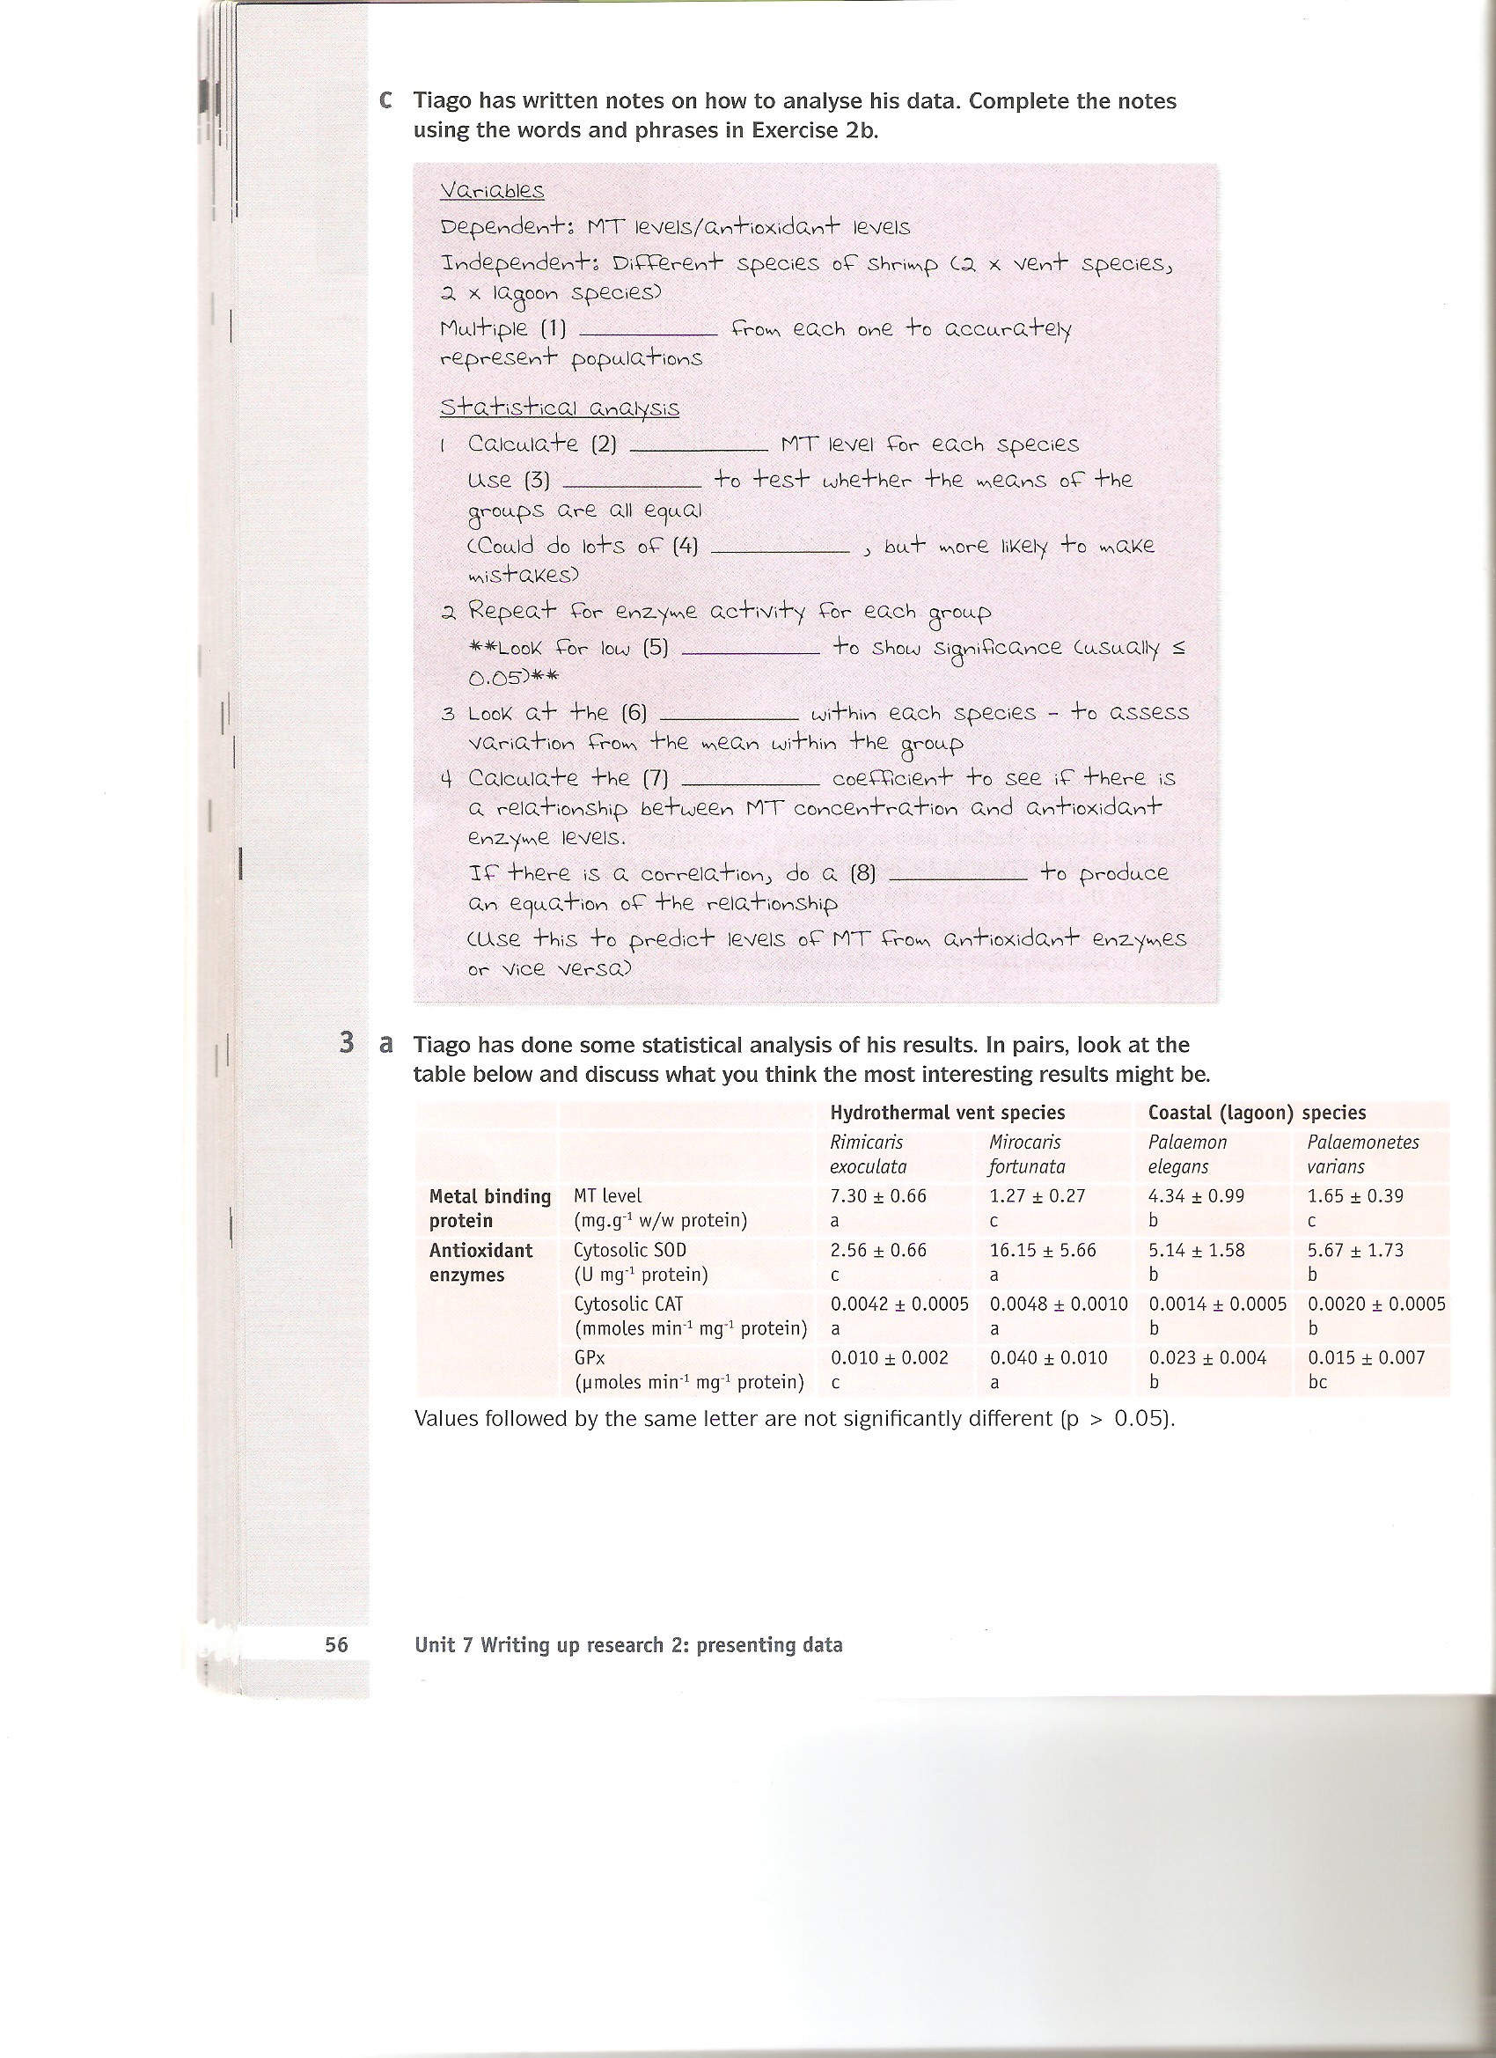

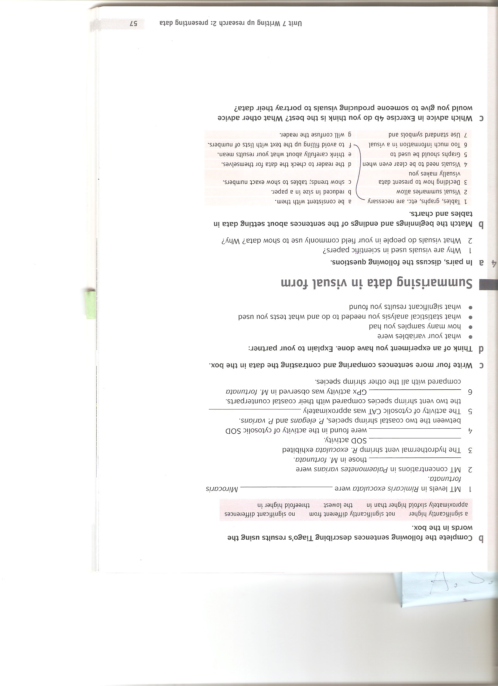

1. Read four captions (A-D) for four different figures. Then answer the questions that follow.

A

Fig. 3. The relationship between the weight of shell and strontium concentration in the shell of *B. azoricus* from the Mid-Atlantic Ridge (n = 51)

B

Table 1. Temperature, pH and concentration of chemical species in the end-member fluids of lagoon system Ria Formosa (South Portugal) and MAR vent field (Rainbow) compared with average seawater (adapted from Caetano *et al.,* 1997; Douville *et al.,* 2002)

C

Fig. 1. Thermal tolerances for the three symbiotic species under investigation (*Alviniconcha sp*., *Ifremeria nautilei* and *Bathymodiolus brevior*). For all experiments each temperature was held for 1 h, then the temperature was reduced to the starting temperature, the animals removed and mortality assessed. If alive, animals were returned to the aquarium and temperature was increased to the next point.

D

Fig. 2. Metallothionein concentrations (MT) in the edible tissues of hydrothermal (*Rimicaris exolucata* and *Mirocaris fortunate*) and coastal shrimp (*Palaemon elegans* and *Palaemonetes varians*). The data represent average ± standard deviation (SD), n = 16. Values followed by the same letter are not statistically different (p > 0.05).

1. What is the grammatical structure of the core information in each caption?
2. Which caption(s) relate(s) to data not collected by the author of the work?
3. Which two-word phrases explain the main purpose of the information in A and B?
4. What information does the second part of the caption in C and D give us?
5. Which phrases in C and D have similar meaning to:

*being studied*

*the results show*

*the same for the purposes of the analysis*

1. Remove four words from each sentence to make noun phrases that could serve as captions.

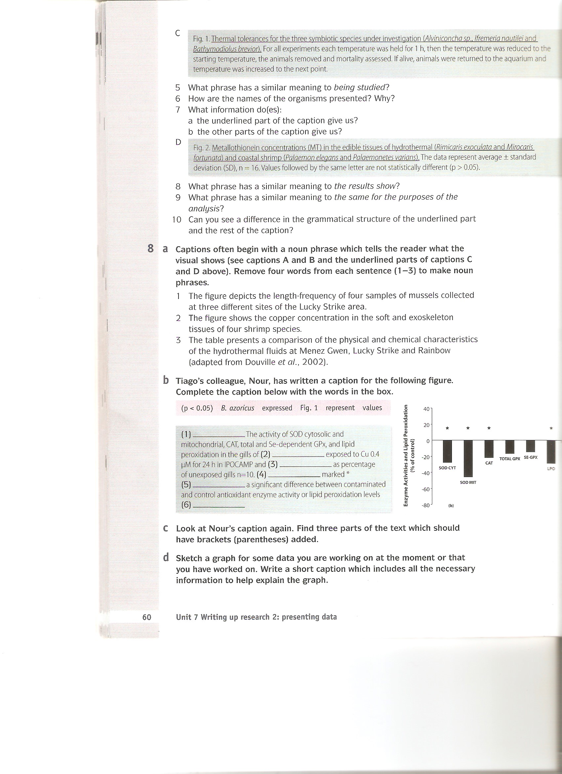

1. Complete the caption below with the words in the box.



1. Look at four graphs and read the two extracts from a paper.
2. Which graphs (1-4) are described in extracts A and B?

