Space travel and the human body
- Discuss these questions.
- Did you want to become an astronaut when you were a child?
- Would you like to go for a trip to the Moon or Mars or to the orbit one day?
- What kind of conditions will you have to prepare for?
- What are the effects of these conditions on the human body?
- What is weightlessness?

- Gravity. Listen to the talk and explain. https://www.youtube.com/watch?v=JHhoHmiiXdc (2:28 – 5:13)
- Which experiment is the professor describing, and what does he want to show?
- What is the difference between G and g?
- What is the professor trying to calculate?
- How is g different for the three given space objects?
- What was impressive about the movement of astronauts on the Moon?
- Gravitational lensing – have you heard about this concept?
(5: 30 – 6:46)
Explain the meaning of these words.
cluster warp into dimple analogy deflect
What is the physicist demonstrating in the experiment?

Now listen to the remaining part and complete the missing expressions. (6:46)

Let’s imagine that we are actually sitting at the telescope – we are sitting over here at a telescope on earth and we are looking out in this 1)……… direction. We detect the light coming from this distant galaxy after it’s been 2)……. but of course we don’t now it’s been bent – in our view, light travels in a straight line, so we think it’s coming in this direction and in fact, we don’t see the original source in its original 3)……….., we see an image of it over here. And simply by measuring the angle that this light has been deflected between where it came from and where we actually see it we can use general 4)……… to measure the mass of this deflecting object, and it doesn’t matter if this is a 5)……….galaxy that we can see or if it’s a big 6)………of invisible dark matter. Gravitational lensing is the 7)…….. that lets us measure its mass.

- Reading. Space travel and the effects of weightlessness on the human body.
Which effects of space travel can you see in the picture?
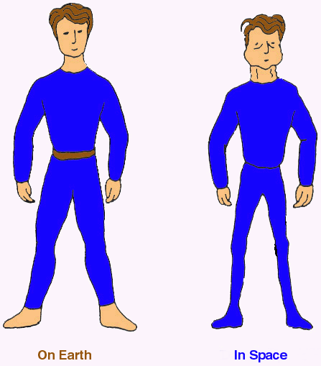
http://www.infobarrel.com/Media/Puffy-Face_Bird-Leg_Syndrome_53902
Scan the text and complete the table with causes and effects.
The human body is an extraordinary, but also, astonishingly complex machine. Like other living organisms, the human body has evolved by adapting to Earth’s gravitational field, and the biological structure and mechanisms of the body have developed to suit normal earth gravity.
When in Earth orbit, the astronaut’s body is still acted on by gravity, but much more weakly because of the distance. In addition, the speed acquired by the spacecraft to send the astronaut into space partially counteracts the gravitational force that continues to act on the spacecraft. This is the law of inertia. Thus, gravity disappears and the astronaut’s body becomes weightless.
“Weightless” means that there is no sensation of weight. The term zero gravity is also used, but to avoid promising too much scientists have adopted the term microgravity, because the effects of Earth’s gravitational force, and other forces, are not completely cancelled out.
An astronaut is in free fall when orbiting Earth. The reason the astronaut floats inside the spacecraft is that he or she is falling at the same speed as it is. Naturally, our astronaut does not fall to Earth, despite being in free fall, because the speed imparted to the spacecraft keeps it in orbit. Both phenomena, microgravity and floating, have an impact on an astronaut’s body in space.
Influence on blood circulation
One of the most visible effects of a space mission is no doubt the “puffy-face”, “bird-leg” look that astronauts get. On Earth, the heart is programmed to distribute blood evenly throughout the body. The heart must do more work to supply the upper body, because blood is naturally drawn downward by the force of gravity. The lower limbs do not have this problem, as the blood coming to them is gravity-assisted.
In space, bodily fluids no longer flow back down naturally by gravity. The heart is still programmed the way it was on Earth. So, under the pressure of the heart and the veins and arteries, the blood rushes to the person’s torso and head, and they then experience “puffy face syndrome.” The veins of the neck and face stand out more than usual, the eyes become red and swollen. This effect is often accompanied by nasal congestion and sometimes even headaches. Astronaut’s legs also grow thinner, because instead of dropping effortlessly down to the lower limbs, the blood has to be pumped there by the heart.
Particularly because of physiological changes such as these, astronauts suffer from space sickness or space adaptation syndrome (the space version of what we call motion sickness on Earth). About 40% of those who have gone into space have had dizziness or nausea. Both generally wear off after 2 or 3 days, as soon as the astronaut’s body has had time to adapt.
Influence on the bone and muscle structure
In space, the musculoskeletal system continuously deteriorates. The muscles, in particular the leg muscles, which are underused, become flabby and lose tone and mass. The astronauts are then subject to muscular atrophy. The bones, too, become weaker because of a loss of minerals (calcium, potassium and sodium). This bone degradation can reduce bone in the lower limbs by up to 10%.
Astronauts try to mitigate these changes by taking medication and, especially, by exercising as often as possible.
Did you know that your body gets taller in space? Because the spine is no longer compressed by the force of gravity, the vertebrae separate slightly from one another and the person’s body lengthens. Astronauts often have backaches, which are caused by relaxation of the muscles and ligaments of the back. Back on Earth, the force of gravity will influence the astronaut’s spine, which will return to its normal size.
Complete the chart with causes and effects from the text.

Cause…………………………………………. | Effect………………………………………
free fall
 | weightlessness
weightlessness
microgravity
 | puffy face syndrome
leg muscles underused
 | bones degradation
no spine compression
physiological changes

- Choose three examples from the table and write sentences indicating cause-effect relationship. Use different cause-effects markers.
- ………………………………………………………………………………………………
- ……………………………………………………………………………………
- ……………………………………………………………………………………
- Find collocations in the text of “speed”, “gravity” or “force of gravity”.
Speed + verbs (…………….., …………………)
Gravity + verbs (……………, …………….., ………………………)
- Complete the table with the opposites.

complex | ………………………..
acquire
grow thinner
deteriorate
mitigate
lengthen

The text and some exercised adopted from Milada Pavlovová

