**1 SOURCES OF ENERGY**

What sources of energy do we use? Can you classify them into different types? What is characteristic of these types?

1. Listen to a student giving a presentation. <https://is.muni.cz/auth/el/1431/jaro2018/JAZ02/um/54193868/67448138/67804048/>

* What does he want to look at?
* Which words does he use for the following meanings (synonyms):

PRODUCING ELECTRICITY WEAK, LIABLE TO FAIL WORRIES, PROBLEMS

ENERGY NETWORK FUNCTIONING EFFECTIVELY

* What suggestion does he have for solving the problems?

2. Look at the pictures. Name the different types of energy they illustrate.

A 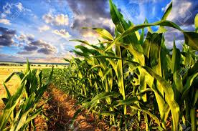 B 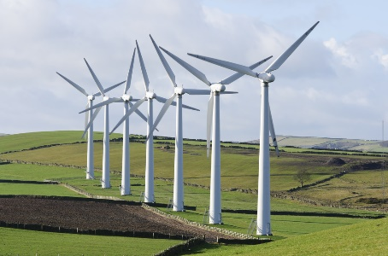 C 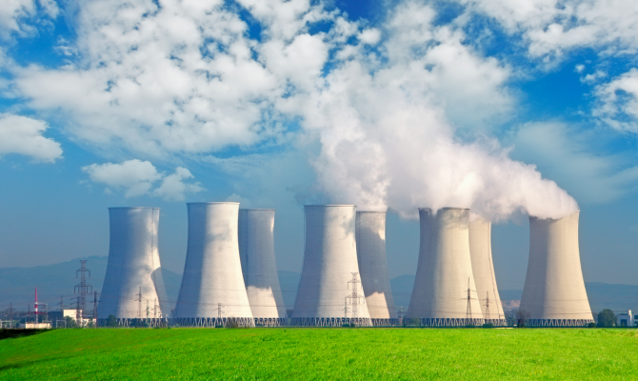

C 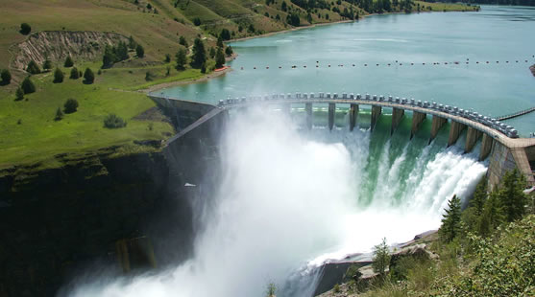 D 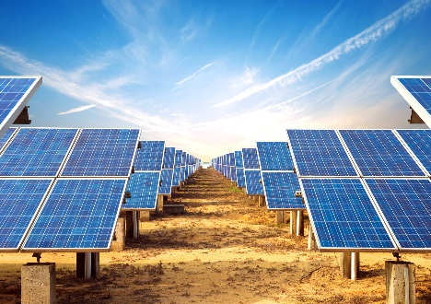 E 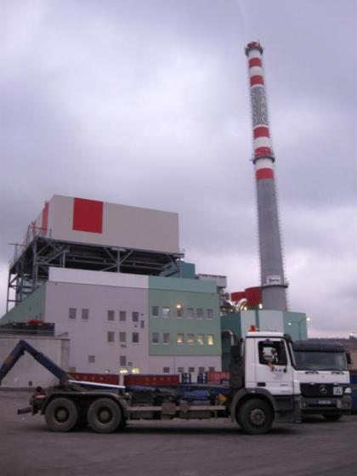

For each energy source B - E try to identify possible problems. Look at the situation from different perspectives.

Example for picture A:

*Biofuels use up a large quantity of plants such as maize, which could be eaten by humans or animals. Growing all these plants takes up a lot of space, which again could be used for other purposes*.

3. Look at an extract from a book *Renewable Energy: Power for a Sustainable Future*.

Does the text function as a) or b)?

1. *a discussion of the environmental problems associated with different energy sources*
2. *a description of the choices for ways of producing energy that are environmentally sustainable*

There are several benefits of using renewable energy supplies in preference to conventional sources. They cut carbon dioxide emissions, they decrease a country’s reliance on imported fuel, and they cut emissions of acid rain pollutants, sulphur dioxide and nitrogen oxides. However, all renewable energy sources have some environmental consequences. Their benefits have to be seen in relation to the alternatives.

It is unlikely, for example, that there will be much further development of large-scale hydroelectricity within the EU, apart from re-powering existing schemes. When new dams are built, large populations have to be relocated. The problems of flooding large areas of land are sufficient to rule out further expansion.

Similarly, municipal solid waste is widely burned, and contributes to national renewable energy totals, yet it faces opposition because of fears of dioxin emissions. This, too, is omitted from many promotion schemes, although the gasification and burning of waste which might have lower emissions are included.

Biomass also needs to be burned cleanly to avoid air pollution. In an extreme case, the Indian government has a policy to discourage the use of firewood as a cooking fuel in cities. Moreover, growing plants for fuel means that there are less crops grown for food.

The intensive cultivation of energy crops is being encouraged in spite of the fact that it may require the use of fossil fuel in the production of fertilizers and the harvesting and transport of the produce.

Source: Oxford EAP B1+, de Chazal & Rogers, OUP 2013, unit 11

* What are the benefits of using renewable energy?
* List the disadvantages of each of the three renewable sources mentioned in the extract.

4. Complex prepositions

Highlight in the text prepositional phrases that consist of more than one word.

Complete the sentences 1 – 5 with a complex preposition used in the text above.

1. Using renewable energy technologies ………………… … conventional source can benefit the environment.
2. There are other factors which must be taken into consideration when planning a new power station, …….…….…….. simply the financial costs.
3. …………………. concerns about safety, many governments are unwilling to commit to nuclear energy programmes.
4. As with any technology, the benefits of wind power need to be evaluated ………….…… other technologies.
5. The gasification and burning of waste is encouraged ………….………... fears of dioxin emissions.

5. Video <https://www.youtube.com/watch?v=RQPs0jAqeGk>

1st extract 0.20 – 1.00, 2nd extract 1.36 – 2.21

Vocabulary: complete the phrases with the words from the list. Check: 0 – 2.39

*entrepreneur underway reserves turbines blades brakes placed tapped*

1. hot water ………………… underground

2. wind power hasn’t been ………………… into

3. work is ………………… on a new concept

4. simplicity, as the ………………… says, is the key

5. traditional ………………… can spin out of control

6. it has precisely engineered …………………

7. it slows down without needing …………………

8. the invention ………………… 2nd on a national reality show

**Summarize the message of the report by answering the questions:**

1. What does the report evaluate?

2. What problem is pointed out?

3. What solution is offered?

**In your opinion, which source of energy is the best?**

**6. Problems & solutions language**

NOUNS

*issue*

*concern*

*threat*

*consequences*

*obstacle*

*setback*

*alternative*

*benefits*

ADJECTIVES

*key benefits*

*major difficulties*

*burning issue*

*minor obstacles*

*serious consequences*

*primary concern*

*short-term solution*

VERBS

*address the problem*

*face a difficulty*

*deal with the situation*

*pose a threat*

*contribute to the problem*

*mitigate the threat*

*aggravate consequences*

*hinder progress*

*overcome obstacles*

*seek alternatives*

Choose a few bubbles with problems – what could be a solution in your opinion?

Now make comments about your chosen topics in which you will use one noun, adjective and verb from the lists above.

7. Complete the presentation structure with your own suggestions.

1. Introduction

* open the presentation, introduce the group
* introduce the …………………..…… of the presentation
* explain how the presentation is …………………..………

2. Main Body

* present each main point
* give …………………………… or supporting information
* evaluate solutions

3. Conclusion

* + summarize what …………………….…… you have made
  + give overall evaluation
* invite the ……………………….…… to ask questions

**Make groups of three. Choose a problem and think about solutions. Prepare a simplified version of presenting the topic in your team, using the structure on the left.**

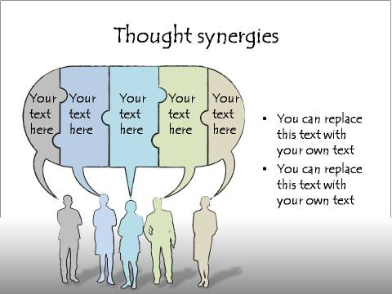

**8. Post-presentation discussion**

At the end of the presentation, there is time for asking questions. During this discussion time you can

* ask the presenter to repeat a detail you missed
* ask for more information about a specific point
* make sure you understood a point well (paraphrase, ask for clarification)
* ask about the presenter’s personal opinion
* express your agreement or disagreement with the presented solutions

**Formality in expressing opinion**

**Study the phrases below and sort them out according to their function.**

#### **1** Strong agreement **2** Weak agreement **3** Asking for an opinion

##### **4** Strong disagreement **5** Weak disagreement **6** Polite disagreement

#### **7** Interruption **8** After being interrupted **9** Expressing caution

<https://www.englishclub.com/vocabulary/functional-language.htm>

1. That's for sure.
2. Would you support the view that
3. No doubt about it.
4. I’m sorry but I don’t agree.
5. I can accept that.
6. Do you have any thoughts on
7. With respect I disagree entirely.
8. That’s quite true, but
9. You can’t be serious.
10. I'm afraid I disagree.
11. Ban on cars in city centres might be a good idea.
12. I totally disagree.
13. I'd say the exact opposite.
14. As I was saying,
15. That's not always true.
16. No, I'm not so sure about that.
17. Can I add something here?
18. Going back to what I was saying,
19. Generally speaking, that solution could be risky.
20. Sorry, go ahead.
21. Sorry, you were saying
22. You didn't let me finish.
23. Sorry for interrupting, but
24. I see what you’re saying, but
25. Actually, I think
26. I’m sorry, but I don’t agree.
27. This idea is absolutely right.
28. It could be argued that the last option is preferable.
29. What are your views on

* **Which of the phrases wouldn’t you expect in formal situations?**
* **Which phrases could possibly appear in the discussion following your presentation you were preparing in task 7?**

**HOMEWORK**

Listen to three extracts form a team presentation about alternative sources of energy. For each speaker, note down the *transitions*, i.e. words they use for opening and closing their parts. Besides, note down examples of evaluative adjectives. <https://is.muni.cz/auth/el/1431/jaro2018/JAC02/um/62184994/67803462/>

|  |  |
| --- | --- |
| Transitions | Evaluative adjectives |
|  |  |