8 THEORY OF PLATE TECTONICS

1. Warm-up
Describe the Earth’s structure: Study the map and answer the questions below.

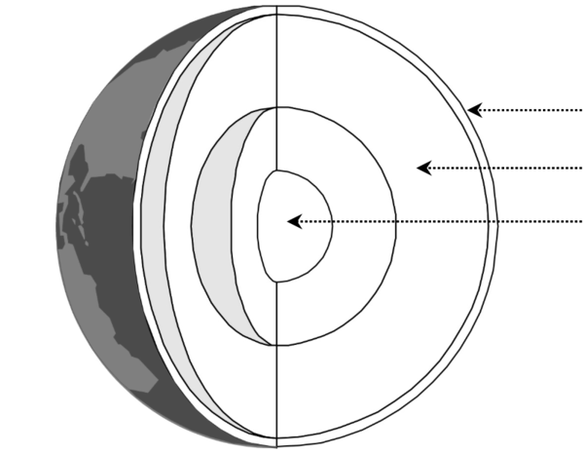

- How many major tectonic plates are there?
- How many minor tectonic plates are there?
- Who proposed the Theory of Continental Drift in 1915?
- The theory of sea floor spreading was developed by an American geophysicist in 1962. What was his name?
- What technique was used to develop the theory of sea floor spreading - seismic survey / echo sounding survey / gravity survey?
- What is the average depth of the ocean floor between mid ocean ridges and oceanic trenches?
- What is the average rate of sea floor spreading in the Atlantic Ocean - 0.02 m / 0.2 m / 2 m a year?
https://www.geolsoc.org.uk/Plate-Tectonics/Test-Your-Knowledge

2. Use the phrases to complete the first column of the table.

- constructive margins / divergence
- collision zones / convergence
- passive margins / transform faults
- destructive margins / subduction zones

TYPE | DESCRIPTION
 | plates move away from each other, new oceanic crust appears forming mid-ocean ridges with volcanoes
 | oceanic crust moves towards continental crust but, being heavier, sinks and is destroyed forming deep trenches and islands with volcanoes
 | two continental crusts collide and, as neither can sink, are forced up into fold mountains
 | two plates move sideways past each other, land is neither formed nor destroyed
D. Waugh, Geography, 2009, p.15
3. Find these on the map in ex. 1.
Mid-Atlantic Ridge, the Andes, the Himalayas, San Andreas fault.
Describe what happens at these places in relation to tectonic plates.
4. Video - Plate Tectonics Theory https://www.youtube.com/watch?v=mB2pzhWUaiU
A) What information is given about the parts of the Earth’s structure (ex.1.)? 0-0.50

B) Complete the details about: 0.50-2.20

- Two kinds of crust:

- Why plates move:
- In what directions:

C) Examples. Check the meanings of these words before watching the last part. 2.20 – 8.10
emerge ooze solidify
friction trench fertile
release ash plume
edge fold debris

Complete the types of plate margins A-D plus the examples and the gaps in the report.

A…………………. EXAMPLE:

In 1963 Icelandic fishermen spotted plumes of ash, 1………….……….. and lava shooting out of the sea.
Almost overnight a new island 2…..……….……. . Later this will be named Surtsey. (ABBREVIATED)
What had happened? At the bottom of the ocean two plates have slowly moved apart. 3 …………………. rock called magma lying below the plates oozed up through the cracks. When it reached the 4………….……….. , the magma cooled and solidified, forming lava. This built up until it broke through to the ocean surface to form an island. A 5 ……………………..… of lava mountains has been formed where the two plates have moved apart.

B…………………. EXAMPLE: Mount Merapi in ……………
C conservative margin EXAMPLE:
D…………………. EXAMPLE:

NOTE
fault - a break in the lithosphere along which movement has occurred

fold - flat and planar surfaces, such as sedimentary strata, are bent or curved as a result of permanent deformation

5. Discuss the questions about the Andes Mountains.

1. Which countries are situated in the Andes?
2. How has the South American plate been deformed?
3. What causes the earthquakes and volcanoes?
4. What is the depth of the Peru-Chile trench?
5. Why is it difficult to live in these areas?

Read the text and check your answers to the questions 2 - 4.

The Andes Mountains run the length of the West Coast of South America, rising in the north in Colombia and finishing in Chile and Argentina in the south. They are the world's longest mountain range running for over 7,000 km and covering 6 countries.
The mountains have been formed as a result of the convergence of the Nazca plate and the South American plate. The heavier oceanic crust of the Nazca plate is pushed towards the South American plate, and because it is denser it is subducted underneath. The South American plate is less dense so it sits on top of this subduction zone, but the rocks of the South American plate have been folded upwards and crumpled into fold mountains. There are also volcanoes and earthquakes along this destructive plate boundary - earthquakes are caused by stresses building up as the two plates try to move past one another, and volcanoes are caused by magma working its way up through vents in the Earth's crust. This has created a sequence of volcanoes and fold mountains, rising up to 6962 m at Aconcagua. The trench (marking the boundary between the Nazca and South American plates) to the West of the Andes mountains is called the Peru-Chile Trench, and reaches an incredible depth of 8066 m under the sea level.
These areas are very hard to live in because of the physical geography. The relief is very steep making farming difficult, and the high altitude makes breathing difficult. Due to the mountainous terrain it is hard to construct roads and railways.
http://www.coolgeography.co.uk/GCSE/AQA/Restless%20Earth/Andes/Andes%20Case%20study.htm

HOMEWORK - Use of grammar

MODALS
Can (expresses ability)
May (expresses possibility)
Must (expresses necessity)
Should (expresses recommendation)

DETERMINERS
Another
Either … or
Neither … nor
Both

CONNECTORS

As a result of
Due to + noun phrase
Such as

Though
When + subject and verb
If

Use the 14 words/phrases given in the three groups above to complete the gaps in the following article about plate movement:

Plate movement
1_________________ the convection cells generated by heat from the centre of the Earth, plates 2_________________ move towards, away from or sideways along adjacent plates. It is at plate boundaries that most of the world’s major landforms occur, and where earthquake, volcanic and mountain-building zones are located. However, before trying to account for the formation of these landforms, several points 3_________________ be noted.

1. 4_________________ its relatively low density, continental crust does not sink and so is permanent; being denser, oceanic crust 5_________________ sink. Oceanic crust is being formed and destroyed continuously.
2. Continental plates, 6_________________ the Eurasian Plate, may consist of 7_________________ continental and oceanic crust.
3. Continental crust may extend far beyond the margins of the landmass.
4. Plates cannot overlap. This means that 8_________________ they must be pushed upwards on impact to form mountains, _____________ one plate 9_________________ be forced downwards into the mantle and destroyed.
5. No ‘gaps’ may occur on the Earth’s surface so, 10_________________ two plates are moving apart, new oceanic crust originating from the mantle must be being formed.
6. The Earth is 11_______________ expanding _____________ shrinking in size. Thus 12_______________ new oceanic crust is being formed in one place, older oceanic crust must be being destroyed in 13_________________.
7. Plate movement is slow (14_________________ not in geological terms) and is usually continuous. Sudden movements are detected as earthquakes.
8. Most significant landforms (fold mountains, volcanos, island arcs, and deep sea trenches) are found at plate boundaries. Very little change occurs in plate centres (shield lands). D. Waugh, Geography, 2009

