**9** **GEOMORPHOLOGY**

1. **Warm-up**

* What does “morphology” study?
* Complete the mind map and explain how the ideas are related to geomorphology.

regolith 2……………

soil creep sedimentary

**mass movement** **types**

3……………..

1………..

**Rocks**

mudflows

**denudation**

4…………. water

weathering 6…………….

5………….. 7…………….

Source Kelly, K: Geography

**2. Change the order of the letters to find names of rocks and complete the translation and places where they can be found in the Czech Republic**.

*rock translation example of region*

**stomeline** the Palava Hills**,** the Moravian Karst

**stosandne** B...................... Paradise

**nigrate** the Jizera Mountains

**issgne** *rula*the Bohemian-Moravian H………

**saltba** *čedič*the D………… Mountains

**conmeglorate** the Iron Mountains

**cami-stschi** *svor*the Bohemian Massif

**3. LISTENING Physical Geography II - Geomorphology** <https://www.youtube.com/watch?v=GkcjTRMTst0>

**Before listening, check the meaning of the words.**

LANDFORMS

arch

pinnacle

dune

canyon

river bed

dome

PROCESSES

erosion

deposition

exfoliation

folding

faulting

ROCKS

sandstone

granite

quartz

feldspar

hornblende

mica

VERBS

grind

wear down

scrape

scour

crack

**Discuss**

* What is the effect of wind on the landscape ?
* Which landforms were formed by running water?
* What does temperature cause in rocks?

**Watch the video and fill in the missing parts of sentences.**

1. Erosion is the process by which……………………………………………………….
2. Depositional features are those which ...............………………………………………
3. Grinding and smashing effect is caused by……………………………………………
4. Natural arches and pinnacles can be found in …………………………………………
5. Dunes are created when ……………………………………………………………….
6. Given enough time, water can wear away even ………………………………………
7. V shaped canyon was formed by ………………………………………………………
8. Arroyos or washes are …………………………………………………………………
9. Repeated heating and cooling of rocks causes…………………………………………
10. At night, water in cracks …………………………, causing rock …………………….
11. Granite, which is subject to exfoliation, is a result of once ……………………………
12. Gravity influences rocks in a way that they ……………………………………………

**4. DESCRIBING PROCESSES**

Match the different types of activities with the pictures.

*seasonal change (spring, summer, autumn, winter) / making a car / writing an essay/report (researching, drafting, rewriting, submitting) / driving a car / water in natural environment …*

A 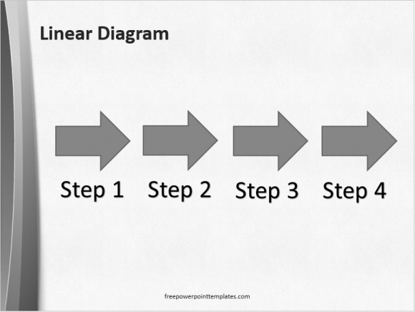 B  C 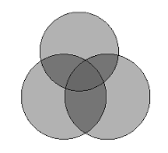

Decide which words /phrases are typical for describing each of the three types of processes.

WHILE WHEN DURING AS THE FOLLOWING STEP RESULT IN UNTIL INITIALLY IN THE LAST STAGE CAUSE LEAD TO

AFTER SUBSEQUENTLY EVENTUALLY MOREOVER BESIDES DUE TO

**WRITING ABOUT A PROCESS**

The notes below describe two different processes. First, write a heading for each process, then put the steps in the right order. Source Waugh, D.: Geography, An Integrated Approach

……………………………………………….

1. winter – freezing of active layer – soil contracts
2. summer – meltwater in cracks, + deposits (wind, water)
3. cracks – shape of irregular polygons (like bottom of dried up lake)
4. repetition, wedges on polygon perimeter grow (1m thick, 3m deep)
5. water freezes, cracks widen, deepen – wedges
6. fossil wedges – mean earlier periglacial conditions

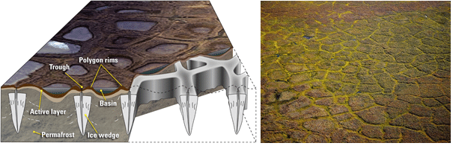

**…………………………………………**

1. wind: strength determines how much and what type of material is removed

strength increases – more and larger particles removed

1. formation of desert pavement (reg)
2. fine particles are removed, more and more removed - the surface lowers in elevation
3. the surface – settled, wind-polished
4. deflation - until the floor is closely packed pebbles and rocks - too heavy to move
5. older pavement – appears smoother, flatter (like worn cobblestone street)

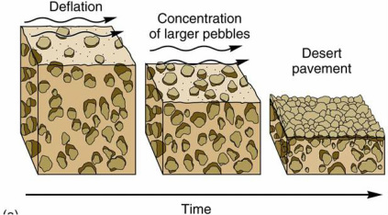

**Choose one of the processes. Use the notes to write a paragraph of approximately 130 words. Add cohesive language to connect the sentences.**

Pictures

<https://www.researchgate.net/figure/A-schematic-illustrating-the-formation-of-ice-wedges-and-ice-wedge-polygon-landscapes_fig33_309034919> , <https://desertlandforms.weebly.com/desert-processes.html>

**How sand moves** ( homework)

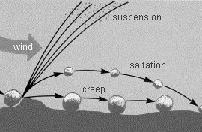

* Underline parts of the text which describe different stages in the process.
* Do the stages happen one at a time in a sequence or at the same time?

When the wind blows over the desert floor, its flow is influenced by the nature of that surface, its roughness on all scales. Such surface roughness interferes with the smooth flow of air, causing disturbances in the air and currents. These in turn interact with the sand grains on the surface, which may be moved along or temporarily kicked up by the wind, which modifies its movement – a constant interaction between the wind and the grains. The act of moving sand grains removes energy from the wind and transfers it to the grains, which, crashing into their colleagues, transfer that energy in turn to them. The result is that close to the ground surface, where most of the action is going on, the wind speed is reduced. There is a speed gradient whereby the wind speed increases with the height. Speed gradients cause pressure gradients, and pressure gradients mean grains can fly. What happens on a very small scale very close to the surface of the ground in the desert is critical to the grand-scale results. Edward de Chazal: Oxford EAP B2, OUP, 2012, p.88

* Complete the stage in the process of sand movement in the diagram below. For each gap you need to identify the verb in the text and convert it to the appropriate noun

Example: *the wind* ***blow****s – the* ***blowing*** *of the wind*

the *blowing* of the wind

the……………….. of smooth air flow by rough surfaces

the ……………….. between the wind and the sand

the movement of sand along the desert floor

A ………………….. in the wind speed close to the ground

the ………………… of energy from wind to sand

the saltation of the sand grains

the …………………. / suspension of grains in the air