**2 ECO-CITIES**

1. You are going to watch a student (Ben) giving a presentation on a new eco-city. Decide which definition best describes an eco-city.

1. a city which has very little industry and does not allow the use of cars
2. a city which is planned to have low energy use and low emissions
3. a city which has lots of green, open spaces and plenty of trees

**2. Use the question words and write five questions which you expect to be discussed in the presentation:**

1. What
2. Where
3. When
4. Why
5. How

**Watch Ben’s presentation. Note down his answers to your questions above.**

**3. Using noun phrases in presentations. Match adjectives in A with nouns/noun phrases in B**

|  |  |
| --- | --- |
| **A** | *carbon-neutral emerging renewable environmentally-based completely new major* |
| **B** | *clean-tech cluster energy sources companies oil-producing region planned city energy systems* |

**Use the phrases you have made to complete sentences 1 – 6 below. Listen and check.** 0.25 -2.36

1. Basically, Masdar is a …………………..
2. It’s been described as an …………………
3. They’re based around clean technology like ……………….
4. So, as I said, Masdar is this new development for new and …………….
5. Obviously, it’s in the middle of a …………….
6. It uses solar energy, and other ……………….

**4. Relative pronouns. Complete the phrases below with suitable expressions.**

**Example:** *a company …….. is expanding rapidly - a company* ***that / which*** *is expanding rapidly*

1. an organization ……….. is international but little known
2. a country ………... importance is increasing
3. a building ……..…. is modern, and …….…. is environmentally friendly
4. reasons ………... costs have increased
5. a region ………... formal colonization never took place

**Now change the text 1 – 5 above into noun phrases**

*a company that is expanding rapidly – a rapidly expanding company*

**5. What do you think about Masdar? Would you like to live there?**

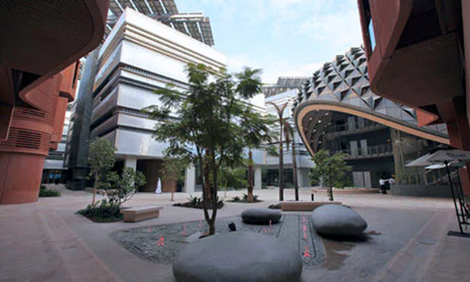 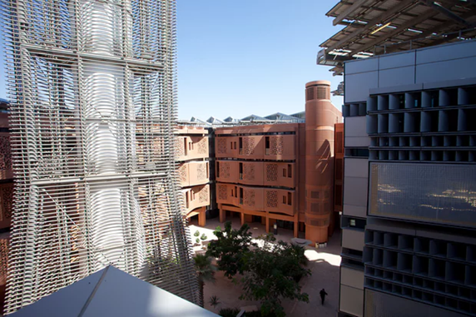

**Read more to find out how effective the project is.**

<https://www.theguardian.com/environment/2011/apr/26/masdar-city-desert-future>

<https://www.theguardian.com/environment/2016/feb/16/masdars-zero-carbon-dream-could-become-worlds-first-green-ghost-town>

**6. Read about Curitiba**

* **Curitiba is an example of a successful eco-city. In which two areas is it ecological?**
* **What did the city do to make favelas ‘greener’?**

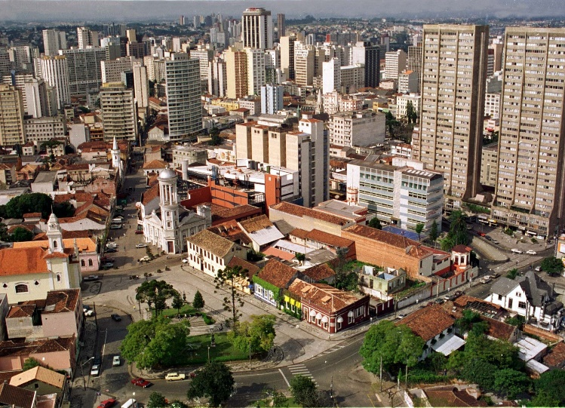

Curitiba, Brazil, is the greatest example of sustainable transport in a city in the world today.

Curitiba has become an international model for sustainable development because it puts its people first and plans in a strategic and integrated way. The city was led in the 1970's and 1980's by mayor Jaime Lerner who imagined the ideal and helped create what the city has become today. Curitiba is best known now as a pioneer of [sustainable mass transportation](http://www.greencitytimes.com/Sustainable-Student/sustainable-mass-transit.html) and waste recycling.

<http://www.greencitytimes.com/Sustainable-Cities/curtiba.html>

The city has succeeded in introducing a Green Exchange employment programme to the benefit of the environment and socially deprived groups. Low income families living in the favelas, shantytowns out of reach of the city's dustcarts, can exchange their rubbish bags for bus tickets and food. Children can exchange reusable waste with school articles, chocolate, toys and tickets to entertainment events. The project results in less household waste in the streets as well as in sensitive areas such as rivers and parks. In combination with other initiatives, 70% of Curitiba's waste is recycled by the city's inhabitants.

<http://www.dac.dk/en/dac-cities/sustainable-cities/all-cases/green-city/curitiba-the-green-capital/?bbredirect=true>

**7. Listen to A song of the city, a speech by Jaime Lerner**

### <https://www.ted.com/talks/jaime_lerner_sings_of_the_city/transcript?language=en#t-740464>

*Jaime Lerner, an architect and urban planner, used massive creativity and tiny budgets to create the world's greenest city.* casque –krunýř, articulated bus – kloubový autobus

**1. The speaker believes that cities**

A make climate change worse

B have little money for improvement

C need co-responsibility and good design

D need a lot of time to be improved

**2. Which character from his book never wants to leave his position**

A Accordion, the bus

B the turtle

C Otto, the automobile

D a Brazilian

**3.The boarding tubes at bus stops**

A make transport more effective

B make buses compete with subway

C are useless for handicapped people

D were designed by Norman Foster

**4.Your car becomes a problem when you**

A have bad relationship to cars

B make it dominant

C give lifts to your mother-in-law

D want to drive through old quarries

**5**.**J. Lerner says that creativity starts when you**

A teach children

B cut a zero from your budget

C use alternative materials

D co-operate with residents

**8. Here are a few sentences from J. Lerner. Try to explain what he meant by these comments.**

"City is not a problem, it's a solution." And more and more, I'm convinced that it's not only a solution for a country, but it's a solution for the problem of climate change.

If we cut the casque of the turtle, how sad she's going to be? And that's what we're doing in our cities: living here, working here, having leisure here.

That means mostly two main issues —mobility and sustainability — are becoming very important for the cities.

What in the design that made the difference is the boarding tubes: the boarding tube gives to the bus the same performance as a subway.

You cannot have empty places during 18 hours a day. You should have always a structure of living and working together. Try to understand the sectors in the city that could play different roles during the 24 hours.

So, in a city, you have to work fast. Planning takes time.

This is the main pedestrian mall; we did it in 72 hours. Yes, you have to be fast

**9. Revision activity: How many noun phrases can you identify in this extract?**

The core of Masdar City is in place, anchored by the large square-ish building that is the Middle East headquarters of Siemens. A 45-metre Teflon-coated wind tower helps channel cooling breezes down a shaded street equipped with a grocery store, bank, post office, a canteen, and a few coffee shops.

The pioneering autonomous transport system - which was originally supposed to stretch to 100 stations - was scrapped after the first two stops. There is a bike-sharing station – though it’s 10 miles away from Abu Dhabi, and there are no bike paths. Meanwhile, the jet-set transport system was overtaken by technological developments in the auto sector. The expensive purpose-built system no longer made sense in an era when zero-emission electric cars were widely available.

<https://www.theguardian.com/environment/2016/feb/16/masdars-zero-carbon-dream-could-become-worlds-first-green-ghost-town>

**HOMEWORK**  Grammar for definitions- relative clauses (vztažné věty) <https://is.muni.cz/auth/el/1431/jaro2017/JAZ02/um/54193868/67580948/> - homework: parts 5.3, 5.5