**Interplay of redox potential and p*Ka* in aminoferrocene**

Jakub Věžníka,b, Libuše Trnkováa Karel Lacinab

*a Department of Chemistry, Faculty of Science, Masaryk University*

*b* *CEITEC - Central European Institute of Technology, Masaryk University*

*Kamenice 5, 625 00 Brno*

*jveznik@mail.muni.cz*

Due to the simplicity of the redox reactions of Fe2+/3+ ions, ferrocenes are popular for electrochemical measurements (calibration, testing, sensing). While ferrocene itself is rather nonpolar for direct use in aqueous solvents, its many derivatives (aminoferrocene, ferroceneboronic acid etc.) are soluble enough to be of use in aqueous solvents.

Similarly to aniline, aminoferrocene is slightly acidic (p*Ka*= 5.9) due to conjugation of amino group with the cyclopentadienyl ring. The acidity of the compound is strongly dependent on the oxidation state of the Fe2+/3+ ion, as oxidation to Fe3+ lowers p*Ka*to 3.0. This interplay between redox potential and p*Ka* leads to interesting electrochemical behavior, as can be seen in the figure. Different behavior is observed in buffered and unbuffered solutions. In that case, aminoferrocene has the ability to locally change pH upon oxidation, which leads to appearance of two distinct forms in cyclic voltammetry. Next to possible use for pH sensing, this system could be used for reversible electrochemical switching of pH.

In our contribution we focused mostly on how electrochemical behavior can be used to predict p*Ka*of oxidized form of aminoferrocene, utilizing measurement in both buffered and unbuffered solutions and different electrode materials (gold, platinum, boron doped diamond).

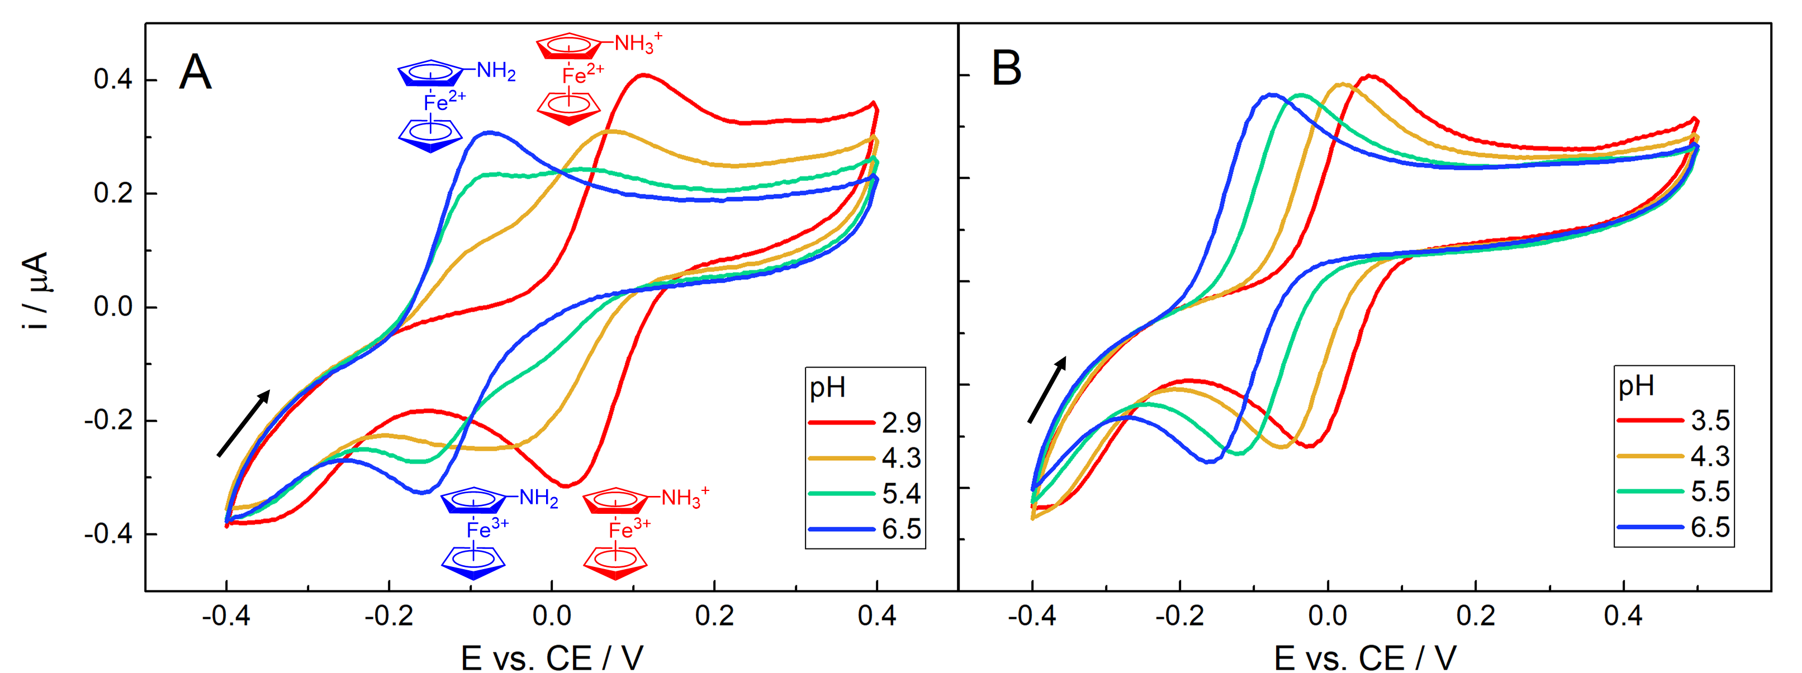

**Figure:** Cyclic voltammetry of aminoferrocene in A) unbuffered (0.1 M KCl) and B) buffered solution (0.1 M acetate). Gold disk (0.5 mm) electrode, platinum wire and calomel electrode (3 M KCl) were used as working, counter and reference electrode, respectively.

**Acknowledgements**

This research has been financially supported by the project CEITEC 2020 (LQ1601), MUNI/A/1359/2018 and by the Czech Science Foundation, grant nr. 19-16273Y.