Mapování biotopů 2020 – Přední kout

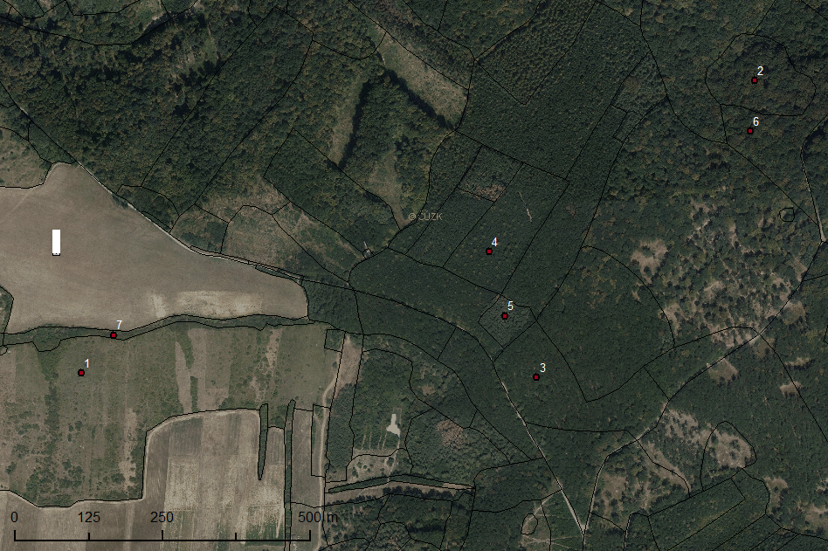

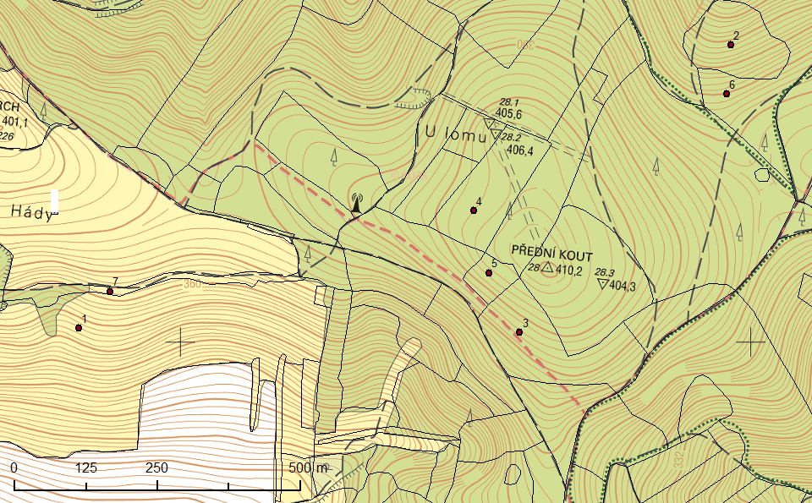

|  |  |  |
| --- | --- | --- |
| Id | x | y |
| 1 | 16.76853 | 48.96922 |
| 2 | 16.78333 | 48.97475 |
| 3 | 16.77903 | 48.96988 |
| 4 | 16.77763 | 48.97172 |
| 5 | 16.77814 | 48.97077 |
| 6 | 16.78336 | 48.97396 |
| 7 | 16.76917 | 48.96985 |