**WEEK 3: Bacteria and Viruses**

**1 Bacteria:** Vocabulary: Read through the description below and complete it with the words from the list. There are three words you will not need.

fission fusion harmful beneficial infectious genetic separate connected involved abundant

Bacteria are ubiquitous one-celled organisms, spherical, spiral, or rod-shaped and appearing single or in chains. Various species are 1. _____________ in fermentation, putrefaction, 2.____________ diseases, or nitrogen fixation.

They lack a cell nucleus and reproduce by 3. _____________or by forming spores. They are the most 4. _____________ life forms on Earth, and are found in all living things and in all of the Earth's environments. Bacteria usually live off other organisms. Bacteria make up most of the kingdom of prokaryotes (Monera or Prokaryota), with one group (the archaea or archaebacteria) often classified as a 5. _____________kingdom.

Some bacteria are 6. _____________to humans (for example, those that live in the [stomach](http://dictionary.reference.com/browse/stomach) and aid [digestion](http://dictionary.reference.com/browse/digestion)), and some are 7. _______________(for example, those that cause diseases).

**2 Comparing and Contrasting**: In the article below, underline the expressions we use for comparing and contrasting.

There are more differences than similarities between bacteria and viruses, yet, they have a few things in common.

Both bacteria and viruses are microbes that can cause diseases. Bacteria are like viruses with respect to the ways of spreading. You can contract them via being exposed to someone coughing, sneezing, or by coming into contact with contaminated animals, people or items. Some diseases caused by viruses and bacteria are so serious that they are even capable of killing humans. Fortunately, there exist vaccinations against viral infections. Likewise, you can be vaccinated against bacterial infections.The lastsimilarity I would like to refer to concerns the internal structure: bacteria alsoresemble viruses in that they have no nuclei.

**3 Look at the table describing the characteristics of bacteria and viruses** (on page 2). Make 5 sentences comparing and contrasting bacteria and viruses. Use expressions for comparing and contrasting

Like Unlike as big as

Likewise In contrast to bigger than

Same as As opposed to

As well as Different from

Also Whereas

**4 Listening:** Add some information to the following dates

December 2019

December 31, 2019

January 7, 2020

January 13, 2020

April 2003

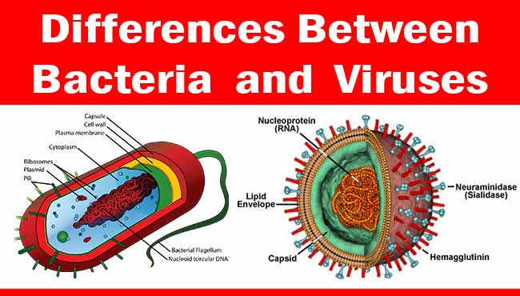

|  |  |  |  |
| --- | --- | --- | --- |
| ***S.N.*** | ***Characteristics*** | ***Bacteria*** | ***Viruses*** |
| **1** | **Size** | Larger (1000 nm) | Smaller (20-400 nm) |
| **2** | **Cell Wall** | Peptidoglycan or Lipopolysaccharide | No cell wall. Protein coat present instead. |
| **3** | **Ribosomes** | Present | Absent |
| **4** | **Number of cells** | One cell (Unicellular) | No cells |
| **5** | **Living/Non-Living** | Living organisms | Between living and non-living things. |
| **6** | **DNA and RNA** | DNA and RNA floating freely in cytoplasm. | DNA or RNA enclosed inside a coat of protein. |
| 7 | **Reproduce** | Able to reproduce by itself | Need a living cell to reproduce |
| **8** | **Reproduction** | Fission- a form of asexual reproduction | Invades a host cell and takes over the cell causing it to make copies of the viral DNA/RNA. Destroys the host cell releasing new viruses. |
| **9** | **Under Microscope** | Visible under Light Microscope. | Visible only under Electron Microscope. |
| **10** | **Diseases/Infections** | Food poisoning, gastritis and ulcers, meningitis, pneumonia, etc | AIDS, common cold, influenza, chickenpox, etc |

**6 Bacteria: Shape of Bacterial Cell**

The three basic bacterial shapes are coccus (spherical), bacillus (rod-shaped), and spiral (twisted), however pleomorphic bacteria can assume several shapes.

[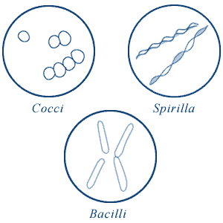](https://microbiologyinfo.com/wp-content/uploads/2015/05/Shape-of-Bacterial-Cell.gif)**Shape of Bacterial Cell**

* **Cocci** (or coccus for a single cell) are round cells, sometimes slightly flattened when they are adjacent to one another.
* **Bacilli** (or bacillus for a single cell) are rod-shaped bacteria.
* **Spirilla** (or spirillum for a single cell) are curved bacteria which can range from a gently curved shape to a corkscrew-like spiral. Many spirilla are rigid and capable of movement. A special group of spirilla known as spirochetes are long, slender, and flexible.

**7 Word Formation:** The discovery of penicillin

One of the most amazing advances ever made in medicine began with an unexpected event. Sir Alexander Fleming, a Scottish 1 ___________________, had been conducting an 2 ______________ looking into new ways of killing germs, when he came upon something puzzling in his laboratory.

Some mould had 3 ____________ landed on one of the dishes and for some 4 ______________ reason, had killed the bacteria he was growing. At first, he was 5 ______________ by his discovery and grew more of the mould, giving it the name penicillin. However, his 6 ________________ wore off when he decided that penicillin would only really be 7 ________________ as an antiseptic against certain skin 8 ______________ and soon lost his interest as he believed that antiseptics often did more harm than good. It wasn’t until ten years later that two other scientists managed to isolate the substance that killed the bacteria, and 9 ________ began to save people’s lives with it. In 1945 Fleming and the two others were awarded the Nobel Prize in Medicine.

1 BACTERIUM 6 EXCITE

2 INVESTIGATE 7 EFFECT

3 ACCIDENT 8 INFECT

4 KNOW 9 SUCCESS

5 DELIGHT

Sources:

Bell, Jan and Roger Gower. *First Expert*. Harlow: Pearson Education Limited, 2014.

*Microbiologyinfo.com*<https://microbiologyinfo.com/different-size-shape-and-arrangement-of-bacterial-cells/>

“Why labs are printing the coronavirus genome.” *Verge Science*

“3 min guide: How scientists are fighting the coronavirus.” *Nature News*