**JAG04 Unit 1**

**Task 1** **About the course**

Work in small groups. Share all the information you have about the current course and the compulsory exam JA002 or talk about your hopes and expectations.

Consider the following:

* credit requirements - attendance, homework, assignments…
* exam – level, structure, content, pass mark…

**Task 2 Academic skills**

1. Which skills do you think are the most important for your academic studies? Which are the least important?
2. Which two skills do you think are your strengths and which do you think you need to practise more?

* Understanding lectures in English
* Taking part in group work
* Giving presentations
* Reading academic texts
* Finding information to include in my own writing
* Summarising what I have read
* Writing academic texts
* Learning academic vocabulary
* …………………………………..

1. In pairs, discuss your answers. Do you have any advice to give on how to improve these skills?

**Task 3 Speaking**

1. Work in pairs. Everyone wastes time sometimes. When you waste time, what do you think is the reason? Stress? Boredom? Something else?
2. What is the purpose of the flow chart?

Work your way through the questions on the chart. What does it tell you about yourself?

Do you find the tips useful?

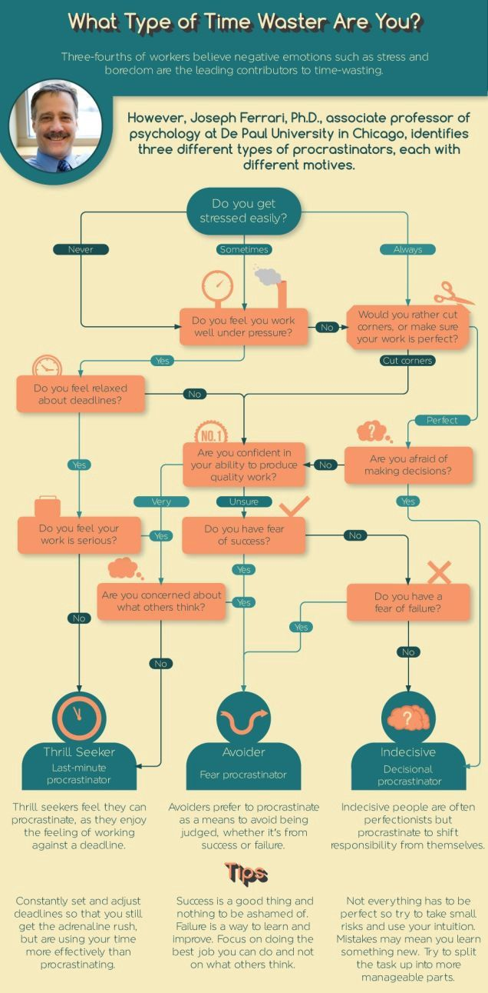

(www.businessinsider.com)