STUDY HABITS

### **1 Discuss the questions with a partner.**

1 What was/is your favourite and least favourite subject at school? Why?

2 When do you find it best to study? Why?

### **2 Complete the following quiz and discuss the questions with a partner.**

1 What is your learning style?

2 Do you agree with your result? Why (not)?

**A What is your learning style?**

Answer the questions to find out how you learn best!

**1** **Do you think you learn better by**

A reading? B listening to lectures?

**2** **How do you prefer to learn from lectures?**

A I like to make notes during the lecture.

B I like to record the lecture and listen again.

**3** **When the teacher uses a new word, do you want to see it written…**

A immediately? B later?

**4** **If you need to memorize something, e.g. a formula or a quotation,, do you…**

A write it out several times?

B repeat it aloud to yourself and/or other people?

**5** **When you record new vocabulary, do you record the pronunciation?**

A Hardly ever B usually

**6** **Do you ever read aloud to yourself (in your own language or in English)?**

A Rarely B sometimes

|  |
| --- |
| **Results**  Mostly As  If you scored mostly As, you are a more visual learner. You prefer to see the written word. You learn by reading and writing. Visual learners often think in pictures. If you find a particular task or text difficult, look for sources that will suit your learning style e.g. sources with illustrations, charts, tables, or videos.  Mostly Bs  If you scored mostly Bs, you are probably a more auditory learner. You prefer to learn by listening and speaking. Auditory learners often learn best from lectures, discussions, by reading aloud, and by listening to audio material.  Mixture As and Bs  If you scored a mixture of As and Bs, like most people you probably learn through a mixture of styles. Sometimes you may prefer to learn by reading, at other times by listening. Ask yourself which is the best style for the particular task you are doing. |
|
|
|
|

**3 Read Text B quickly. Answer the questions and compare with a partner**.

1 Which is better: planned target or a vague commitment?

2 What two rewards are mentioned?

3 What two reasons are given for delaying starting work?

4 What is a more effective way of revising?

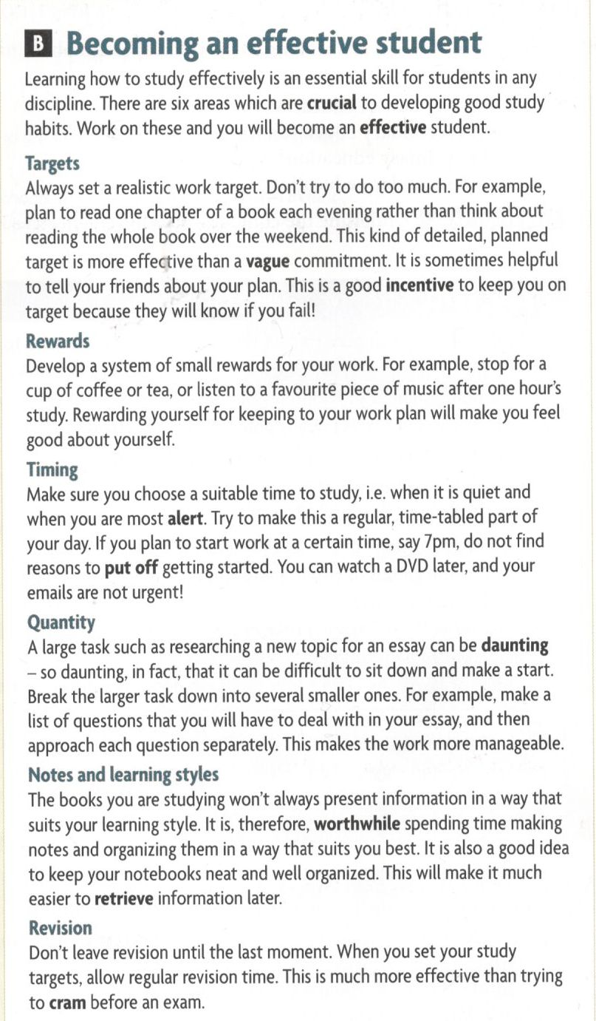

**4a Match the words with their meanings and write the part of speech.**

|  |  |  |
| --- | --- | --- |
| **word from text B** | **part of speech** | **meaning** |
| a crucial (7) | adjective | 1 producing a successful result |
| b effective |  | 2 awake/able to concentrate |
| c vague |  | 3 find (information) again |
| d incentive |  | 4 frightening or worrying |
| e alert |  | 5 something that encourages you |
| f put off |  | 6 study hard in a short time |
| g daunting |  | 7 extremely important |
| h worthwhile |  | 8 delay doing something |
| i retrieve |  | 9 not clear or definite |
| j cram |  | 10 useful |

**4b Play quizlet live to practise the above words.**

<https://quizlet.com/485925207/live>

**4c Complete the sentences below with the words from the box**.

1 Do you tend to _______________studying for an exam until the last moment?

2 What do you think is the most ________________way of studying for an exam?

3 How do you keep yourself _____________, that is awake and able to concentrate?

4 What tasks in your studies do you find _____________, in other words worrying?

5 What would you say was a good ______________to keep you motivated?

**5 Read the text again and write answers to these questions.**

1 How does the writer think you can develop good study habits?

2 Why is it a good idea to tell other people about your work plans?

3 Why does the writer believe it is useful to reward yourself?

4 What makes one time to study better than another?

5 How can a large or complicated piece of work be made easier?

6 What is the main benefit of keeping good class or lecture notes?

7 How does the writer suggest you could improve your revision?

Adapted from Headway Academic Skills, level 3, pp 4 - 5, Oxford University Press, 2011

**Extra:** Write down your target for this course. What would you like to achieve? Make it realistic.

By the end of this course I will be able to...

**6 Jumbled Questionnaire**

**a Can you put the words in the right order to make questions?**

1_________________________________________? do/where/you/study/to/like

a at home b in a library c other place

2 _________________________________________? usually/study/when/you/do

a in the morning b in the afternoon c in the evening d at night

3 _________________________________________? to/study/do/how/prefer/you

a alone b with a friend c in a study group

4 _________________________________________? make/you/notes/do/when you study

a always b usually c sometimes d never

5 _________________________________________? study/many/do /how/you/hours/in a week

a 0 - 2 hours b 3 - 6 hours c 7 - 10 hours d more than 10 hours

6 __________________________________________? make/do/study plan/how often/you/a

a never b every day c every week

**b Summarise your results in writing and share them with your partner**

_________________________________________________________________________

_________________________________________________________________________

_________________________________________________________________________

_________________________________________________________________________

_________________________________________________________________________

_________________________________________________________________________

Source: Headway Academic Skills, level 1, Oxford University Press, 2011

**7 Word Development: Word Formation**

**Complete the text with the right form of the words given in CAPITALS.**

***Remembering for exams***

It’s frustrating for everybody not to be able to remember things but having a bad memory can be a particular

(1)______________(ADVANTAGE) for students at exam time. Anyway, I did a search on the internet and found (2)______________(COUNT) ideas for improving your memory. One idea I thought particularly   
(3) _______________(VALUE) was that we should try and use all our senses when given information to learn. So, for example, instead of reading (4)_____________(SILENT), we should record the material and then listen to it. Apparently, the (5)______________(COMBINE) of speaking and listening helps reinforce (6)____________(WRITE) text. Another theory is that there is a greater (7)___________ (POSSIBLE) of our memorising something (8)____________(SUCCESS) if we do it when the house is (9)_____________(PEACE) and, preferably just before bedtime.

1 Which answers required a) nouns? b) adjectives? c) adverbs?

2 Which answers required a) a suffix? b) a prefix?