**Quantum Chemical Analysis of Isomerization Mechanisms**

**within Acetylene Bromoboration**

Hugo Semrád and Markéta Munzarová

*Department of Chemistry, Faculty of Science, Kamenice 5, CZ-625 00 Brno, Czech Republic*

Haloboration reactions of alkynes represent key elements in many organic synthetic routes, as evidenced in a series of 21 papers by A. Suzuki through 1983-1992.1 During an acetylene bromoboration reaction, (*Z*)-dibromo(2-bromovinyl)borane [**(*Z*)-1**] is formed by the direct addition of boron tribromide to acetylene which undergoes a subsequent isomerization into **(*E*)-1** by means of hydrogen bromide and/or bromine radical (**Fig. 1**).2

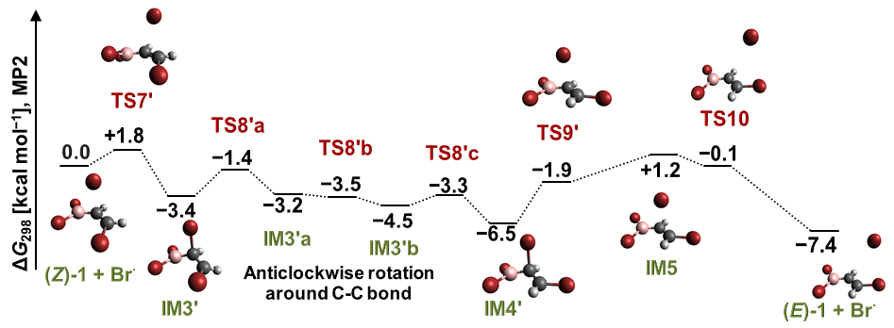

**Figure 1:** *Z*/*E* isomerization of (*Z*)-dibromo(2-bromovinyl)borane caused by a bromine radical.

The results published in 2012 by Wang and Uchyiama3 are in contrast with recent experimental findings obtained in our department.2 The present study concentrates on alternative mechanisms initiated by a reaction of *Z*-alkene with the HBr molecule and with the bromine radical, whose presence is expected due to the interaction with residual air humidity. The calculations show the reaction pathway caused by HBr molecule provides high energy barriers at addition–elimination step whereas the radical isomerization reactions seem more probable because of much lower energy barriers.

[1] Suzuki, A. *Heterocycles* *80* (2010) 15.

[2] Polášek, J.; Paciorek, J.; Stošek, J.; Semrád, H.; Munzarová, M. and Mazal, C. Stereoselective Bromoboration of Acetylene with Boron Tribromide. A Preparation of (*Z*)-Bromovinylboronates. *Journal of Organic Chemistry*. **2020**. **Articles ASAP (Article)** **Publication Date (Web):** May 21, 2020.

[3] Wang, C., Uchyiama, M. *Eur. J. Org. Chem.* (2012) 6548.