**Work and Health - Practical session**

PART A:

In paper from 1998, Bosma et al looked at the role of job control and effort-reward imbalance on incidence of coronary heart disease in Whitehall II study. Please see results summarised in following two pictures:

What would you say about the role of two measures of work stress and its role in developing CHD in this population? Why do you think that researchers used adjusting strategy as shown in the figures?

PART B: Job loss and lower healthcare utilisation due to COVID-19 among older adults across 27 European countries

Please read the abstract of the paper by Ksinan Jiskrova et al (2021) focusing on inequalities in possible job loss during the first phase of COVID-19 pandemic using data from European SHARE study.

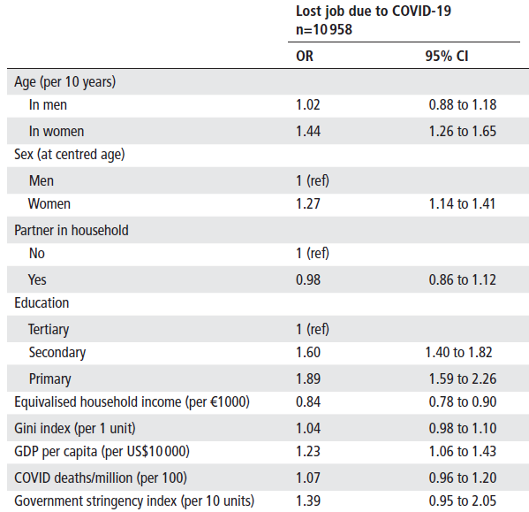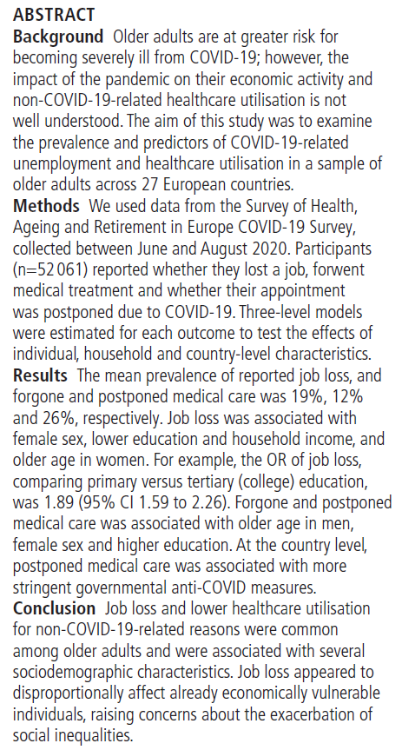

What would be your conclusions on the basis of this abstract and shown results? What would you do the next with the data? What would you plan as the next steps? Are there any possible policy implications?

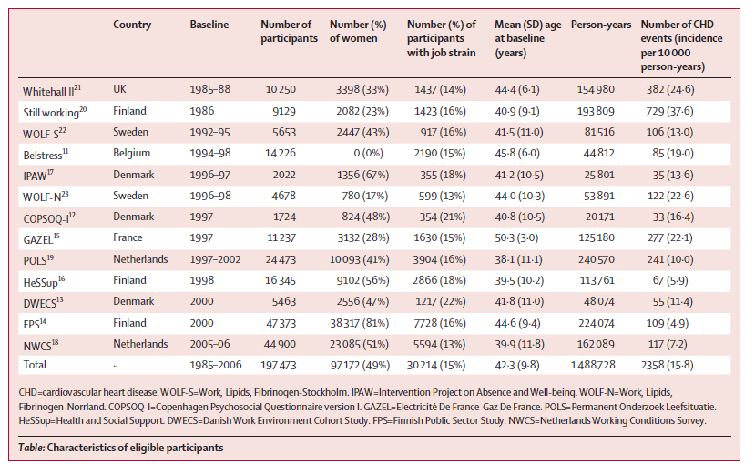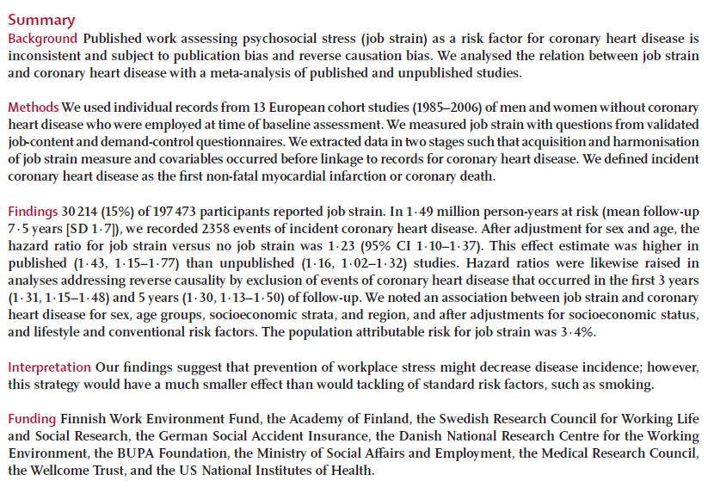PART C: Job strain as a risk-factor for CHD: a collaborative meta-analysis of individual participant data (Kivimaki et al, 2012)

Please read the abstract and look at the descriptive table. Summarize main findings of the study on the basis of the abstract.

Please look at the table on the left side of next page. On the basis of the results shown there do you still believe all the results presented in the abstract being valid summary of findings?

Look at remaining two figures. Why did authors display such figures? Please explain.

The findings of this paper were widely discussed and some researchers were quite critical. What do you think was the main criticism of this paper?

