## **Energy for Our Civilization**

The development of our civilization and the well-being of every single person would not be possible without a big amount of energy. In the past, people used the power of wind, water, wood or animals to support their energy consumption. Everything changed during the Industrial Revolution as the energy needs of humans grew dramatically. This trend has been topical till today.

World primary energy consumption is the total energy amount acquired by humans, typically measured per year. The most important sectors in which the energy is used are transportation, electricity generation, heating and industry. World primary energy differs from the world final energy consumption because much of the energy is lost as other forms of energy during the process of its refinement into usable forms of energy and its transport from its initial place of supply to consumers.

The total primary energy consumption in the world has been growing rapidly in the last 100 years. Today (2018), it is more than 150 000 TWh and still growing. More than 90 % of primary energy is gained by burning fossil fuels (oil, gas and coal), as you can see in the graph. According to IEA (International Energy Agency) data from 1990 to 2008, the average energy use per person increased 10 % while the world population increased 27 %. In total it represents the world overall growth by 39 % (the Middle East increased by 170 %, China by 146 %, India by 91 %, Africa by 70 %, Latin America by 66 %, the United States by 20 %, the European Union by 7 %).

Nowadays it seems clear that the change in the foreseen future is inevitable. First, the fossil fuels supplies are shrinking. The second problem is that the amount of carbon dioxide in the Earth atmosphere is growing with every ton of burned coal, gas or oil and this process affects the climate on the Earth. This is one of the most challenging problems of our civilization. How can we produce enough energy in the future?

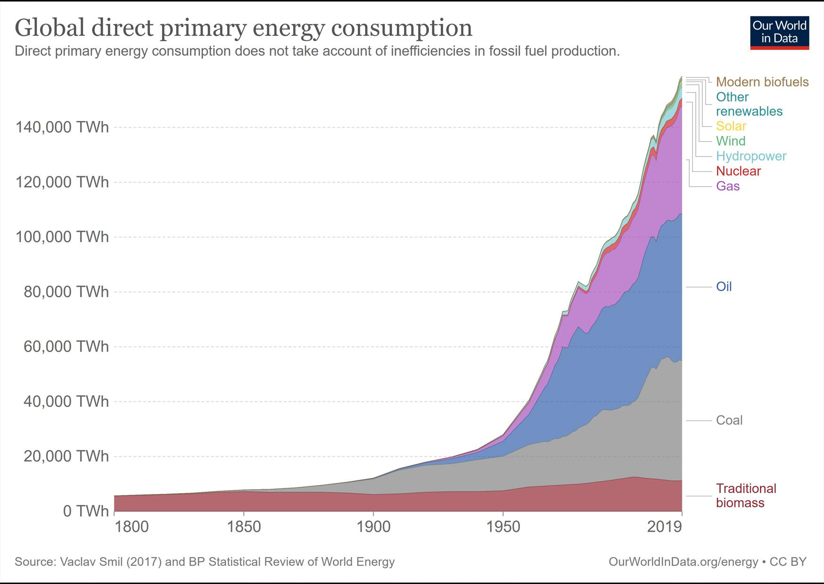

# **Energy for our civilization**

1. Kde spotřebováváme největší množství energie?
2. Z jakých zdrojů získáváme největší množství energie?
3. Jaká byla celosvětová roční spotřeba primární energie?
4. Jaká byla průměrná roční spotřeba energie na jednoho obyvatele planety? V roce 2018 žilo na Zemi cca 7,5 miliardy lidí.
5. Jaký je průměrný příkon (rychlost spotřeby) energie na jednoho obyvatele planety? Výsledek vyjádřete ve wattech.
6. Jaké jsou dva hlavní důvody růstu světové spotřeby energie?
7. Proč není možné dlouhodobě pokračovat v současném trendu a způsobu získávání energie?

***Bonusový úkol:* diskutujte se spolužáky o vašich návrzích, jak problém zajištění dostatku energie do budoucna vyřešit.**