**JAG04 Revision + Reflection**

**Task 1 Use these words in sentences:**

*opinionated*

*misconception*

*displacement*

*remote*

*species*

*debris*

*distract*

*cryosphere*

**Task 2 Conditionals**

**Finish the sentences:**

My English will be perfect if / when…

It would be better for my English if…

I would have learned more this semester if…

**Task 3 Describe these graphs:**

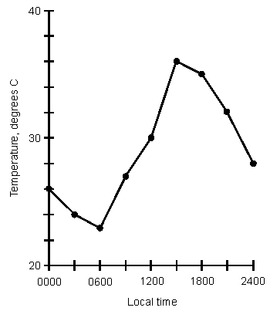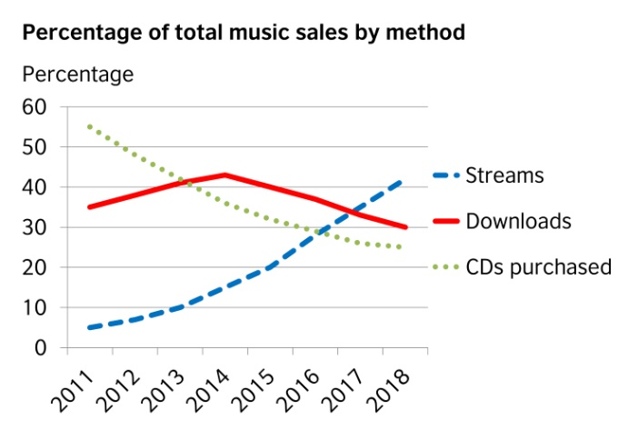

**Task 4 Give examples of…**

* principles of writing an abstract for a presentation
* transition phrases in presentations
* principles of effective presentations

**Task 5 Pronunciation. Can you pronounce the phrases using linking sounds?**

*a war against us*

*something in your eye*

*the Tower of London*

*Never again!*

*Is the loo on the ground floor?*

*Who is she?*

*He grew up so quickly.*

*I want some blue on the poster.*

**Task 6 Swearing**

Research has linked swearing to – among other things – honesty, better vocabulary, better credibility, improved camaraderie with our peers, and helping us process and handle anger.

There was an experiment comparing how long a person can withstand the pain of cold water while being allowed to swear and while using neutral words. What do you think the results suggest?

**Do you know which swearwords we replace with the expressions below?**

Darn!

OMG / Oh my goodness / Oh gosh!

Holy cow!

F-word / Fudge! / freaking good / Are you fricking kidding?

SOB / Son of a gun

**Task 4 Reflection**

**Please, write a few sentences summarising your learning this semester:**

**What have you learned / improved?**

**What would you say was missing?**

**Any other suggestions / comments to the teacher:**