A UNIFIED SYNTHETIC APPROACH TO POROUS HYBRID SINGLE-SITE METALLOSILICATES

Martin Kejik 1, Zdenek Moravec 1, Lucie Simonikova 1, Ales Styskalik 1, Craig Barnes 2, Jiri Pinkas 1

1 Masaryk University, Department of Chemistry, CZ-61137 Brno, Czech Republic; 2 University of Tennessee, Department of Chemistry, Knoxville, TN 37996-1600, USA; corresponding author: jpinkas@chemi.muni.cz

**ABSTRACT:**

A generalized low-temperature non-hydrolytic sol-gel strategy to produce uniformly dispersed metallosilicate sites in highly porous hybrid silicate matrices is reported *(Figure 1)*. The materials can be used either directly as catalysts or as well-defined model systems in the research and development of heterogeneous catalysis. In the procedure, the readily available1,2 spherosilicate molecular building block (Me3Sn)8Si8O20 is cross-linked in two steps by irreversible condensation reactions with high-valence d- and p-block chlorides and alkyl-metals in toluene or THF to form statistically connected rigid amorphous networks. Initially, a limited amount of the metal site precursor (e.g., pyridine-AlCl3,3 Et3N-AlMe3, [Me4N+][AlCl4-],3 ZnEt2, SbCl3, Ph3SbCl2, PCl3, TiCl4,2 VOCl3,1,4) is introduced to an excess of the building block to achieve full condensation and uniformity. A minimum site separation of ≈1 nm is ensured by the bulky building block. In the second step, a limited amount of a ditopic hybrid linker – ClMe2SiCH2CH2SiMe2Cl or ClMe2Si(C6H4)2SiMe2Cl – is added to produce extensively cross-linked gels while maximizing the probability of full condensation. The byproducts of the condensations (Me3SnCl or Me3SnR) are inert and volatile and they do not interfere with subsequent steps. Removal of all volatiles under vacuum affords pure xerogels. Since a kinetically-driven approach and mild conditions are used, a variety of complex sites can be produced, incorporating organic ligands and sensitive moieties (pyridine-Al(OSi≡)3, Sb(OSi≡)3, Ph3Sb(OSi≡)2). The prepared xerogels were characterized by IR and MAS NMR spectroscopies, N2 gas adsorption, gravimetry, STEM/EDS, ICP-OES, and TG/DSC. The fundamental limits of the system and the interplay of parameters, such as site loading, linker flexibility, stoichiometry, and solvent effects, were explored and correlated with structure, condensation, and porosity. Observed precursor reactivity was supported by quantum chemistry DFT calculations on model compounds.

The financial support by GACR Junior 20-03636Y is appreciated. CIISB research infrastructure project LM2018127 funded by MEYS CR is gratefully acknowledged for the financial support of the measurements at the Josef Dadok National NMR Centre.

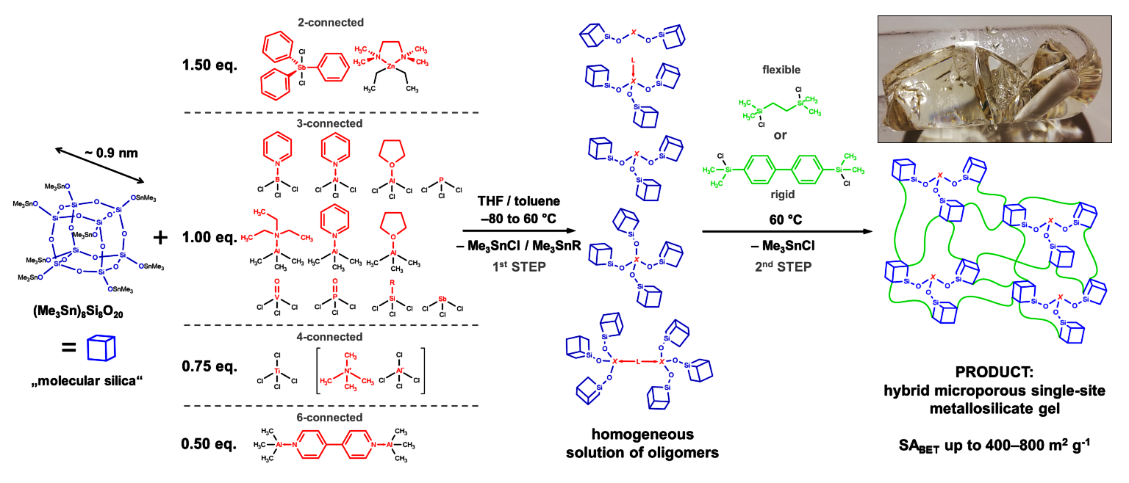

**Figure 1: Generalized reaction scheme**

**References**

1- Ghosh NN, Clark JC, Eldridge GT, Barnes CE (2004) Chem. Commun.: 856–857

2- Clark JC, Barnes CE (2007) Chem. Mater. 19: 3212–3218

3- Styskalik A, Abbott JG, Orick MC, Debecker DP, Barnes CE (2019) Catalysis Today 334: 131–139

4- Lee M-Y, Jiao J, Mayes R, Hagaman E, Barnes CE (2011) Catalysis Today 160: 153–164