**Klonování genu pro glukosa oxidasu z *A. niger***

>AF234246.2:486-2303 Aspergillus niger glucose oxidase (GO2) gene, complete cds

ATGCAGACTCTCCTTGTGAGCTCGCTTGTGGTCTCCCTCGCTGCGGCCCTGCCACACTACATCAGGAGCA

ATGGCATTGAAGCCAGCCTCCTGACTGATCCCAAGGATGTCTCCGGCCGCACGGTCGACTACATCATCGC

TGGTGGAGGTCTGACTGGACTCACCACCGCTGCTCGTCTGACGGAGAACCCCAACATCAGTGTGCTCGTC

ATCGAAAGTGGCTCCTACGAGTCGGACAGAGGTCCTATCATTGAGGACCTGAACGCCTACGGCGACATCT

TTGGCAGCAGTGTAGACCACGCCTACGAGACCGTGGAGCTCGCTACCAACAATCAAACCGCGCTGATCCG

CTCCGGAAATGGTCTCGGTGGCTCTACTCTAGTGAATGGTGGCACCTGGACTCGCCCCCACAAGGCACAG

GTTGACTCTTGGGAGACTGTCTTTGGAAATGAGGGCTGGAACTGGGACAATGTGGCCGCCTACTCCCTCC

AGGCTGAGCGTGCTCGCGCACCAAATGCCAAACAGATCGCTGCTGGCCACTACTTCAACGCATCCTGCCA

TGGTGTTAATGGTACTGTCCATGCCGGACCCCGCGACACCGGCGATGACTATTCTCCCATCGTCAAGGCT

CTCATGAGCGCTGTCGAAGACCGGGGCGTTCCCACCAAGAAAGACTTCGGATGCGGTGACCCCCATGGTG

TGTCCATGTTCCCCAACACCTTGCACGAAGACCAAGTGCGCTCCGATGCCGCTCGCGAATGGCTACTTCC

CAACTACCAACGTCCCAACCTGCAAGTCCTGACCGGACAGTATGTTGGTAAGGTGCTCCTTAGCCAGAAC

GGCACCACCCCTCGTGCCGTTGGCGTGGAATTCGGCACCCACAAGGGCAACACCCACAACGTTTACGCTA

AGCACGAGGTCCTCCTGGCCGCGGGCTCCGCTGTCTCTCCCACAATCCTCGAATATTCCGGTATCGGAAT

GAAGTCCATCCTGGAGCCCCTTGGTATCGACACCGTCGTTGACCTGCCCGTCGGCTTGAACCTGCAGGAC

CAGACCACCGCTACCGTCCGCTCCCGCATCACCTCTGCTGGTGCAGGACAGGGACAGGCCGCTTGGTTCG

CCACCTTCAACGAGACCTTTGGTGACTATTCCGAAAAGGCACACGAGCTGCTCAACACCAAGCTGGAGCA

GTGGGCCGAAGAGGCCGTCGCCCGTGGCGGATTCCACAACACCACCGCCTTGCTCATCCAGTACGAGAAC

TACCGCGACTGGATTGTCAATCACAACGTCGCGTACTCGGAACTCTTCCTCGACACTGCCGGAGTGGCCA

GCTTCGATGTGTGGGACCTTCTGCCCTTCGACCGAGGATACGTCCACATCCTCGACAAGGACCCCTACCT

CCACCACTTTGCCTACGACCCTCAGTACTTCCTCAACGAGCTCGACCTGCTCGGTCAGGCTGCCGCTACT

CAGCTGGCCCGCAACATCTCCAACTCCGGTGCCATGCAGACCTACTTCGCTGGGGAGATACTCCCCGGTG

ATAACCTCGCGTATGATGCCGATTTGAGCGCCTGGACTGAGTACATCCCGTACCACTTCCGTCCTAACTA

CCATGACGTAGGTACTTGCTCCATGATGCCGAAGGAGATGGGCAGTGTTGTTGATAATGCTGCCCGTGTG

TATGGTGTGCGGGGACTGCGTGTCATTGATGGTTCTATTCCTCCTACGCAAATGTCGTCCCATGTCATGA

CGGTGTTCTATGCCATGGCTTTGAAAATTTCGGATGCTATCTTGGAAGATTATGCTTCCATGCAGTGA

**N-HIS,T7-GO2-HIS**

*BamH*1(GGATCC)

*Xho*I(CTCGAG)

5` TCGCGGATCCCTGCCACACTACATCAGGAGCA

5` GGTGCTCGAGCTGCATGGAAGCATAATCTTCCA

**N-HIS,T7-GO2**

*BamH*1(GGATCC)

*Xho*I(CTCGAG)

5` TCGCGGATCCCTGCCACACTACATCAGGAGCA

5` GGTGCTCGAGTCACTGCATGGAAGCATAATCTTC

**N-HIS-GO2**

*NdeI*(CATATG)

*Xho*I(CTCGAG)

5` TATGCATATGCTGCCACACTACATCAGGAGCA

5` GGTGCTCGAGTCACTGCATGGAAGCATAATCTTC

>AAF59929.2 glucose oxidase [Aspergillus niger]

MQTLLVSSLVVSLAAALPHYIRSNGIEASLLTDPKDVSGRTVDYIIAGGGLTGLTTAARLTENPNISVLV

IESGSYESDRGPIIEDLNAYGDIFGSSVDHAYETVELATNNQTALIRSGNGLGGSTLVNGGTWTRPHKAQ

VDSWETVFGNEGWNWDNVAAYSLQAERARAPNAKQIAAGHYFNASCHGVNGTVHAGPRDTGDDYSPIVKA

LMSAVEDRGVPTKKDFGCGDPHGVSMFPNTLHEDQVRSDAAREWLLPNYQRPNLQVLTGQYVGKVLLSQN

GTTPRAVGVEFGTHKGNTHNVYAKHEVLLAAGSAVSPTILEYSGIGMKSILEPLGIDTVVDLPVGLNLQD

QTTATVRSRITSAGAGQGQAAWFATFNETFGDYSEKAHELLNTKLEQWAEEAVARGGFHNTTALLIQYEN

YRDWIVNHNVAYSELFLDTAGVASFDVWDLLPFDRGYVHILDKDPYLHHFAYDPQYFLNELDLLGQAAAT

QLARNISNSGAMQTYFAGEILPGDNLAYDADLSAWTEYIPYHFRPNYHDVGTCSMMPKEMGSVVDNAARV

YGVRGLRVIDGSIPPTQMSSHVMTVFYAMALKISDAILEDYASMQ

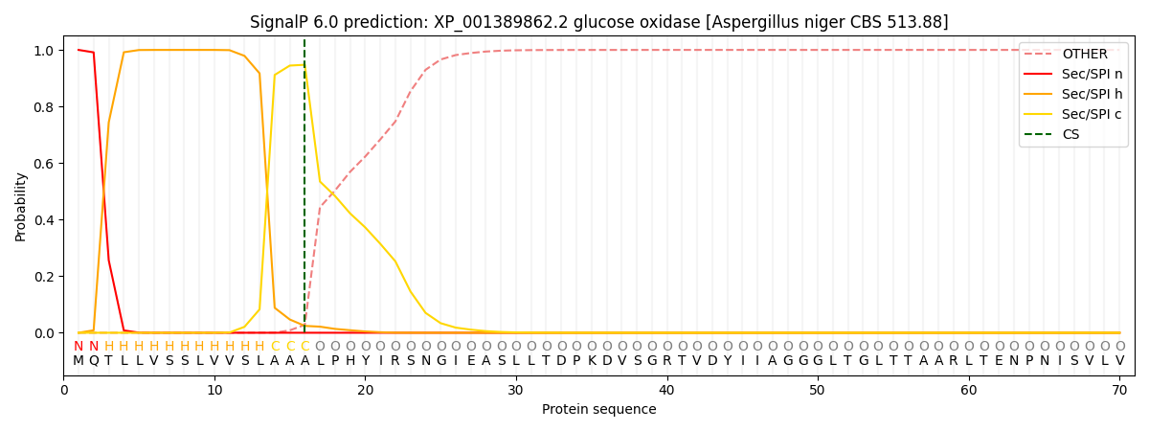

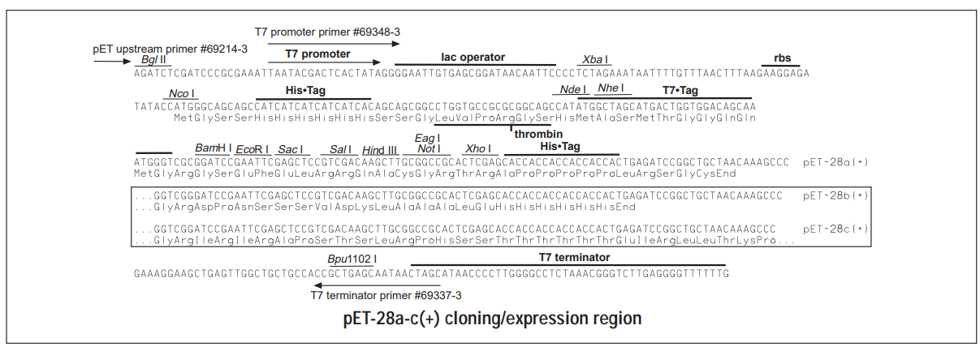

**Amplifikace genu GO2 z gDNA *Aspergillus niger***

Materiál:

Elizyme HS ROBUST MIX RED (Elisabeth Pharmacon)

Primery (viz. přiložený Datasheet):

N-HIS,T7-GO2-HIS (T7-GO2-HIS_FW/GO2-HIS_REV)

N-HIS,T7-GO2 (T7-GO2-HIS_FW/GO2_REV)

N-HIS-GO2 (HIS-GO2_FW/GO2_REV)

Složení PCR reakční směsi (50 ul)

HS ROBUST MIX RED 25.0 ul

FW primer (10 uM) 2.0 ul

REV primer (10 uM) 2.0 ul

PCR voda 16.0 ul

gDNA 5.0 ul

Teplotní protokol:

95°C 2:30 1 x

95°C 10s

60°C 20s 40 x

72°C 50s

72°C 5 min 1 x

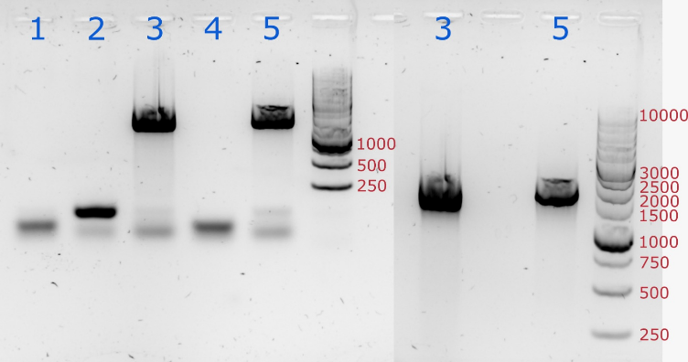

**Přečištění PCR produktu**

Materiál: Monarch® PCR & DNA Cleanup Kit (5 μg) (<https://international.neb.com/-/media/nebus/files/protocols/t1030_quick_protocol_card_monarch_pcrdna_cleanup.pdf?rev=a562d8f1f21741b0ac6d59ea9020cef3&hash=E4845F80E8B2BE925A09DAD6562A41EC>

**Restrikční analýza**

Materiál:

Restriktázy

*Nde*I (<https://international.neb.com/products/r0111-ndei#Product%20Information>)

*Xho*I (<https://international.neb.com/products/r0146-xhoi#Product%20Information>)

*BamH*I-HF (<https://international.neb.com/products/r3136-bamhi-hf#Product%20Information>)

Vektor pET28a

Složení směsi RA (50 ul)

CutSmart buffer (10x) 5.0 ul

PCR produkt/vektor 15 ul

PCR voda 28 ul

NcoI-HF/ BamHI-HF 1.0 ul (10U)

XhoI 1.0 ul (10U)

Teplotní protokol: Inkubace při 37°C po dobu 3 hodin

**Izolace naštěpeného PCR produktu a plasmidu z agarózového gelu**

Materiál: Monarch® DNA Gel Extraction Kit (<https://international.neb.com/-/media/nebus/files/protocols/t1020_quick_protocol_card_monarch_dna_gel_extraction.pdf?rev=09308c01500f43c6a8589b01845765d9&hash=0FD4350A9DE2AEAC84913DB2A00140AF>)

**Ligace PCR produktu do vektoru pET28a**

Materiál: Instant Sticky-end Ligase Master Mix (<https://international.neb.com/protocols/2012/08/27/protocol-transfer-master-mix-to-ice-prior-to-reaction-set-up-mix-tube-by-finger-flicking-before-u>)

Protokol:

1. Transfer master mix to ice prior to reaction set up. Mix tube by finger flicking before use.
2. Combine 100 ng of vector pET28a with a 3-fold molar excess of insert and adjust volume to 5 μl with dH2O.
3. Add 5 μl of Instant Sticky-end Ligase Master Mix, mix thoroughly by pipetting up and down 7-10 times, and place on ice. The sample is now ready to be used for transformation.

**Transformace vektoru po ligaci do NEB 5-alpha E. coli**

Materiál:

NEB 5-alpha Competent E. coli (High Efficiency) (<https://international.neb.com/products/c2987-neb-5-alpha-competent-e-coli-high-efficiency#Product%20Information>)

Protokol:

1. Thaw a tube of NEB 5-alpha Competent E. coli cells on ice for 10 minutes.
2. Add 2 µl of plasmid DNA to the cell mixture. Carefully flick the tube 4-5 times to mix cells and DNA. Do not vortex.
3. Place the mixture on ice for 30 minutes. Do not mix.
4. Heat shock at exactly 42°C for exactly 30 seconds. Do not mix.
5. Place on ice for 5 minutes. Do not mix.
6. Pipette 950 µl of room temperature SOC into the mixture.
7. Place at 37°C for 60 minutes. Shake vigorously (250 rpm) or rotate.
8. Warm selection plates to 37°C.
9. Spread 50-100 µl of each dilution onto a selection plate and incubate overnight at 37°C.