**Unit 5 – Describing and explaining a process - Matrices in Mathematics**

**I Definition and Operations**

***1. a) Look at the matrix below and give names for the parts with arrows:***

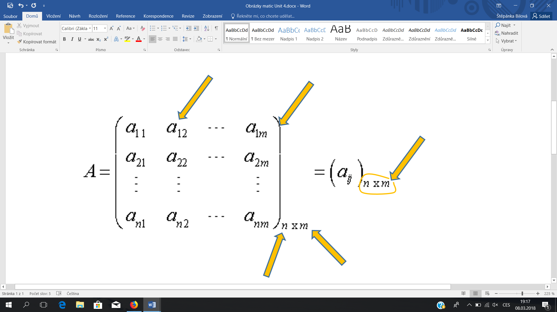

***b) Read the text below and check/complete your answers:***

In mathematics, matrices play a very important role. A matrix is defined as a rectangular array of elements. It is divided into rows and columns which contain numbers or expressions or variables, called elements. A particular row and column corresponds to a certain element. If the arrangement has m rows and n columns, then the matrix is said to be of order (read as by ), or we say that the matrix has the dimension . A matrix is enclosed by a pair of parentheses, i.e. ( ), or square brackets, i.e. [ ], and is denoted by a capital letter. The variables , where index denote the elements or members or entries of a matrix.

Based on: <https://math.tutorvista.com/algebra/matrices.html>

***Basic properties and operations of matrices.***

***2. Read the properties of matrices below and complete the sentences using the word given in brackets to form a word that fits in the gap. Do not use –ing forms. (EXAM PRACTICE)***

1. Addition and _________________ of two matrices is possible only if they have the same order. (SUBTRACT)
2. The _________________ of two matrices A and B is possible if the number of columns of A is equal to the number of rows B. (MULTIPLY)
3. Two matrices are said to be _________________ if they have the same order. (COMPARE)
4. The _________________ inverse of a matrix A is -A. (ADDITION)
5. A square is said to be _________________ if . (SYMMETRY)

***3. Describing a process. Read the time expressions and put the five missing words/phrases in the tables next to their synonyms:***

*while … concludes with prior to this … commences with subsequently*

|  |  |  |  |
| --- | --- | --- | --- |
| Firstly, | The first step is | Secondly, Thirdly, | After this, |
| First of all, | The first stage is | Next, | Further, |
| To begin with, | …begins with | Then, | In the next stage, |
| Initially, |  |  | In the following stage, |
| Beforehand, | Before this, | Later, | Following this, |
| Previously, |  | Eventually, | …until… |
| Once | When this happens | Lastly | …finishes with… |
| At the same time, | During | Finally, |  |
| Simultaneously, |  | In the last stage, | The last step is… |

***3. Speaking in pairs. Choose one operation with matrices, e.g. addition, subtraction, … and explain how it is done.***

### *Compare matrix multiplication with the video. Which property is missing in MM?*

### [*https://www.youtube.com/watch?v=wTUSz-HSaBg*](https://www.youtube.com/watch?v=wTUSz-HSaBg)(4:40 – 6:40)

### *4. There is an example of the matrix multiplication. Read the text and fill in the missing items.*

### multiply dot product product last

## height row width coordinate column

## Ordinary matrix product

The ordinary matrix product is the most often used and the most important way to (1)…………………….. matrices. It is defined between two matrices only if the width of the first matrix equals the (2)………………….. of the second matrix. Multiplying an matrix with an matrix results in an matrix. If many matrices are multiplied together, and their dimensions are written in a list in order, e.g. , the size of the result is given by the first and the (3)…………………….. numbers (), and the values surrounding each comma must match for the result to be defined. The ordinary matrix product is not commutative.

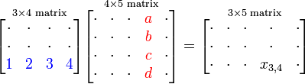

The element of the above matrix (4) …………………….. is computed as follows



## The first (5) …………………….. in matrix notation denotes the (6) …………………….. and the second the column; this order is used both in indexing and in giving the dimensions. The element at the intersection of row and (7) …………………….. of the product matrix is the dot product (scalar product) of row of the first matrix and column of the second matrix. This explains why the (8)…………………….. and the height of the matrices being multiplied must match: otherwise the (9)…………………….. is not defined.

## Text from <https://www.scribd.com/document/36768703/About-Matrices>

***5. Matrices find many applications. Match the first half of sentences with the correct endings.***

|  |  |
| --- | --- |
| 1. Physics makes use of matrices in various domains, for example 2. Graph theory uses matrices to keep track 3. Computer graphics uses matrices to project 4. Serialism and dodecaphonism are musical movements of the 20th century 5. Matrix calculus generalizes classical analytical notions such as 6. Matrices are quite useful 7. Matrices are used in statistics while 8. Matrices have a great importance in economics in | of distances between pairs of vertices in a graph.  in geometrical optics and matrix mechanics.  that use a square mathematical matrix to determine the pattern of music intervals.  functions or exponentials to matrices.  in performing seismic surveys in geology.  3-dimensional space onto a 2-dimensional screen.  the calculation of production of goods effectively.  managing records, drawing graphs and in other calculations. |

**6. Listening. Watch video about an example of matrix application and answer the questions below.** [**https://www.youtube.com/watch?v=3ysnWTtni_4**](https://www.youtube.com/watch?v=3ysnWTtni_4)

1. What does the matrix P describe?
2. What does the matrix Q describe?
3. What does the product PxQ tell us?
4. What helped the speaker to figure out what the product meant?

**7. *Work out the following problems.***

a) Mary found that her new car averaged 18.2 per miles per gallon the first week, 19.0 the second week, 17.6 the third week, and 18.5 the fourth week. Write this information as a row matrix and then as a column matrix.

b) Joan‘ s scores on the first three tests in her math class were 82, 77, and 85. Paula scored 91, 80, and 82 on the same three tests. Janet‘ s scores on the three tests were 90, 82, and 79. Write this information as a 3x3 square matrix in two different ways.

c) Richard Marcias bought 7 shares of Sears stock, 9 shares of IBM stock, and 8 shares of Chrysler stock. The following month, he bought 2 shares of Sears stock, no IBM, and 6 shares of Chrysler. Write this information first as a 3x2 matrix and then as a 2x3 matrix.

d) Margie Bezzone works in a computer store. The first week she sold 5 computers, 3 printers, 4 disc drives, and 6 monitors. The next week she sold 4 computers, 2 printers, 6 disc drives, and 5 monitors, Write this information first as a 2x4 matrix and then as a 4x2 matrix.

***8. Language of mathematics:***

***a) Make the plurals:***

|  |  |
| --- | --- |
| matrix |  |
| index |  |
| radius |  |
| vertex |  |
| apex |  |
| calculus |  |
| polyhedron |  |
| axis |  |

***b) Read this notation.***



**9. HW week 6 – Prepare a monologue for the JA001 (B1) exam for the topic 2 – Describe and explain a process related to your field of study.**

**Do not forget about the three-part structure and language for the process description.**