**Unit 9 CLIL – Getting ready to teach**

**Task 1 What makes a great (CLIL) lesson?**

**Teacher´s checklist:**

**-**

**-**

**-**

**Task 2 Designing a lesson**

**→ → → →**

***ACTIVITIES (cognition)***

***CONTENT***

***LANGUAGE SCAFFOLDING (communication)***

***MATERIALS***

**Task 3 CLIL LESSON / ACTIVITY PLAN**

**Topic:**

**Level / Age:**

**Key competences:**

**Content objectives:**

**Language objectives:**

**Teaching strategies / Task(s) description:**

|  |  |  |  |  |
| --- | --- | --- | --- | --- |
| **Activity / timing** | **Aims and objectives** | **Materials** | **Procedure** | **Interaction / seating** |
|  |  |  |  |  |

**Cummins´s matrix**

(Cummins, 2000)

Any teaching and learning situation has, at its heart, a body of content that needs to be delivered to the learner. Teachers should ideally act as facilitators in this process. Cummins´s matrix offers a useful framework for teachers to make strategic decisions about support for their classes.

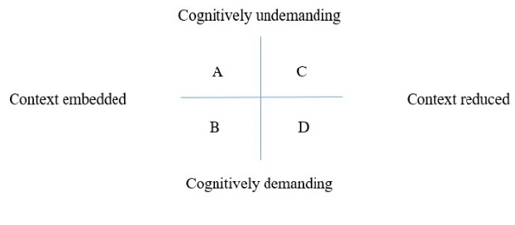

**Note:** The term ´context´ here can mean previous experience of the content, visual materials to enable learners to make connections between new content and something tangible; or it can be very specific and simple language of the content.

Quadrant …………….. is sometimes also referred to as ´the zone of proximal development´.

Quadrant ……………. represents boredom.

Quadrant …………… represents frustration or anxiety.

Quadrant ………..….. represents comfort zone.

**What does ´language in CLIL´ refer to?**

In CLIL, we can identify the following categories:

* vocabulary
* grammar (e.g. tenses, conditionals, comparatives and superlatives, etc.)
* discourse markers (e.g. linking words)
* language functions (e.g. phrases for agreeing, phrases for talking about cause and effect, phrases for comparing, etc.)
* language skills (e.g. giving a presentation or poster, writing a report)

**What kind of language support can we provide for students in CLIL lessons?**