**JAT04 Unit 4 Intelligence**

**Task 1 Warm-up**

1. **Give as many synonyms to “intelligent” and “unintelligent” as possible.**
2. **Identify idioms in the sentences below. Is their meaning ´crystal clear´?**

“I’ve been working with the new software for hours, but I still can’t make heads or tails out of it.“

“Carlos failed his third test this week. – Well, he´s not the sharpest tool in the shed, is he?“

“I hear you gave Emma the same present as me — great minds think alike!“

"My wife's grandmother's maiden name? I **don't have a clue!**"

"There's no need to repeat the instructions. They were **crystal clear**."

"I didn't know our neighbour was an escaped prisoner until the police arrived **- ignorance is bliss**!"

"The new system has a long **learning curve** so we'll have to give the staff time to get used to it."

1. **What is intelligence? What contentious issues arise relating to the concept of IQ?**
2. **Identify the main point of each of the paragraphs below. Are any of your ideas from C mentioned?**
3. According to some researchers, the “cultural specificity” of intelligence makes IQ tests biased towards the environments in which they were developed – namely white, Western society. This makes them [potentially problematic](http://nrcgt.uconn.edu/newsletters/winter052/) in culturally diverse settings. The application of the same test among different communities would fail to recognise the different cultural values that shape what each community values as intelligent behaviour.
4. [Binet-Simon Scale](https://link.springer.com/referenceworkentry/10.1007%2F978-0-387-79061-9_2783#page-1) (1905) became the basis for modern IQ testing. Ironically, Binet actually thought that IQ tests were [inadequate measures](https://www.jstor.org/stable/20298432) for intelligence, pointing to the test’s inability to properly measure creativity or emotional intelligence.
5. Some districts in the US have recently employed a [maximum IQ score](http://abcnews.go.com/US/court-oks-barring-high-iqs-cops/story?id=95836) for admission into the police force. The fear was that those who scored too highly would eventually find the work boring and leave – after significant time and resources had been put towards their training.
6. In 1927, an infamous ruling by the US Supreme Court legalised forced sterilisation of citizens with developmental disabilities and the “feebleminded,” who were frequently identified by their low IQ scores. Those in the US who were forcibly sterilised were disproportionately poor or of colour.
7. IQ tests may be a more objective way to identify children who could benefit from special education services. This includes programmes known as [“gifted education”](http://www.nber.org/papers/w21519) for students who have been identified as exceptionally or highly cognitively able. Ethnic minority children and those whose parents have a low income, are [under-represented](http://gcq.sagepub.com/content/30/2/93) in gifted education.

(adapted from <https://geneticliteracyproject.org/2017/11/16/measuring-intelligence-iq-problems-present/>)

**Task 2 Video: Theories of Intelligence**

(https://www.youtube.com/watch?v=oaJ01Ex7DLw)

**Watch the video. Complete the table below and answer the question below.**

***Is there one general intelligence or multiple intelligences?***

|  |  |  |  |  |
| --- | --- | --- | --- | --- |
| **Theory** | **Theorist** | **Summary** | **Strengths / Evidence** | **Problems** |
|  | Charles Spearman |  |  |  |
|  | L.L. Thurstone |  |  |  |
|  | Howard Gardner |  |  |  |
|  | Robert Sternberg |  |  |  |

**Task 3 Multiple Intelligence**

In 1983 an American developmental psychologist Howard Gardener described 9 types of intelligence:

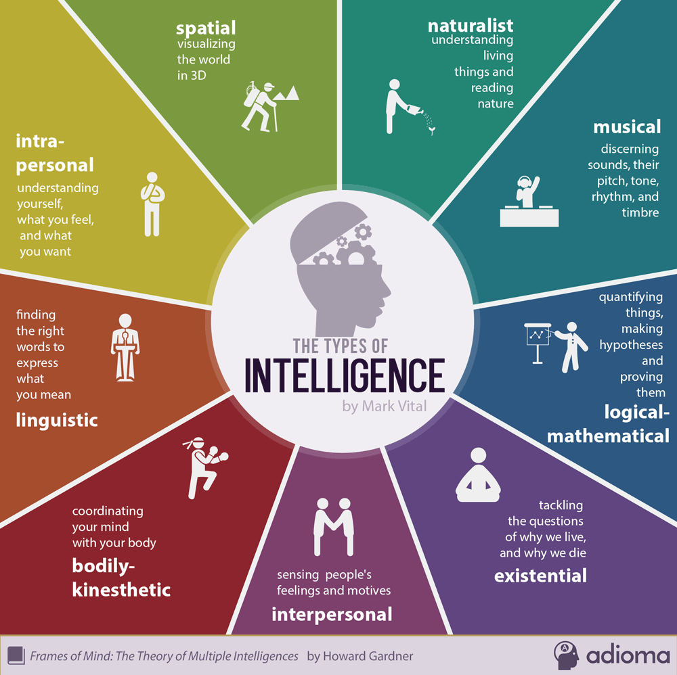

1. **How would you score in a MI test? What are the implications for your studies?**
2. **Choose a type of intelligence and think of teaching activities, teaching materials and instructional strategies suitable for those particular types.**

*E.g. Intrapersonal intelligence*

*- Activities: individualized instruction, options in the course of learning, autonomous learning*

*- Teaching materials: self-study materials, journals, materials for projects*

*- Instructional strategies: connect it to your personal life, reflect on it*

**Task 4 Word formation**

1. **Using prefixes**

**Choose one of the prefixes below to form adjectives that would fit into the sentences.**

*un- in- im- dis-*

1. This job will provide you not only with a decent salary but also with …………. (valuable) experience.
2. Their methods not ……………. (similar) to those of government schools, except that there are uniforms.
3. The headmaster made a few ……………. (popular) decisions.
4. We believe you have been ……………. (honest) with us and that some of the details on your CV are false.
5. Their estimate of the cost of the project was wildly …………….. (accurate).
6. Some of the kids in my class are so …………… (mature) – they are always doing silly things.
7. **Using common prefixes**

**Match each prefix in bold in sentences 1-5 to its meaning a-f.**

1. *again b) too much c) not enough d) wrong e) between f) many*
2. The decision to **re**locate manufacturing to another country is usually a financial one.
3. **Multi**-national companies have more than one base for their operations around the world.
4. **Mis**management of the forest caused many of the native trees and plants to disappear.
5. The two electrical systems are **inter**connected by a high voltage cable that runs under the sea.
6. Many of the employees feel that they are **over**worked and **under**paid.
7. **Complete the sentences with the correct prefix from B.**
8. The product was …………*priced* and as a result sales were very low.
9. Many parts of the city are ………..*populated* and there is not enough housing for everyone.
10. The prospects for a …………-*skilled* engineer are better than for an engineer who concentrates only on one area, like mechanical engineering.
11. In the experiment, the researchers ……………..*created* the conditions of the desert in the laboratory.
12. The two branches of geography – physical and social – are closely ……..*related*.
13. The word *occurrence* is often ………… *spelled* by many native speakers of English.

(Task 4 B,C adapted from Dummett, P. & Hird, J. *Oxford EAP.* OUP, 2015.)