Presentation title:

**Synthesis of porous inorganic matrices by nonhydrolytic sol-gel methods**

## Petr Machac,1 Ales Styskalik,1 Zdenek Moravec,1 Jiri Pinkas1

1 Department of Chemistry, Faculty of Science, Masaryk University, Kotlarska 2, 61137 Brno, Czech Republic

Abstract

Catalysts play a crucial role in meeting increasingly stringent ecological demands. They also reduce the costs in the industrial sector, enabling chemical processes by lowering the activation energy and enhancing economic viability. However, many of the catalysts currently employed in the industry are simple inorganic systems with poorly characterized mechanisms of action, limiting their development. Additionally, these catalysts often suffer from heterogeneity and phase separation issues.1

Conventional synthesis methods for heterogeneous catalysts typically yield crystalline materials with microporosity (<2 nm), which disallow to transform bulky organic substrates.2 The nonhydrolytic sol-gel approach allows the production of kinetically amorphous products with mesoporosity (2-50 nm). The use of nonhydrolytic sol-gel synthesis also improves the homogeneity of mixed oxides.3

Our research is focused on synthesis of heterogenous catalysts with tunable properties. Thanks to the organic-inorganic hybrid character of final material we can control the porosity or influence the hydrophobicity, figure 1. Three major groups of materials were investigated, aluminum phosphonates, zirconium phosphonates and zirconium silicates. The aluminum centers act as small and hard Lewis acid while the zirconium centers exhibit softer behavior.4,5 This determines their application as acid/base catalysts. However, due to variations in the active sites (such as geometry and coordination number), selectivity may be compromised. The possibility of synthesis of well-defined zirconium sites in silica was explored to avoid this issue. The zirconium centers were built by bottom-up methods from molecules. Each zirconium atom is covalently bonded to 2, 3 or 4 bulky and rigid silicate molecules which ensure the uniformity of active sites. To evaluate their activity, all materials were tested in model catalytic reactions.   
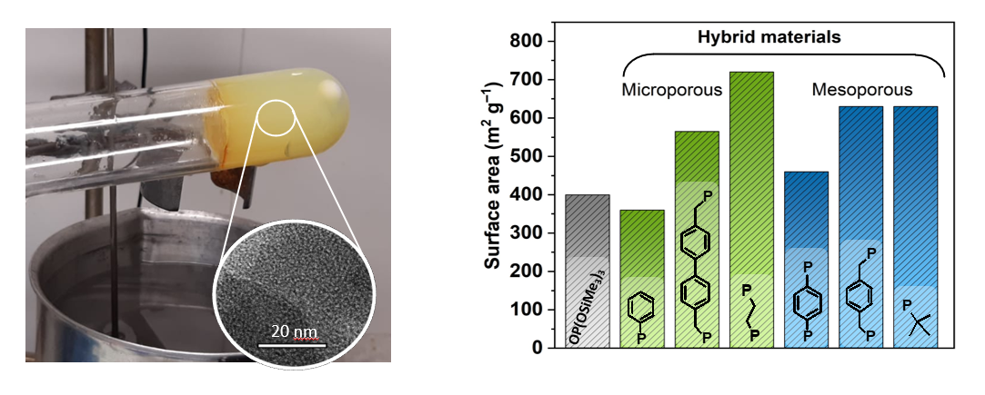

**Figure 1** The TEM image of porous structure of xerogel (left) and surface areas of zirconophosphonates (right)

Acknowledgement

The work has been financially supported by the Czech Science Foundation under the project GJ20-03636Y and by the Grant Agency of Masaryk University under grant project number MUNI/J/0007/2021.

References

(1) Hensen, E. J. M.; Poduval, D. G.; Magusin, P. C. M. M.; Coumans, A. E.; Veen, J. A. R. va. Formation of Acid Sites in Amorphous Silica-Alumina. *J. Catal.* **2010**, *269* (1), 201–218. https://doi.org/10.1016/j.jcat.2009.11.008.

(2) Taddei, M.; Sassi, P.; Costantino, F.; Vivani, R. Amino-Functionalized Layered Crystalline Zirconium Phosphonates: Synthesis, Crystal Structure, and Spectroscopic Characterization. *Inorg. Chem.* **2016**, *55* (12), 6278–6285. https://doi.org/10.1021/acs.inorgchem.6b00943.

(3) Styskalik, A.; Skoda, D.; Barnes, C.; Pinkas, J. The Power of Non-Hydrolytic Sol-Gel Chemistry: A Review. *Catalysts* **2017**, *7* (6), 168. https://doi.org/10.3390/catal7060168.

(4) Machac, P.; Alauzun, J. G.; Styskalik, A.; Debecker, D. P.; Mutin, P. H.; Pinkas, J. Synthesis of High Surface Area Aluminophosphate and -Phosphonate Xerogels by Non-Hydrolytic Sol-Gel Reactions. *Microporous Mesoporous Mater.* **2021**, *311*, 110682. https://doi.org/10.1016/j.micromeso.2020.110682.

(5) Hradsky, D.; Machac, P.; Skoda, D.; Leonova, L.; Sazama, P.; Pastvova, J.; Kaucky, D.; Vsiansky, D.; Moravec, Z.; Styskalik, A. Catalytic Performance of Micro-Mesoporous Zirconosilicates Prepared by Non-Hydrolytic Sol-Gel in Ethanol-Acetaldehyde Conversion to Butadiene and Related Reactions. *Appl. Catal. A Gen.* **2023**, *652*, 119037. https://doi.org/10.1016/j.apcata.2023.119037.