FOLIC ACID-BASED SUPERGELATORS: MECHANICALLY ROBUST SELF-HEALING METALLOGELS

Mahya Asgharian Marzabad,*,1,2 Sami Hietala,3 Nonappa,4 Radek Marek,1,2 Ondřej Jurček1,5

1 CEITEC − Central European Institute of Technology, Masaryk University, CZ-62500 Brno, Czechia

2 Department of Chemistry, Faculty of Science, Masaryk University, CZ-62500 Brno, Czechia

3 Department of Chemistry, University of Helsinki, P.O. Box 55, FI-00014 Helsinki, Finland

4 Faculty of Engineering and Natural Sciences, Tampere University, FI-33720, Tampere, Finland

5 Department of Natural Drugs, Faculty of Pharmacy, Masaryk University, 61200 Brno, Czechia

* 491183@mail.muni.cz

Metallosupramolecular gels offer an exclusive combination of metal–ligand coordination and supramolecular chemistry with exceptional adaptivity and elasticity. Majority of metallogels are based on carefully designed ligands using extensive chemical synthesis and their gelation is often limited to a specific type of metal ion [1]. The metal-ligand coordination can lead to a primary assembly forming a one-dimensional scaffold or can cross-link the available one-dimensional molecular assembly into a two-dimensional or three-dimensional complex network. Metallogels offer multi-responive behaviour by readily undergoing gel ↔ sol transition [2]. This can result in tuneable stiffness, adaptivity, and orderliness of gels. Here, we show that naturally abundant and readily available folic acid (FA) acts as a supergelator in the presence of a wide range of metal salts. We have tested gelating properties of FA with an array of chlorides, nitrates, and acetates of monovalent, divalent and trivalent metal ions at concentrations of 0.2 wt% or lower. Our systematic investigation resulted in a set of 17 mechanically robust metallogels (Figure 1). Using oscillatory rheological measurements, we show that the gels undergo rapid recovery and self-healing. The gels recover up to 95% of their original stiffness within 60 s. Among studied metallogels, FA-chromium(III) acetate at 0.4 wt% gel displayed highest stiffness with a storage modulus of 4.5 kPa. Results suggests that the stiffness, recovery, and sol ↔ gel transitions are readily tuned either by changing the metal ions or counter anions. This study defines the FA as a powerful sustainable building block for the chemistry of soft functional materials. Metallogels from biologically important, natural building blocks can find broad uses in mechanically tunable multi-responsive soft materials.

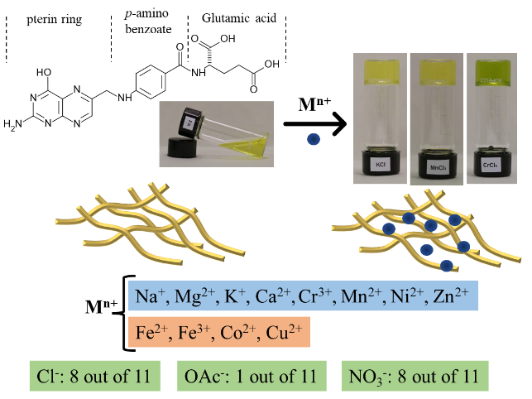

**Figure 1.** Graphical Abstract

[1] P. Dastidar, S. Ganguly, K. Sarkar, Metallogels from Coordination Complexes, Organometallic, and Coordination Polymers, *Chem. Asian J*., 2016, **11 (18)**, 2484–2498.

[2] R. Tatikonda, S. Bhowmik, K. Rissanen, M. Haukka, M. Cametti, Metallogel formation in aqueous DMSO by perfluoroalkyl decorated terpyridine ligands, *Dalton Trans.*, 2016, **45**, 12756–12762.