Porphyrin-Flavonol Hybrid Molecules for Efficient Delivery of CO
Andrea Ramundo,^{1, 2} Jiří Janoš,³ Lucie Muchová,⁴ Mária Šranková,⁴ Libor Vítek,⁴ Petr Slavíček,³ Petr Klán^{1, 2 ,*}

¹Department of Chemistry, Faculty of Science, Masaryk University, Kamenice 5, 62500, Brno, Czech Republic. ²RECETOX, Faculty of Science, Masaryk University, Kamenice 5, 62500, Brno, Czech Republic. ³Department of Physical Chemistry, University of Chemistry and Technology, Technická 5, 16628 Prague 6, Czech Republic. ⁴Institute of Medical Biochemistry and Laboratory Diagnostics, and 4th Department of Internal Medicine, General University Hospital in Prague and 1st Faculty of Medicine, Charles University, Na Bojišti 3, 12108 Prague 2, Czech Republic. E-mail: andre.ramundo@gmail.com

Since carbon monoxide (CO) has been recognized as a gas signaling molecule with attractive properties and considerable potential as a therapeutic agent, light-activated CO-releasing molecules (photoCORMs) soon emerged as the keystone for controlled, targeted delivery.^{1,2} Although many photoCORMs have been proposed, the need for full water solubility, harmless red to near infrared light activation, and high quantum efficiency is still preventing their widespread adoption. In this study, we present a novel class of photoCORMs based on a central light harvesting porphyrin covalently combined with four flavonol-based, CO releasing appendices.³ Multiple CO molecules are released upon irradiation with red light (up to 670 nm) in both methanol and water solution. A facile metal insertion is used to modulate the photoproperties to the extent that uncaging cross sections (Φ_{CO}ε_{max}) exceeding 10⁴ M^{–1}cm^{–1} became accessible. The system biocompatibility has been tested in vitro, and a proton-coupled energy transfer (PCEnT)⁴ mechanism has been proposed, supported both experimentally and thorough quantum-chemical calculations.
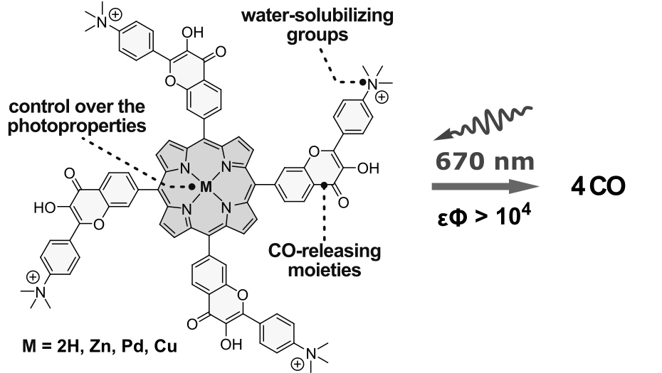
References
- Verma, A.; Hirsch, D.; Glatt, C.; Ronnett, G. Science 1993, 259, 381-384.
- Motterlini, R.; Otterbein, L. E. Nat. Rev. Drug Discov. 2010, 9, 728-743.
- Studer, L. S.; Brewer W. E.; Martinez, M. L.; Chou, P. J. Am. Chem. Soc. 1989, 111, 7643-7644.
- Rimgard, B. P; Tao, Z.; Parada, G. A.; Cotter L. F.; Hammes-Schiffer, S.; Mayer J. M.; Hammarström, L. Science 2022, 377, 742-747.

