**Synthesis and Application of Unsubstituted Bambus[n]urils**

*Jacopo Torrisi,1,2 Pia Jurček,1,2 Vladimír Šindelář*,1,2*

*1Department of Chemistry and 2RECETOX, Faculty of Science, Masaryk University, Kamenice 5, 625 00 Brno, Czech Republic,*

[*jacopo.torrisi@mail.muni.cz*](mailto:jacopo.torrisi@mail.muni.cz)

Bambusurils (BUs) are a family of macrocyclic anion receptors formed by four or six glycoluril units, presenting alternating conformations with two methine hydrogen atoms pointing towards the cavity and connected by methylene bridges. During the macrocyclization reaction, it is possible to form four- and six-membered rings, but only bambus[6]urils can bind anions inside their cavities due to their size.

So far, only a few examples of enantiomerically pure bambus[6]urils have been reported.1,2 Here, we present two synthetic routes for the synthesis of enantiomerically pure bambus[6]urils. Both strategies employ the chiral auxiliary (*S*)-1-phenylethylamine.3

In the first route, diastereomerically pure glycolurils are orthogonally protected followed by macrocyclization to yield enantiomerically pure bambus[6]urils (**BU3**). The second route involves post-macrocyclization modification of diastereomerically pure bambus[6]uril (**BU1**), where the (*S*)-1-phenylethyl groups are cleaved off to obtain unsubstituted bambus[6]uril (**BU2**), which serves as a key intermediate for further functionalizations. The successful synthesis of enantiopure bambus[6]urils opens up new possibilities for their applications in host-guest chemistry, molecular recognition, and transmembrane transport.

Furthermore, considering their potential biological applications,4 we aim to expand the family of transmembrane receptors based on post-macrocyclization modification of BU2 aiming at formation of anionic channels.

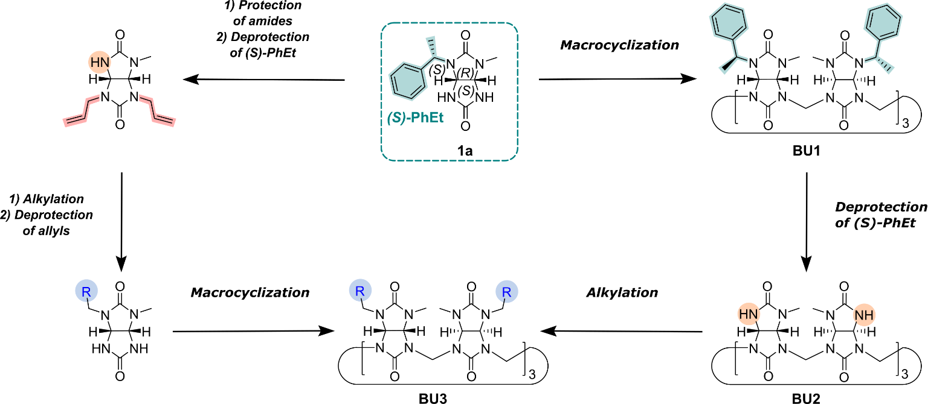

1. Sokolov, J.; Šindelář, V. *Chemistry-A European Journal*, **2018**, *58*, 15482-15485.
2. Sokolov, J.; Štefek, A.; Šindelář, V. *ChemPlusChem*, **2020**, *85*, 1307-1314.
3. Slávik, P.; Torrisi, J; Jurček, P; Sokolov, J; Šindelář, V. *manuscript submitted*.
4. Jentsch, T. J.; Maritzen, T.; Zdebik, A. A. *J. Clin. Invest.* **2005**, *115*, 2039– 2046.