**Teeth in Bioanthropology – Spring 2024**

**Teeth & Evolution – 13/03/2024**

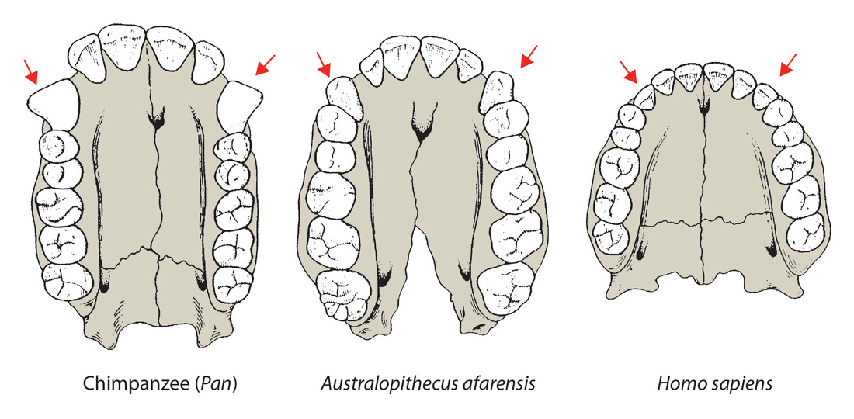

**A B C**

**Examine the teeth of each of the upper jaws shown in the figure above and record your observations in the table below:**

|  |  |  |  |
| --- | --- | --- | --- |
|  | Number of teeth | | |
| Characteristic | A | B | C |
| Incisors |  |  |  |
| Canines |  |  |  |
| Premolars |  |  |  |
| Molars |  |  |  |
| Tooth row parallel? |  |  |  |
| Primate Name? |  |  |  |

**Common points? Big differences?**