Protocol of embryology - lesson 10 Name:

Gastrointestinální trakt

GIT, kidney

25.4.2024

**Oesophagus, stomach**

1. H.S.S. in the slides from 8. a 16. week i.u.d. find oesophagus. How did you distinguish it? What is the second tube beside oesophagus?
2. T.E.18d, M.M. E12: Compare layers of stomach of these slides with the adult human slide, and write down, what are the main differences.
3. G.G. HH28 Find the stomach, and distinguish if it is proventriculus or gizzard.



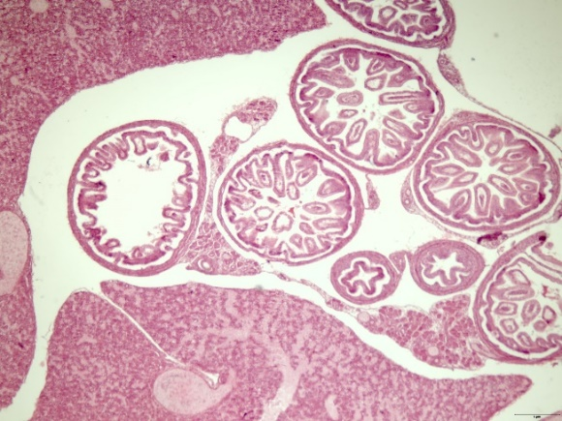**Intestine:**

1. H.S.S. slides set of small intestine 11th week till adult: When the diameter   
   of lumen gets increased so the villi are not filling it completely?   
   When you can find for the first time the layer of smooth muscle cells?

2

1

3

4

5

6

1. H.S.S. In the slide of large intestine from 10th week can you see all the  
    layers? How would you decide if it is large or small intestine? What   
   numbers are the large intestines?
2. D.R. 5 days PC (embryo with arrow) - what layers can you distinguish in the intestine?

**Liver:**

1. HSS 6th week – adult: Find the hematopoietic cells and assess their approximate number. Can you find the portal tridade?
2. Compare the liver of H.S.S. 6th week iud and M.M. E12 and G.G. HH20. Are they similar? Should they be similar?
3. G.G. HH 20, 28: Describe the morphological features of developing liver.



**Pancreas:**

1. H.S.S. 11., 22. iud, adult: Find the Langerhans islets on all the slides and count what number of cell creates them.
2. H.S.S. Judge if the slide from the 22nd week of iud is the more similar to younger or older embryo.
3. Compare M.M. E14,5 d and HSS 11. week iud and describe morphological differences. What is the more progressed stadium?



**Kidney**

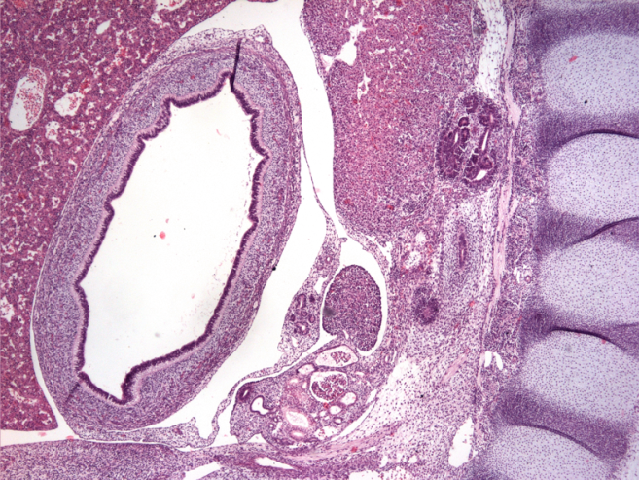

**1**

**2**

**3**

**5**

**4**

1. H.S.S What are the numbered organs?

1

2

3

4

**6**

5

6

14. G.G. Find kidney at HH 20-28 and try to decide what developmental stage they are. Is there any difference between cranial and caudal part?

15. M.M. What is the developmental stage of kidney of E12.

16. T.E. What is the difference of adult H.S.S. kidney and kidney of T.E. 27d (before the birth)?



**Adrenals, urinary tract**

17. HSS: Decide, whether the layers of 14th week of iud are more similar to adult adrenals or the 7th week old embryo. What are the clusters of highly hematoxylin stained cells in the 14th week embryo?

18. GG HH28 Find the adrenal gland. How many layers can you distinguish? What is missing?

19. T.E. 27D What kind of epithelium we can see in the bladder of this embryo? Compare it with the stomach nearby.

20. What is the difference between ureter and uretra – label the scheme parts.