**Chimera X**

**Open the file with the structure**

***open*** PDB ID ***open 5O1Z*** (Nrd1, RNA)

***open*** Desktop/Name.pdb(mrc,cxs,etc.)

File -> Open

**Movements (using mouse)**

**Left-click-holding** - rotate the structure about the vertical and horizontal axis  
**Right-click-hold** - move the centre of the protein about the screen

**Sequence viewer**

* **Tools** -> **Sequence** -> **Show sequence viewer**
* **Log window** -> Click on the link in the Chain information table
* **Molecule Display (Analysis section)** -> **Sequence** A screenshot of a computer

  Description automatically generated

**Model panel**

color

Model ID

select

**Structure depiction**

* Actions - > Atoms/Cartoon/Surface…hide/show
* **show** atoms/cartoon/surface  **hide** atoms/cartoon/surface

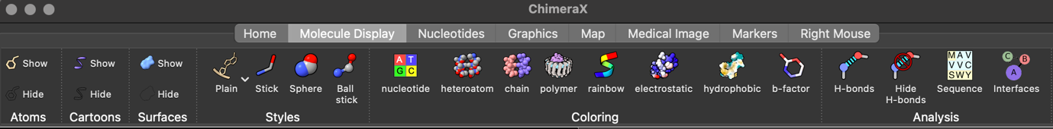

**Select**

* Ctrl/(Ctrl+Shift) + LeftMouse
* Select -> Chains, Chemistry,…
* Sequence viewer
* ***sel***

**Nomenclature**

**#1** => model ID ***sel #1*** (model/structure 1)

**/A** => chain ***sel #1/A*** (model/structure 1, chain A)

**:400** => residue number

***sel #1/A:464*** (one residue nr. 464) **- show atoms**

***sel #1/A:373-414*** (residues from 373 to 414)

***sel #1/A: 373-414 &:arg*** (residues from 373 to 414 that are arginines) **- show atoms**

***sel #1/A:378, sel #1/A:342, sel #1/A:376*** (residue 378, 342, 376)**- show atoms**

**:arg** => all arginines in the selection

**@** => atom specifier (e.g. @ca). ***sel #1/A@ca*** or ***sel #1/A:400-450@ca***

**Color**



* Actions -> Color
* ***color*** [what] [color] ***color #1/A red***

from **N-term** to **C-term**

**Zoom**

* ***zoom* 1.5**
* mouse -> spinning the middle wheel

**Hbond**



* Tools -> Structure analysis-> H-Bonds
* ***hbonds hbonds*** or ***hbond #1/B*** *or* ***hbond ligand***
* ***hide*** hbonds

**Contacts**

* Tools -> Structure analysis-> Contacts
* ***contacts***

**contacts #1/A@C* restrict #1/B@C* distance 3.8 reveal true name vdW**

**Distance/angles**

* Tools -> Structure analysis-> Distance

**ctrl+shift** and pick the two/three atoms of interest

(Model panel -> distances + distances labels – editing)

**Surface**



* Actions -> Surfaces-> hide/show
* Tools -> Depiction -> Surface Color ….by electrostatics -> Key. (remove from model panel)

**NMR vs Crystallography**

**NMR** -> bundle of structures (***open 2li8***)

Tools -> Structure analysis -> Matchmaker

Crystalography -> ***delete*** solvent

**Hide/delete**

* Actions -> Atoms/Bonds -> Delete
* ***del del #1/A:400-450***
* Actions -> Atoms/Bonds, Surface,… ->Show/Hide
* ***hid*e** [what]

**Save**

File -> Save (cxs, pdb,…)

**Tutorials**

<https://www.cgl.ucsf.edu/chimera/tutorials.html>

<https://www.cgl.ucsf.edu/Outreach/Tutorials/GettingStarted.html>