R output | Regression line formula | β-coefficient significance and the model significance | Model evaluation criteria
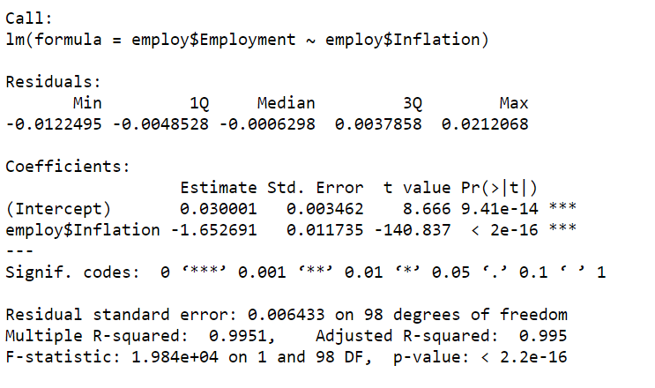  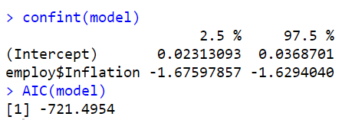 | Y(employment)= | β-coefficient  p-value=  the model  p-value= | R²_{adjusted}=  RSE=  95% CI=  AIC=
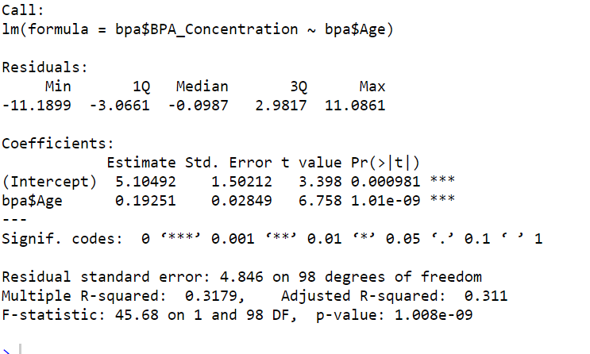  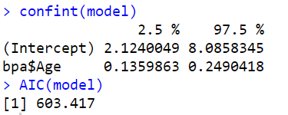 | Y( )= | β-coefficient  p-value=  the model  p-value= | R²_{adjusted}=  RSE=  95% CI=  AIC=
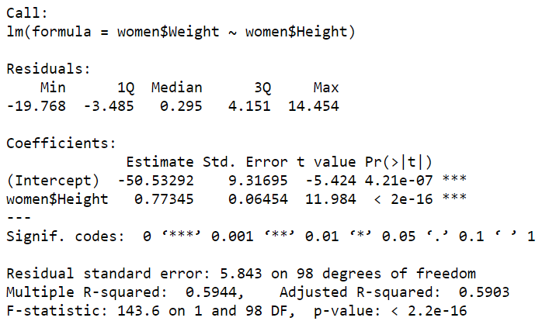  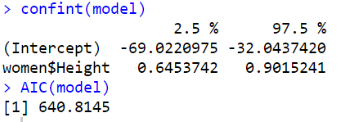 | Y( )= | β-coefficient  p-value=  the model  p-value= | R²_{adjusted}=  RSE=  95% CI=  AIC=
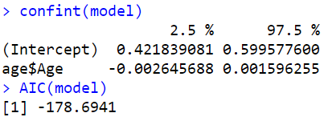 | Y( )= | β-coefficient  p-value=  the model  p-value= | R²_{adjusted}=  RSE=  95% CI=  AIC=

Conclusions:
1. The assumptions are met; the model and the independent variable (inflation) are significant (p<0.001).
The inflation variable explains 99.5% of the employment variability, RSE equals 0.006.
The estimate of the β-coefficient equals -1.65 (95% CI [-1.68;-1.63]), the intercept α equals 0.03.
Y(employment)=0.03-1.65*X(inflation) (for each one-unit shift of the inflation the employment decreases by 1.65).
2. The assumptions are met; the model and the independent variable (age) are significant (p<0.001). The age variable explains 31% of the BPA concentration variability, RSE equals 4.85.
The estimate of the β-coefficient equals 0.19 (95% CI [0.14;0.25]), the intercept α equals 5.10.
Y(BPA conc.)=5.10+0.19*X(age) (for each one-unit shift of the age (one year) the BPA concentration increases by 0.19 ug/L).
3. The assumptions are met; the model and the independent variable (height) are significant (p<0.001). The height variable explains 59% of the weight variability, RSE equals 5.84.
The estimate of the β-coefficient equals 0.77 (95% CI [0.65;0.90]), the intercept α equals -50.53.
Y(weight)=-50.53+0.77*X(height) (for each one-unit shift of the height (cm) the weight increases by 0.77 kg).
4. The assumptions are not met; the model and the independent variable (age) are not significant. We can't use linear regression for the relationship quantification between the variables and should use other methods.

