R output | Regression line formula | Significance | Model evaluation criteria
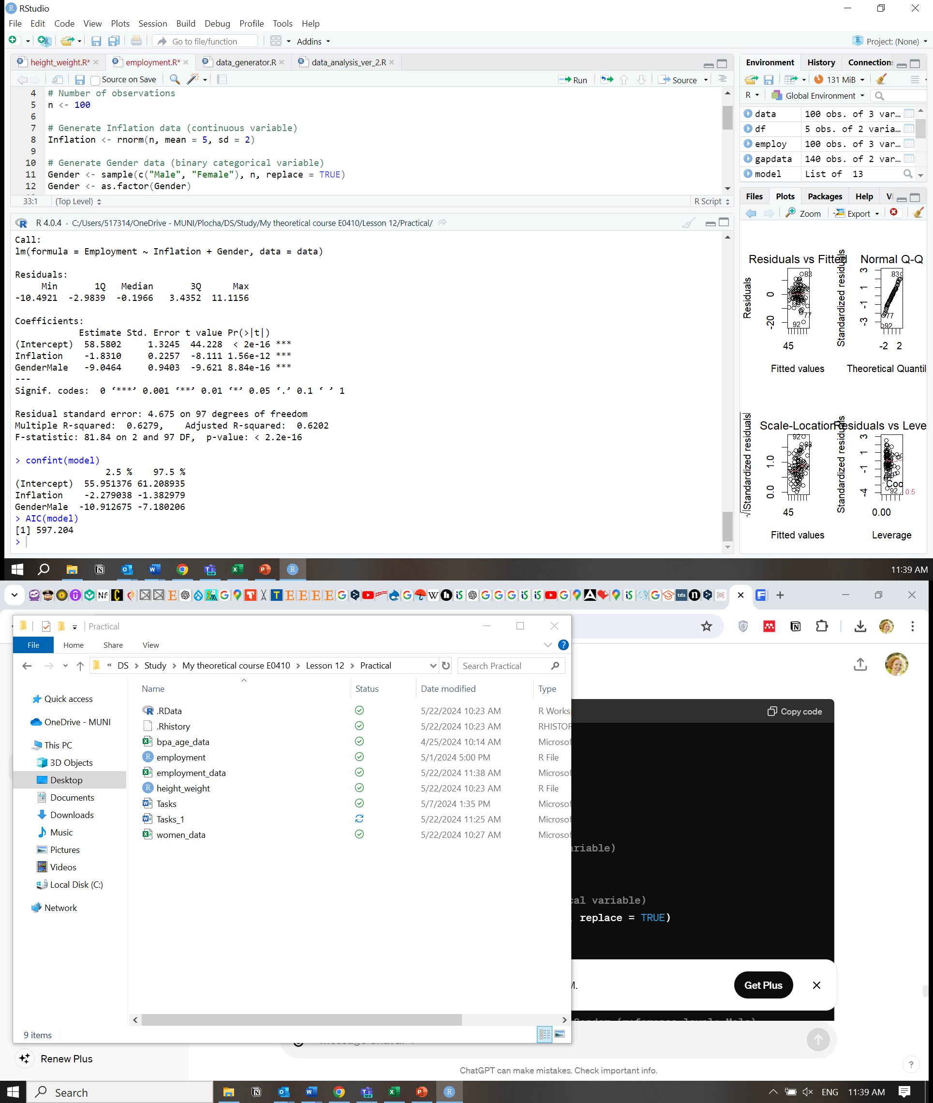 | Find the employment level for a male with the inflation level  2.273.  Find the employment level for a female with the inflation level  10.867. | β1-coefficient  p-value=  β2-coefficient  p-value=  the model  p-value= | R²_{adjusted}=  RSE=  95% CI=  AIC=
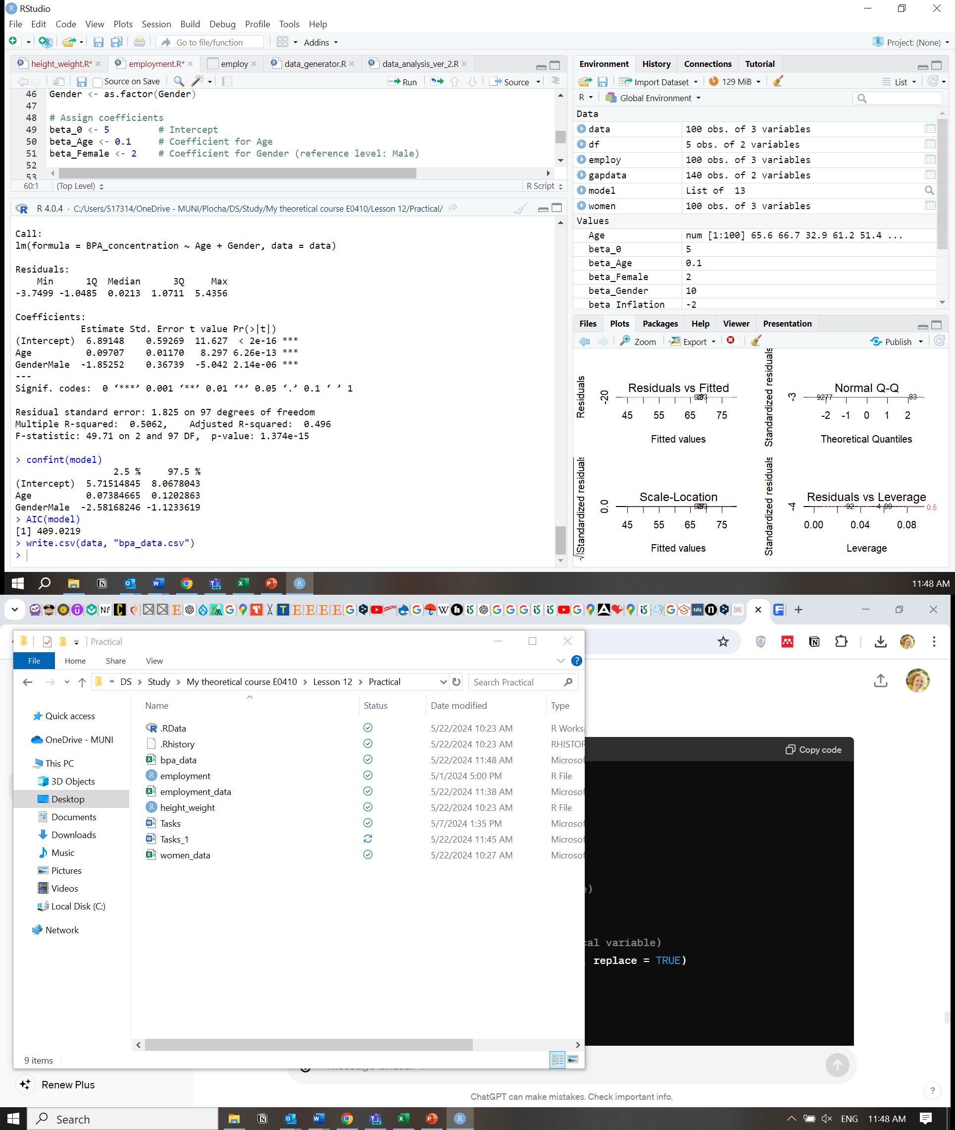 | Find the BPA level for a 50 y.o. female.  Find the BPA level for a 10 y.o. boy. | β1-coefficient  p-value=  β2-coefficient  p-value=  the model  p-value= | R²_{adjusted}=  RSE=  95% CI=  AIC=

R output | Regression line formula | Significance | Model evaluation criteria
 | Find the employment level for a male with the inflation level  2.273.  45.43¹  Find the employment level for a female with the inflation level  10.867.  38.70² | β1-coefficient  p-value=  <0.001  β2-coefficient  p-value=  <0.001  the model  p-value=  <0.001 | R²_{adjusted}=0.62  RSE=4.68  95% CI=  β1[-2.28;-1.38]  β2[-10.91;-7.18]  AIC=597.2
 | Find the BPA level for a 50 y.o. female.  11.89³  Find the BPA level for a 10 y.o. boy.  6.04⁴ | β1-coefficient  p-value=  <0.001  β2-coefficient  p-value=  <0.001  the model  p-value=  <0.001 | R²_{adjusted}=0.50  RSE=1.83  95% CI=  β1[0.07;0.12]  β2[-2.58;-1.12]  AIC=409
¹ Y(employment)= α + β1*X1(inflation) + β2*X2(gender)= 58.58-1.83*X1(inflation)-9.05*X2(gender)
Y(employment)=58.58-1.83*(2.273)-9.05*1=58.58-4.103-9.05=45.427
² Y(employment)= α + β1*X1(inflation) + β2*X2(gender)= 58.58-1.83*X1(inflation)-9.05*X2(gender)
Y(employment)=58.58-1.83*(10.863)-9.05*0=58.58-19.88=38.70

³ Y(bpa)= α + β1*X1(age) + β2*X2(gender)= 6.89+0.10*X1(age)-1.85*X2(gender)
Y(bpa)= 6.89+0.10*50-1.85*0=6.89+5=11.89
⁴ Y(bpa)= α + β1*X1(age) + β2*X2(gender)= 6.89+0.10*X1(age)-1.85*X2(gender)
Y(bpa)= 6.89+0.10*10-1.85*1=6.89+1-1.85=6.04

