Lesson 1 – Introduction to the course, organizing a conference
- Look at the word cloud and explain how these expressions are related to physics.
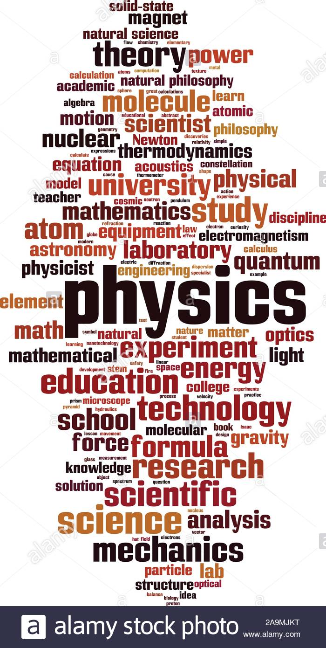

- Listening. Listen to the talk and answer questions. (0:00 – 5:00) https://www.youtube.com/watch?v=WqNVw23JRRo
- Who is John Debs and what is he interested in? ……………………………………………………………………………………………
- Why is the knowledge of physics valuable? ……………………………………………………………………………………………
- Why does John think physics is a good subject to major in? ……………………………………………………………………………………………
- What is the difference between physics exams and doing research in physics? ……………………………………………………………………………………………
- Which important skills do physics majors have? ……………………………………………………………………………………………
- What advice does John give to the physics students?
……………………………………………………………………………………………
- Organizing a conference
1) Warm-up
Have you ever attended a conference? If yes, what was it like? If not, would you like to attend one?
Do you plan to attend any conferences in the near future?
What might be difficult about attending a conference where the main (or only) language is English?

2) Benefits of attending conferences
https://conferencemonkey.org/advice/8-benefits-of-attending-conferences-1038397
- Get feedback on an early version of your latest work.
- Get to know other people in your field.
- Hear about the latest research.
- Improve your presentation and communication skills.
- Visit a new place and have fun.
- Meet your academic heroes.
- Engage in high-level debates and refine your ideas.
- Adding to your CV.

- Which of them are the most important, in your opinion? Why?

3) What do the following words mean?

BIO/BIONOTE/ BIOSKETCH:

CFP:

ABSTRACT:

SECTION CHAIR:

PROCEEDINGS:

4) You are going to ATTEND a conference. What do you think you will need to do
BEFORE / DURING / AFTER a conference?

BEFORE | DURING | AFTER

5) You are going to ORGANIZE a conference. What do you think you will need to do BEFORE / DURING / AFTER a conference?

BEFORE | DURING | AFTER

6) Preparing a Call for Papers
Call for Papers for ICAMP 2024: The 14th International Conference on Physics (ICAMP 2024)
9-10 May 2024 Taipei, Taiwan http://www.icapm.org/
The conference is intended to provide an international platform that allows researchers, academicians, teachers, and industry experts to share and discuss their latest research, ideas, and survey reports in the theoretical and practical areas regarding all aspects of Physics Sciences.
All accepted papers will be published in the open access ICAMP Proceedings Book 2024
Selected papers will be published in the open access International Journal of Recent Advances in Physics

IMPORTANT DATES

- Extended deadline for abstract submission: February 4, 2024
- Final deadline for early registration fee payment: March 1, 2024
- Final deadline for regular registration fee payment: April 1, 2024
- Conference Dates: 9-10 May 2024

TOPICS (not limited to)
- Advanced Functional Materials
- Applied & Fiber Optics
- Atomic and Molecular Experiments
- Condensed Matter Physics
- Elementary Particle Physics Theory and Experiment
- Magnetics
- Nano-Photonics, Nano-fabrication & Analysis
- Nuclear Physics Theory and Experiment
- Optics
- Physics of Complex Systems & Biophysics
- Plasma Physics
- Quantum Physics
- Spectroscopy
- Theoretical High Energy Physics

Official language: English
Full paper template
Poster presentation template
All submitted articles should be original work, not published in any proceedings or journal.
Registration form with abstract submission (all authors and co-authors should be registered)
Contact Email: info@icamp.org

PAYMENT
Type of Registration | early registration (before March 1) | regular registration (after March 1)
Full Participant (author or co-author) | 180€ | 250€
PhD Student, MSc | 140€ | 250€
Guest* | 80€
*Guests cannot present and publish papers on ICAMP Conference proceedings
Study the call for papers and try to list the parts included in it.
1)

2)

3)

4)

5)

6)

7)

8)
7) Vocabulary
a) Complete the following phrases with the words in the box.

early-bird deadline keynote session template registration submit proceedings field platform

1. extended ............................. 6. international …………………
2. publish a paper in the …………………......... 7. ............................ fees
3. ................... speakers 8. to ........................an abstract
4. the topic of ..................... 9. .......................... registration
5. poster presentation ............................. 10. .................. trip

b) Match words and phrases (1-10) to the definitions (a-j)
- pre-formatted document for summarising research in a visual display...........................................
- the main areas of interest in thematic blocks…………………....................
- excursion by a group of people to an interesting place to learn about the destination ...................
- money you must pay to attend the conference.........................................
- applying as soon as possible and paying less..............................................
- a forum for experts from many countries to share ideas........................................
- the latest date that applications can be sent to the conference....................................
- the most important presenters at the conference..............................
- write a paper to be published after the conference......................................................
- to send a written summary of your research because you want to give a presentation……….........
8. Prepare the Call for Papers for our seminar mock conference:
Write a Call for Papers - tailored to the series of presentations in JAF04 at the end of the semester. Make sure to include the following points:
NAME OF THE EVENT
OBJECTIVES
PRESENTATION TOPICS – your presentation topic
9. Typical conference activities. In pairs, look at the list of typical conference activities below and discuss the questions.

1 Which of these activities have you done (or might expect to do) at conferences?
2 Which activities are easier / more difficult for you?
3 Do you know any words or phrases which are appropriate for these activities?

a making arrangements for coffee, lunch or an evening out
b asking someone which talks they have been to
c asking someone for their opinion on a talk
d finding out about where someone works and what research they are doing
e asking someone if they are giving talk
f asking someone how successful their presentation was
g introducing yourself or someone else for the first time
h networking (making useful contacts)

10. Listening - Milan is socialising at the conference in Cambridge. Listen to extracts from eight different conversations Milan has. For each conversation, say which activity in Exercise 9 you hear. Sometimes, more than one correct answer is possible.

Conversation 1: ................................ Conversation 5:.............................
Conversation 2:................................. Conversation 6:............................
Conversation 3:................................ Conversation 7:...........................
Conversation 4:................................. Conversation 8:...........................

