**Unit 10 – Academic English**

***1. Common errors in academic English***

***a) Listening. Watch the introduction to the video about academic English and answer the questions*** [**https://youtu.be/mZQgd2sPxpk**](https://youtu.be/mZQgd2sPxpk) **.**

i) How does the speaker define academic English?………………………….

ii) The speaker mentions three features of academic English:

* It is more ………………………….
* It is more ………………………….
* It uses …………………………

iii) Which serious problem does the speaker mention? ………………………….

***b) The speaker mentions the following 12 common errors in academic English, which did you know and which can you explain?***

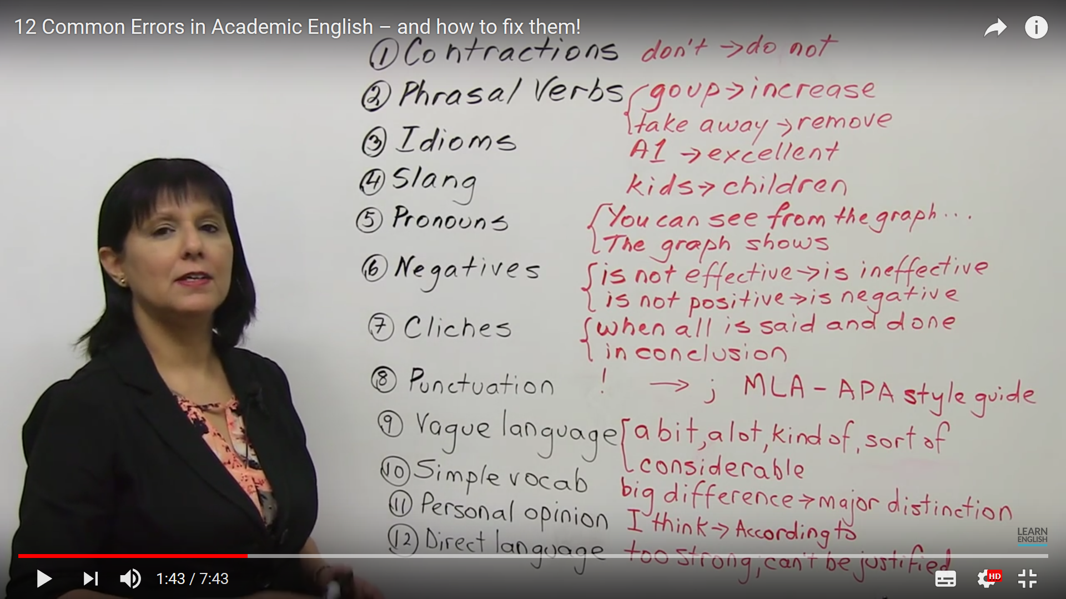

***2. Verbs useful for academic assignments*** *(Based on Academic Vocabulary in Use, CUP, pp.14-15 )*

***a) Match the verbs on the left to their more formal synonyms on the right.***

|  |  |
| --- | --- |
| to influence  to try  to give  to show  to look into  to talk about  to question | to attempt  to provide  to affect  to investigate  to demonstrate  to challenge  to discuss |

***b) Fill in the gaps in the sentences with suitable verbs from the exercise above. Put the verbs in the correct form.***

* This theory ………………………………… to build bridges between different philosophical schools.
* The graph ……………………..………… the correlation between the place where people live and drinks they prefer.
* He did not ………………………………… sufficient statistical evidence for his conclusions.
* The thesis ………………………………… the attitude of young people to diet and health.

***c) Explain the difference between the sentences in each pair.***

|  |  |
| --- | --- |
| Greg’s article supports Park’s theory. | Greg’s article challenges Park’s theory. |
| Describe the new tax regulations. | Discuss the new tax regulations. |
| Liam provides new data. | Liam considers new data. |
| Tarski conducted four sets of experiments. | Tarski examined four sets of experiments. |
| Lee established why such changes occur. | Lee investigated why such changes occur. |
| John assumed that the data were reliable. | John proved that the data were reliable. |
| Illustrate the magnitude of the deceleration. | Find the magnitude of the deceleration. |

***d) In academic style, noun phrases are sometimes used instead of verbs (e.g. to investigate = to conduct/carry out an investigation of/into, to classify = to make/provide a classification of). Rewrite each sentence using the word in brackets and make necessary changes to replace the verb with a noun phrase.***

* Erikson’s theory explains the fluctuations in the figures in the figures for this period. (PROVIDE)
* Bakker explores the relationship between family background and education. (EXPLORATION)
* The book describes the life of Abraham Lincoln. (DESCRIPTION)
* Cheng’s theory emphasizes the importance of reading in language acquisition. (PLACE)

***e) What do you do in various courses/subjects? Choose two of them and describe typical activities you do there.***

***3. Study habits*** *(Based on Academic Vocabulary in Use, CUP, pp. 50-51)*

***a) Match the first part of the word combination on the left with the second part on the right.***

|  |  |
| --- | --- |
| to meet  to-do  to request  to draw  lecture  first  time | list  deadlines  mind maps  an extension  draft  management  notes |

***b) What are your study habits? Tick those that apply to you:***

* I prioritize the most difficult or urgent tasks.
* I am not able to revise for more than two hours, so preparing for an exam takes me many days.
* I review my lecture notes within 24 hours after I took them.
* I use tricks to memorize things, like mnemonics or visualizing.
* I draw mind maps.
* I am very good at note taking during lectures, so I don’t need any additional materials.
* I always write a first draft of the assignment and then I improve it after 2 or 3 days.
* I find it useful to learn some things by heart.
* I make a study plan each exam period.
* I spent the last day before an exam cramming.

***c) Here are questions from a self-assessment questionnaire on students’ time management. Ask your neighbour and compare his/her answers with yours.***

|  |  |  |  |
| --- | --- | --- | --- |
|  | often | sometimes | never |
| 1 Do you begin working on end-of-semester assignments early in the semester? |  |  |  |
| 2 Do you meet deadlines for submitting work? |  |  |  |
| 3 Do you have to request an extension for your work? |  |  |  |

***d) Prepare a similar questionnaire for your classmates. The topic can be study habits or academic assignments.***

***Make a survey in your group, analyze the data and present the results.***

|  |  |  |  |
| --- | --- | --- | --- |
|  | often | sometimes | never |
| 1  2  3  4 |  |  |  |