**UNIT 1 ARTEMIS MISSION**

**Comparing and contrasting**

1)Pair work - look at two pictures and find differences.

<https://www.nbcbayarea.com/news/national-international/artemis-vs-apollo-see-how-the-technology-of-nasas-missions-to-the-moon-compare/2987400/>

After that, list down the differences you can remember between the Apollo and Artemis missions. You can divide the differences into categories.

<https://spacecenter.org/artemis-i-how-does-artemis-compare-to-apollo/>

|  |  |  |
| --- | --- | --- |
|  | **Apollo** | **Artemis** |
| Spacecraft |  |  |
| Rocket |  |  |
| Distance |  |  |
| Technology |  |  |
| Goals |  |  |
| Composition of the crew |  |  |
| Crew size |  |  |
| Mission name |  |  |
| Anything else |  |  |

2) Writing – Comparing and contrasting. Using the structures for comparing and contrasting, summarize the differences between the Apollo and Artemis missions in 5 sentences.

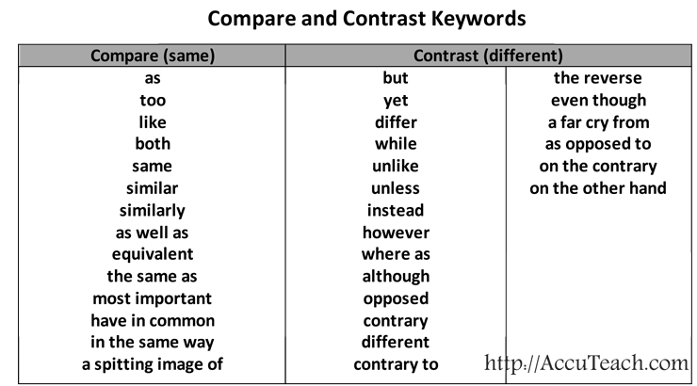

……………………………………………………………………………………………………………………………………………………………………………………………………………………………………………………………………………………………………………………………………………………………………………………………………………………………………………………………………………………………………………………………………………………………………………………………………………………………………………………………………………………………………………………………………………..

3) Listening. Decide whether the statements are true or false, then check using the link.

<https://www.youtube.com/watch?v=AvVFy3Feb1U>

1. The trajectory of the Artemis 1 spacecraft is different from the trajectories of previous spacecraft.

2. Orion´s journey was shorter than the Apollo 8 journey.

3. It takes more energy to land on Mars than it takes to land on the Moon.

4. The aims of the Apollo and Artemis missions are similar.

5. SLS is more powerful than the Saturn 5.

6. delta-v shows how much the aircraft has to change its speed to complete its journey.

7. delta-v is the same for all rockets and all routes.

8. Any change in the rocket velocity requires energy.

9. The command module in Artemis 1 is bigger than the service module.

10. The Apollo mission had to take the quickest route to the Moon because the crew would not survive a longer journey.

4) Read the text and underline expressions indicating comparison and contrast.

Comparing Artemis with Apollo is only natural. The spacecraft look similar, they are both lunar exploration programs, and even the names suggest a familial bond. But when it comes to the larger geopolitical context —and the question of whether or not we are in the midst of a new Space Race — the similarities between the programs dissolve. President [*Kennedy proposed Project Apollo*](https://astronomy.com/news/2022/09/we-choose-to-go-to-the-moon-remembering-jfks-rice-university-speech) as a political response to the threat of Soviet influence on the world order. He saw spaceflight as an essential form of soft power in the United States’ contest for geopolitical alignment and international influence. The Artemis program is not primarily aimed at international audiences and global influence. The United States is not sending humans to the lunar South Pole to win the hearts and minds of the world, and convince countries to pursue liberal democracy as opposed to socialist democracy or communism. Spaceflight does not serve the same role in international politics that it did in the 1960s. Today, we look to space diplomacy to create stronger bonds between nations, advance science, and prevent military conflict, among other objectives. In the 1960s, however, it was part of a larger ideological contest about how societies should be organized. The first lunar landing brought people together. It drew the largest audience in history. People on every continent stopped what they were doing — no matter what time of day or night — to watch those first steps live, together. Across the world, people expressed a sense of global citizenship and unity. Will Artemis inspire the same sentiment? Will it close the divisions we observe today? It is too early to tell. But, like Apollo, it will expand human experience. Humans will experience something that has never been experienced before. For Apollo, it was setting foot on another celestial object. For Artemis, it will be living and working on another world. By extending the bounds of our experience, spaceflight will again broaden what it means to be human, a process that is likely as meaningful today as it was in 1969.

— **Teasel Muir-Harmony**  
Project Apollo curator, National Air and Space Museum

**5) Language practice: Rewrite the sentences using the word(s) in brackets.**

1. Critics have complained that school exams are not as difficult as they used to be. (than) ………………………………………………………………………………………………………………………………………………

2. As an institution gets closer to a financial crisis, it feels the pain more. (the more) ………………………………………………………………………………………………………………………………………………..

3. Campaigners hoping for change within the country have become increasingly pessimistic. (and more) …………………………………………………………………………………………………………………………………………..

4. The Swiss wind turbines have not worked as efficiently as the Italian ones. (The Swiss…than) ……………………………………………………………………………………………………………………………………………………..

5. The particles become easier to observe when they gain weight. (The heavier…)

……………………………………………………………………………………………………………………………………………………

6. Introverts do not absorb information as quickly as extroverts, according to research. (Introverts…than)…………………………………………………………………………………………………………………………

**6) Are these statements true or false? Label them as T or F.**

1 If two things are mutually exclusive, one makes the other impossible. 2 If two methods of doing something are compatible, they cannot both be used. 3 If two things are equated, they are said to be similar or the same. 4 If there are parallels between phenomena, they are very different from each other. 5 If there is an overlap between two things, they share some properties.

