INORGANIC MATERIALS

Final Test 100 points ................................... name

1. a) (10 points) Consider coordination number of cations and anions in the following structure type compounds, fill the blank positions:

n:m = 1:1 | CN (a:b) | n:m = 1:2 | CN (a:b) | n:m = 1:3 | CN (a:b) | n:m = 2:3 | CN (a:b)
NaCl |  | CaF₂ | 8:4 | ReO₃ |  | Al₂O₃ | 6:4
CsCl |  | TiO₂ rutile | 6:3 | AlCl₃ | 6:2 | ♣♣♣♣♣ | ♣♣♣♣♣
ZnS |  | SiO₂ quartz |  | ♣♣♣♣♣ | ♣♣♣♣♣ | ♣♣♣♣♣ | ♣♣♣♣♣
NiAs | 6:6 | ♣♣♣♣♣ | ♣♣♣♣♣ | ♣♣♣♣♣ | ♣♣♣♣♣ | ♣♣♣♣♣ | ♣♣♣♣♣

b) (10 points) Devise a general rule which links stoichiometric coefficients n, m in M_{n}X_{m} with coordination numbers a and b for cations and anions, respectively.

2. (10 points) Zeolite-A (LTA) has a single peak in the ²⁹Si NMR spectrum (- 89 ppm) and has a Si/Al ratio of 1. Comment on these observations with respect to the Si and Al distribution and ordering.

3. (20 points) Semiconductors of the 13/15 and 12/16 types frequently adopt the sphalerite (zinc blende) structure. Draw a unit cell of ZnS-blende and calculate the number of formula units in the unit cell.

4. (10 points) Stishovite is a high-pressure modification of SiO₂ having the rutile structure. Should it have longer or shorter bond lengths then quartz?
5. (10 points) Which of these polyhedra represent the coordination environment of a metal atom in
a) copper
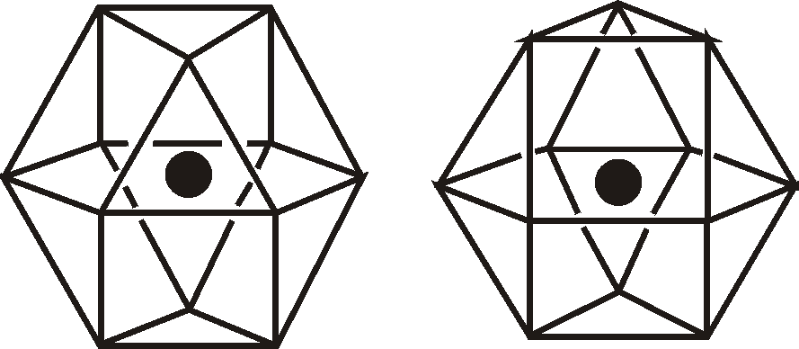
b) magnesium

6. The solid state reaction between CaO and SiO₂ is an important process in the cement and iron production (slag formation). Ca₂SiO₄ is formed in the first step. Write chemical reactions taking place at the interfaces and calculate the Kirkendall ratio for this process
a) (10 points) First, assume counter diffusion of Ca²⁺ and Si⁴⁺
b) (20 points) The assumption a) is unrealistic, because the highly charged Si⁴⁺ is very strongly bound to the oxide network and its diffusion coefficient is negligible. Suggest alternative diffusion process and calculate the Kirkendall ratio.

