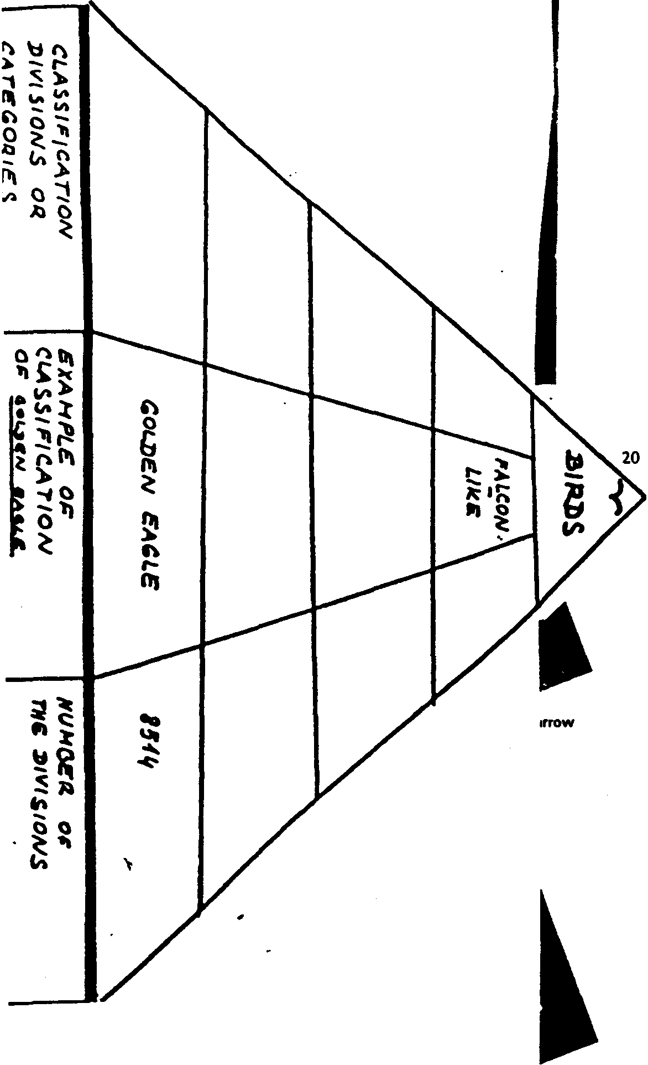

The Classification of Birds

Birds are instantly recognisable creatures. Perhaps it is their ability to fly that causes this. Some people might consider that their shape was the most distinguishing feature. Everyone, however, agrees upon the characteristics that a bird

possesses: two wings, feathers, two legs, a toothless bill or beak, warm blood, and it lays eggs.

The modern system of classifying birds is like a pyramid, with the base formed by 8514 different species. A convenient definition of species is: an interbreeding group of birds which do not normally mate with other such groups.

The next division above the species is the genus, a group of species showing strong similarities. The scientific name of a bird gives the genus first, then the species. Thus, the scientific (Latin) name of the golden eagle is 'Aquila

chrysaetos' (eagle, golden). When there are strong points of similarity between one genus and another, these related genera are grouped together and are said to belong to the same family. The names of the 215 families of birds always end in 'idae'. The golden eagle, for instance, is one of the 'Falconidae' (falcon family).

Families with broadly similar characteristics are grouped together into 27 orders, whose names end in 'iformes'. The golden eagle falls into the order of 'Falconiformes' (falcon-like birds). The largest order is 'Passeriformes' or perching birds. This contains 63 families, and more species than all the rest put together. The feet are designed so that they can grip a perch, with three toes in front and one behind. In addition, all are known as song-birds. Two large families within this order are sparrows, with 155 species, and crows, with 100 species.
Finally, all of the orders make up the class 'Aves' (birds).
This system of classification has enabled scientists to differentiate 8514 species of birds. Placing a bird in the right family depends upon a number of features. Among them are

external characteristics, such as the shape of the beak and feet, and the colour pattern of the feathers. However, at the level of order, the next higher category, distinctions are based on such features as the structure of the skull, the arrangement of the muscles in the legs, and the condition of the young at the time of hatching.

Robert Jordan, Academic Writing Cour se

