PLANTS
- The structure of a flower (2/2)

- Label the diagram with the words from the list

receptacle – lůžko  petal – korunní plátek  sepal – kališní lístek  stamen (M)– tyčinka  anther – prašník  filament –nitka | pistil (F)– pestík  stigma – blizna  style - čnělka  ovary – semeník  ovum – vajíčko  ovule – vajíčko

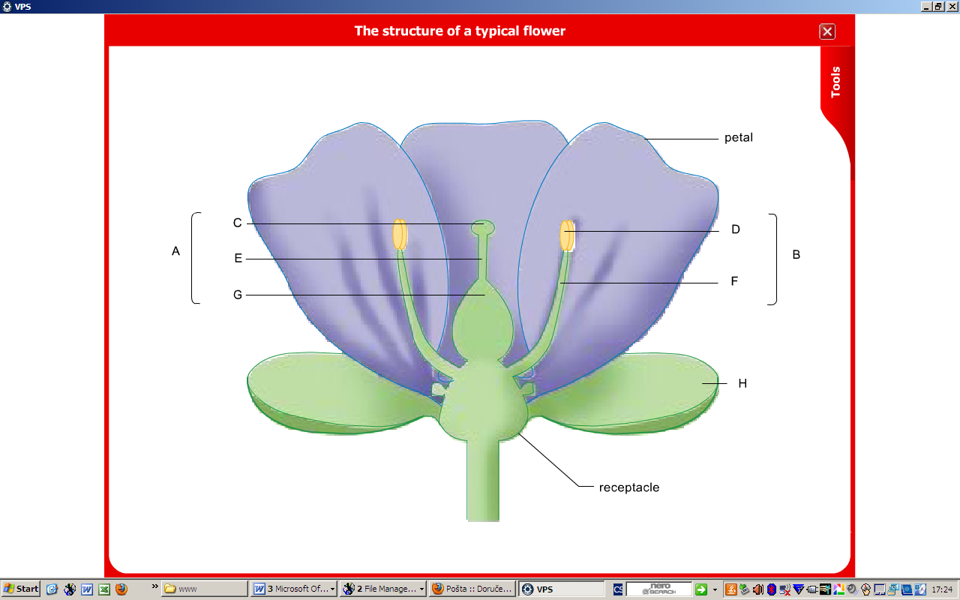

- Listen and complete the gaps
The structure of a flower

The flower consists of four regular floral structures: ....................., .....................,, ....................., and ......................
These originate from the base of the flower, the ......................
Flowers that have all four floral structures are described as complete.
Some flowers such as those of grass have missing floral parts. These are called incomplete flowers.
All the flower structures play an important role in the ..................... process.
But only the male reproductive organ, the ..................... and the female reproductive organ, the ..................... produce the sex cells.
The ..................... form the leaf-like outermost layer that is usually green in colour, though they are sometimes brightly coloured.
The ..................... protect the flower while in the bud stage.
The ..................... are found just inside the sepals. They are often brightly coloured to attract insects and birds that will aid in pollination, the transfer of the pollen fragments from a stamen to the stigma of the pistil.
The ..................... play an important role in protecting the reproductive structures that are inside the flower.
The male reproductive structure is the ..................... which is made up of two parts.
It has a slender stalk called the filament and a swollen head called the anther,
The anther contains the pollen sacs in which the pollen grains are made and stored .
The pollen grains contain the male sex cells.
The female reproductive structure, the ....................., is located at the centre of the flower. It has three parts, the stigma, style and ovary.
The stigma is the swollen sticky or feathery tip of the ...................... It is the surface on which the pollen grains will land during pollination.
The style is a long slender stalk which connects the stigma to the ......................
The ovary is the enlarged structure at the base of the pistil which contains one or more ......................
Each ovule contains a female sex cell – ovum.
The wall of the ovary is very thick to protect the ovules and sex cells.

- Make questions to get the missing information

- The flower consists of four regular floral structures: ...............................

- These originate from the base of the flower, ...............................

- But only the male reproductive organ, the stamen, and the female reproductive organ, the pistil, produce ...............................

- ...............................form the leaf-like outermost layer that is usually green in colour,
though they are sometimes brightly coloured.

- ............................... protect the flower while in the bud stage.

- The anther contains ............................... in which the pollen grains are made and stored.

- The style is a long slender stalk which connects the stigma to ................................
- Photosynthesis (5/3)
Listen to the recording and put the steps of photosynthesis in order

  - proteins and fats using minerals absorbed from the soil with water;

  - Water and minerals are absorbed from the soil through the roots.

  - The glucose that is made during photosynthesis is transported to other parts of the plant.

  - Carbon dioxide enters the plant from the air through small holes in the leaf called stomata.

  - cellulose, which is used to form cell walls;

  - Here it is used in respiration to provide energy for the cell reactions or to make new materials such as complex sugars like sucrose;

  - During photosynthesis, chlorophyll, the green pigment in plants, traps the energy from the sunlight and uses it to join carbon dioxide and water to make glucose and oxygen.

  - starch, which is stored in various parts of the plants such as stems roots and seeds for use another time.

  - Glucose is the food the plant uses to make everything else it needs for growth.
- The movement of water from the soil to the stem (12/2) STUDENT A

Study the text and the diagram and be ready to present it to your colleague.

Water enters a plant through its roots which spread out into the soil.
The outer cells of the root cortex have very fine root hairs.
These greatly increase the surface area of the roots able to take up water.
This only happens through the selectively permeable cell membrane.
In the soil, the soil particles are surrounded by soil water.
In the soil, there is usually more water than in the root cells so water molecules move into the root hair cells.
At this point there are more water molecules in those cells compared with the inner cells next to them so water continues to move inwards.
This process will continue from one root cell to the next until the water reaches the xylem vessels in he centre.

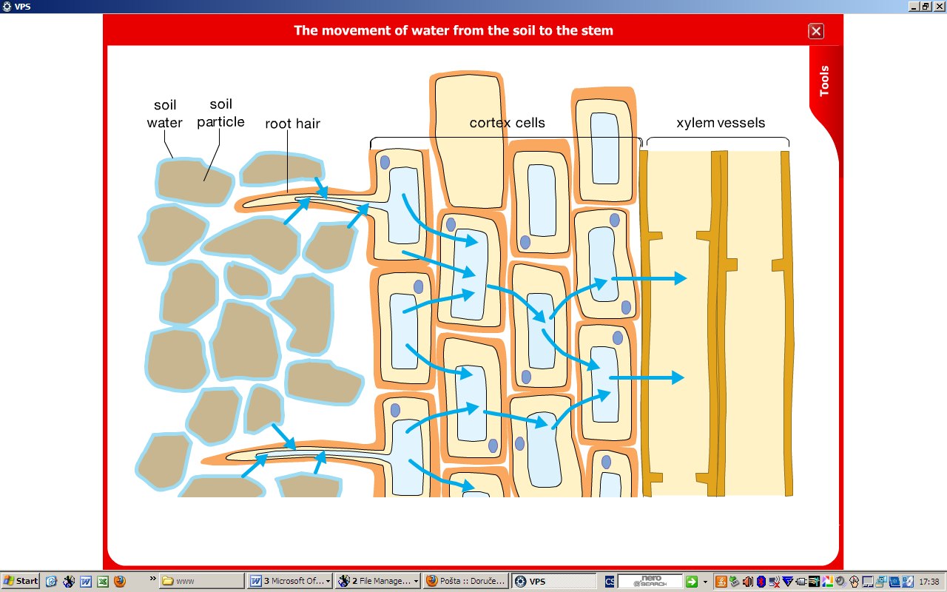
STUDENT B

water  soil  outer cells  root cortex  root hairs  cell membrane  soil particles  soil water  root cells  water molecules  inner cells  xylem vessels | increase  spread out  enters  happens  are surrounded  continues  reaches  move into

STUDENT B

- Pollination (2/4)
Study the text and the diagram and be ready to present it to your colleague

Fertilization is the fusing of the male and female sex cells.

This can only occur if these cells come into contact with each other.
In flowering plants they are found in different structures in the flower or even in different flowers so the male cells have to travel to the female stigma before fertilization can happen. This process of transfer is called pollination.
Because the male and female reproductive structures are separate it is possible that the pollen from one flower could pollinate the stigma of the same flower or of a different flower.
So there could be: self-pollination where the pollen grains are dropped on the stigma of the same flower or cross-pollination where the pollen grains are transferred from the anther of one flower to the stigma of a different flower.
In reality most plants have ways that reduce the chances of self-pollination such as the stamens of a flower ripen first and release their pollen before the stigma in that flower is ready to be fertilized.

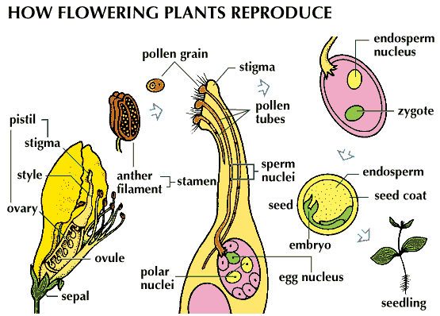

http://www.britannica.com/EBchecked/topic-art/552842/53831/Reproduction-in-flowering-plants-begins-with-pollination-the-transfer-of

STUDENT A

http://www.britannica.com/EBchecked/topic-art/552842/53831/Reproduction-in-flowering-plants-begins-with-pollination-the-transfer-of

dropped on  are found  pollinate  transferred from  release  fertilized  occur  ripen  travel | fertilization  flowering plants  different structures  male cells  stigma  transfer  pollination  self-pollination  anther  cross-pollination  stigma  stamens

