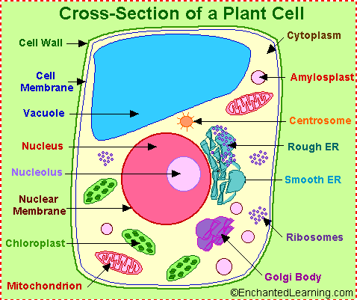
The following is a glossary of plant cell anatomy terms.

amyloplast - an organelle in some plant cells that stores starch. Amyloplasts are found in starchy plants like tubers and fruits.
ATP - ATP is short for adenosine triphosphate; it is a high-energy molecule used for energy storage by organisms. In plant cells, ATP is produced in the cristae of mitochondria and chloroplasts.
cell membrane - the thin layer of protein and fat that surrounds the cell, but is inside the cell wall. The cell membrane is semipermeable, allowing some substances to pass into the cell and blocking others.
cell wall - a thick, rigid membrane that surrounds a plant cell. This layer of cellulose fiber gives the cell most of its support and structure. The cell wall also bonds with other cell walls to form the structure of the plant.
centrosome - (also called the "microtubule organizing center") a small body located near the nucleus - it has a dense center and radiating tubules. The centrosomes is where microtubules are made. During cell division (mitosis), the centrosome divides and the two parts move to opposite sides of the dividing cell. Unlike the centrosomes in animal cells, plant cell centrosomes do not have centrioles.
chlorophyll - chlorophyll is a molecule that can use light energy from sunlight to turn water and carbon dioxide gas into sugar and oxygen (this process is called photosynthesis). Chlorophyll is magnesium based and is usually green.
chloroplast - an elongated or disc-shaped organelle containing chlorophyll. Photosynthesis (in which energy from sunlight is converted into chemical energy - food) takes place in the chloroplasts.
christae - (singular crista) the multiply-folded inner membrane of a cell's mitochondrion that are finger-like projections. The walls of the cristae are the site of the cell's energy production (it is where ATP is generated).
cytoplasm - the jellylike material outside the cell nucleus in which the organelles are located.
Golgi body - (also called the golgi apparatus or golgi complex) a flattened, layered, sac-like organelle that looks like a stack of pancakes and is located near the nucleus. The golgi body packages proteins and carbohydrates into membrane-bound vesicles for "export" from the cell.
granum - (plural grana) A stack of thylakoid disks within the chloroplast is called a granum.
mitochondrion - spherical to rod-shaped organelles with a double membrane. The inner membrane is infolded many times, forming a series of projections (called cristae). The mitochondrion converts the energy stored in glucose into ATP (adenosine triphosphate) for the cell.
nuclear membrane - the membrane that surrounds the nucleus.
nucleolus - an organelle within the nucleus - it is where ribosomal RNA is produced.
nucleus - spherical body containing many organelles, including the nucleolus. The nucleus controls many of the functions of the cell (by controlling protein synthesis) and contains DNA (in chromosomes). The nucleus is surrounded by the nuclear membrane
photosynthesis - a process in which plants convert sunlight, water, and carbon dioxide into food energy (sugars and starches), oxygen and water. Chlorophyll or closely-related pigments (substances that color the plant) are essential to the photosynthetic process.
ribosome - small organelles composed of RNA-rich cytoplasmic granules that are sites of protein synthesis.
rough endoplasmic reticulum - (rough ER) a vast system of interconnected, membranous, infolded and convoluted sacks that are located in the cell's cytoplasm (the ER is continuous with the outer nuclear membrane). Rough ER is covered with ribosomes that give it a rough appearance. Rough ER transport materials through the cell and produces proteins in sacks called cisternae (which are sent to the Golgi body, or inserted into the cell membrane).
smooth endoplasmic reticulum - (smooth ER) a vast system of interconnected, membranous, infolded and convoluted tubes that are located in the cell's cytoplasm (the ER is continuous with the outer nuclear membrane). The space within the ER is called the ER lumen. Smooth ER transport materials through the cell. It contains enzymes and produces and digests lipids (fats) and membrane proteins; smooth ER buds off from rough ER, moving the newly-made proteins and lipids to the Golgi body and membranes
stroma - part of the chloroplasts in plant cells, located within the inner membrane of chloroplasts, between the grana.
thylakoid disk - thylakoid disks are disk-shaped membrane structures in chloroplasts that contain chlorophyll. Chloroplasts are made up of stacks of thylakoid disks; a stack of thylakoid disks is called a granum. Photosynthesis (the production of ATP molecules from sunlight) takes place on thylakoid disks.
vacuole - a large, membrane-bound space within a plant cell that is filled with fluid. Most plant cells have a single vacuole that takes up much of the cell. It helps maintain the shape of the cell.

http://www.enchantedlearning.com/subjects/plants/cell/

