How Did We Find Out the Earth Is Round?
1 Through the ages, the earth has been thought to be flat, pear shaped, and perfectly round. What evidences led to the conclusion that the earth is round?
2 Back in the fourth century B.C., Aristotle offered the earth's shadow during a lunar eclipse as evidence that the earth is round. When a lunar eclipse takes place,
the earth passes between the sun and the moon. This causes a shadow of the earth to appear on the surface of the moon. Aristotle noticed that the earth's shadow
is curved.
3 Aristotle obtained another evidence of the earth's roundness by observing stars from different places. If, for example, you observe a star at an angle of 45° above the northern horizon and then move south, the star will appear to get lower in the sky. If the earth's surface were flat, then the star would always appear at 45° above the horizon.
4 Based on Aristotle's assumptions, Eratosthenes actually determined
the circumference of the earth in the second century B.C. He did this by comparing the length of shadows in two different places at the same time.
5 Even much later, in Columbus's time, there was still doubt about the earth's shape. One argument used to support the earth's roundness had to do with a ship's "disappearing" over the horizon. As a ship sailed away from an observer, the ship gradually disappeared, with the lower parts disappearing before the sails and masts.
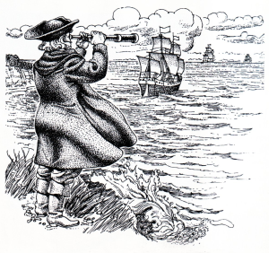
6 Many other evidences of the earth's shape have, of course, been offered between Aristotle's lifetime and the present day. Depending on your interest, you might research some of these other evidences on your own.
Vocabulary and grammar

Explain these words:
pear shaped (1), pear is a) geometric shape b) fruit c) vegetable
lunar eclipse (2), angle (3), actually (4), circumference (4), sails (5), masts (5)
Explain by English words of similar meaning:
evidences (1) obtained (3) assumptions (4)
determined (4) without a doubt (5)
gradually (5) research (6)
Say the opposite:
round curved (2) above (3)

Note these grammar points:

Vazba akuzativu s infinitivem e.g. I want you to remember this.
Takto se převádějí české věty typu Chci, aby sis to pamatoval.
This causes a shadow of the earth to appear on the surface of the moon.

Conditional 2
If the earth's surface were flat, then the star would appear ….
Kdyby …………………byl…………………….by se jevila …..
If I …………………….. (observe) the stars, I would not see them.
If I ………………………(want), I would observe the night sky.

Explain three possible meanings of used to support (5):
1. I used to support poor people. I used to play the piano.
2. I am used to support missions. I am used to swim long distances.
3. One argument used to support the earth's roundness had to do with a ship's "disappearing" over the horizon.

Form similar sentences:
1.
2.
3.

